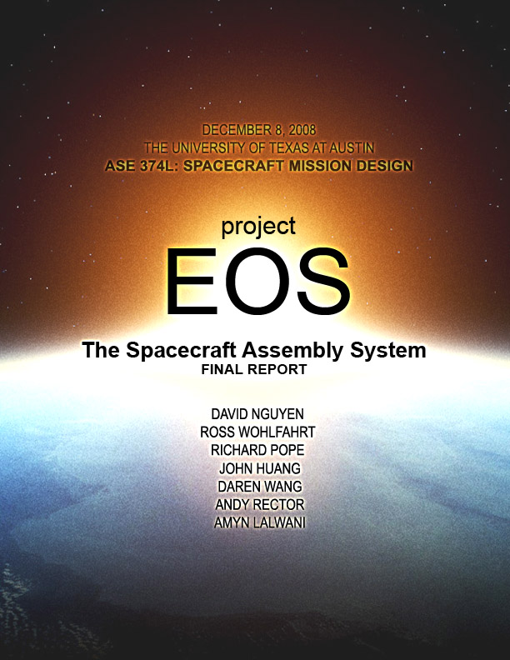

Low Earth Orbit Assembly System Final Report
ASE 374L
The University of Texas at Austin
December 08, 2008

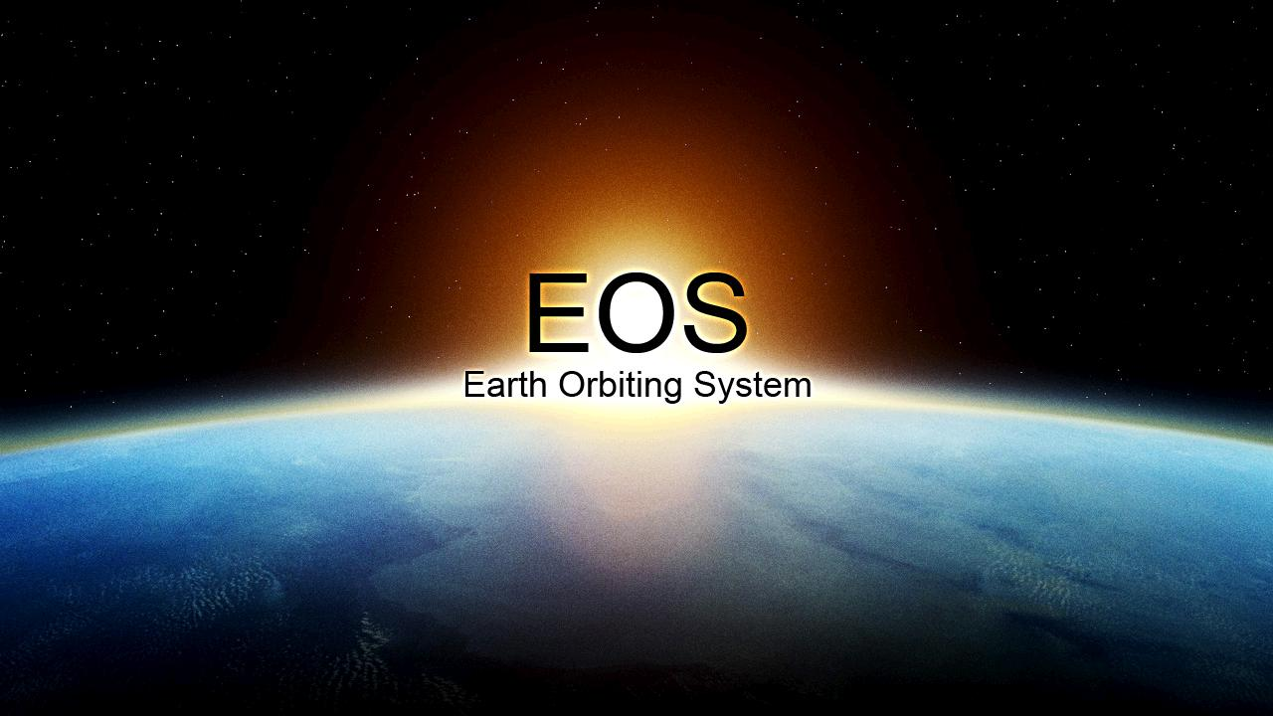

Project Manager: David Nguyen
Chief Engineer: Ross Wohlfahrt
Systems Engineer: Richard Pope
Subsystems Engineers:
John Huang
Daren Wang
Andrew Rector
Amyn Lalwani

ACKNOWLEDGEMENT
Team EOS would like to thank Dr. Fowler for his invaluable insights and guidance for this project. His knowledge of spacecraft and past missions strongly influenced the overall design. Team EOS is thankful to Michael Gardner for his advice, not only for his technical expertise, but also his advice for the team in general. John Christian was very helpful in the design process, helping with major spacecraft subsystems, such as communication, ADCS and robotics. Finally, team EOS is indebted to Lisa Guerra for her knowledge in past NASA missions.

Team EOS

EXECUTIVE SUMMARY
When the shuttle retires in around 2010, the primary means for space assembly in low Earth orbit will be gone. Ambitious projects like assembling the International Space Station will not be possible without a space assembly system. If such projects cannot be realized, then projects which involve interplanetary missions and large spacecraft will not be feasible.

In the design of such an assembly system, team EOS has assumed the development and completion of the Ares V rocket by the time of launch of the system. The Spacecraft Being Assembled, or SBA, can be modularized into components which can be sent into orbit. Also, the robotics necessary for assembly is assumed to be ready by 2020.

The project specified an assembly system in low earth orbit (LEO) which could be capable of assembling large spacecraft. The basic requirements for this system included teleoperated control of the assembly station from Earth and the exclusion of human interfaces aboard the station.

Based on these assumptions and requirements, Team EOS has developed an assembly system named the Spacecraft Assembly System (SCAS) shall assemble spacecraft in LEO. The Spacecraft Assembly System, or SCAS, will consist of the Orbiting Spacecraft Assembly Platform (OSAP) residing at an altitude of 341 km with an inclination orbit of 28.5 degrees. The Spacecraft Being Assembled (SBA) will be transported by the Component Transport System (CTS). The CTS will transport Spacecraft Being Assembled Parts (SBAPs) to the construction site.

The first SCAS launch will place OSAP and the initial CTS in a single Ares V rocket. Once all SBAP supplies have been used, subsequent CTSs will rendezvous with the OSAP by attaching themselves to the OSAP CTS dock. Modules will be carried from the CTS to the OSAP assembly site, where the SBA will be assembled, by robotic arms. The CTS can then either deorbit to burn in the atmosphere, or be reused in the SBA design.

The OSAP will be an unmanned spacecraft. Assembly of the SBA will be entirely teleoperated or automated. The robotic arms used will be similar to Canadarm2 and Special Purpose Dexterous Manipulator. They will move from one spot to another by attaching their end effectors to Power and Data Grappling Fixtures (PDGFs). PDGFs provide both power and communications from the OSAP to the arms and will be located on the OSAP and CTS structures. As such, the SBA modules must also have PDGFs for the arms to grab them. Each Canadarms will also have Dextre end-effectors, capable of more finesses operations on the SBA. Cameras are located at each elbow joints and at the end of the Dextre. They allow operators on Earth to control the arms with visual feedback. Two External Camera Video Groups, or ETVCGs, will downlink video streams of the SBA as more modules are assembled. ETCVGs can be rotated and slew, providing a near 360 degree field of vision of the entire system. Furthermore, they can be moved by attaching them to PDGFs as well.

The Attitude Determination and Control System (ADCS) will be responsible for controlling the moments applied on OSAP due to the torque induced by the movements of the robotic arms, the movement of the modules, and other environmental torques. The ADCS system will also be used for the rotation of the OSAP during rendezvous with the CTS. The ADCS subsystem will use Control Moment Gyroscopes (CMGs) as well as cold nitrogen propellant to rotate the spacecraft as necessary. 4 CMGs, each capable of producing 4500 Nms of angular momentum, will be located inside the OSAP. 32 dry nitrogen thrusters will be clustered into groups of 4, with a total of 8 clusters located on the OSAP.

The Command and Data Handling system (C&DH) will use a centralized architecture, which will control the arms and ETVCGs, as well as all the other subsystems. The C&DH will communicate with ground control operations through the TDRSS network with the Ku-Band and S-Band. The Ku-Band and S-Band will downlink video observations of the SBA assembly as well as telemetry. The S-Band will be used to uplink commands and data to the robotic arms and OSAP. The UHF band will be used to communicate with incoming spacecraft for rendezvous maneuvers. The Video Distribution Network (VDS) will be used to transmit video signals to the OSAP C&DH.

The thermal system will consist of both active and passive systems. A thermal radiator will be used to expel excess heat during sun-side orbit while heaters will be used for dark-side periods. Power will be provided by both retractable solar panels and lithium ion batteries. There will be seven power operations modes.

Structure will include the OSAP and CTS body, which will house the thermal, power, ADCS, and C&DH subsystem. The OSAP main body will also have a docking system at both ends. One of the docking systems will be a multi-dock which attaches to the SBA, and will allow other spacecrafts to attach them to the OSAP. Spaceship like the Orion will be able to dock to the OSAP. The other docking system will be used to attach CTS to OSAP.

Table of Contents
ACKNOWLEDGEMENT 2
EXECUTIVE SUMMARY 3
GLOSSARY 7
Acronyms 7
Figures 8
Tables 9
1 INTRODUCTION 11
2 STATEMENT OF NEED AND PROJECT SCOPE 13
3 PROJECT REQUIREMENTS 14
3.1 System 14
3.2 Structural 15
3.3 Assembly Mission 16
3.4 ADCS 17
3.5 Robotics 18
3.6 C&DH 22
3.7 Communication 22
3.8 Propulsions 23
3.9 Thermal 23
3.10 Power 23
4 CONCEPT OF OPERATIONS 24
4.1 CTS Operations 25
5 DESIGN 26
5.1 Design Approach 26
5.2 Subsystem Approach 26
5.3 Final Design 27
6 ROBOTICS 28
6.1 Assumptions 28
6.2 Robotics and Assembly Operation Philosophy 28
6.3 Baseline Robotics Payload Description 28
6.4 2 Large Manipulators (LM) 29
6.5 2 Medium Dexterous Manipulators (MDMs) 30
6.6 Robotics Operations 32
6.7 Robotics System Transportation 32
6.8 Large Manipulator Movement about the Construction Site 32
6.9 Conversion of SBAP’s into walking transportation devices 33
6.10 OSAP traversal 34
6.11 Robotics Stowage 34
6.12 OSAP and SBA Inspection and Maintenance 35
6.13 Performance and Mass 35
6.14 Trade Study 37
7 ATTITUDE DETERMINATION AND CONTROL SYSTEM (ADCS) 38
7.1 Assumptions 38
7.2 Orbit Design 38
7.3 Sensor Selection 38
7.4 Controller Selection 38
7.5 Orbit Design 38
7.6 Inclination 39
7.7 Altitude 39
7.8 Resulting Sunlight Exposure 41
7.9 State Determination Trade Summary 42
7.10 Position and Velocity Determination 42
7.11 Rotational Attitude Determination 42
7.12 Sensor Decision 43
7.13 Rotational Attitude Control 44
7.14 Controller Selection 44
7.15 Translational Attitude Control 46
7.16 ADCS Strengths and Weaknesses 46
8 PROPULSION 47
8.1 Introduction 47
8.2 Propulsion Subsystem Assumptions 47
8.3 Attitude Control and Maneuvering Thruster System (ACMTS) 47
8.4 ACMTS Propellant and Propellant Feed System 49
8.5 Orbit Maintenance System (OMS) 50
9 COMMAND AND DATA HANDLING (C&DH) 52
9.1 Type of C&DH Systems 52
9.2 C&DH Design Process 53
9.3 C&DH Final Design 53
10 COMMUNICATIONS 54
10.1 Types of Communication Architectures 54
10.2 Communication Heritage 54
10.3 Communication Design Process 55
10.4 Data rates 55
10.5 Communication Network 55
10.6 Communication Band 56
10.7 S-Band 56
10.8 UHF Subsystem 57
10.9 Video Distribution System 57
10.10 Ku-Band 57
10.11 Communication Configuration 58
11 THERMAL 59
11.1 Types of Thermal Control Systems 59
11.2 Thermal Control Subsystem Design Process 59
11.3 Thermal Control Subsystem Strengths and Weaknesses 62
12 POWER 63
12.1 Power Systems 63
12.2 Power Modes 63
12.3 Power Sizing 64
13 STRUCTURE 65
13.1 Structural Design Scope 65
13.2 Launch Vehicle 65
13.3 SCAS geometry 66
14 MASS TABLE 69
15 VOLUME TABLE 71
16 MISSION TIMELINE 72
17 ESTIMATED COSTS 73
18 DESIGN EVALUATION 74
18.1 Design Strengths 74
18.2 Design Weaknesses 74
18.3 Future Work 75
19 CONCLUSION 77
20 REFERENCES 78
21 APPENDICES 83
21.1 ADCS 83
21.2 Propulsions 90
21.3 Thermal 92
21.4 Power 94
21.5 Structure 102
21.6 Communication 103
21.7 Organization Chart 103
21.8 Résumés 104

GLOSSARY

Acronyms
ACMTS: Attitude Control and Maneuvering Thruster System
ADCS: Attitude Determination and Control
AIM: Assembly, Inspection, Maintenance
AMM: Attached Mobile Manipulator
ATA: Ammonia Tank Assembly
C&DH: Command and Data Handling
CMG: Control Moment Gyroscope
CTS: Component Transportation System
CVIU: Common Video Interface Unit
DPT: Duel Propellant Tank
DWA: Duel Wield Adapter
ERA: European Robotic Arm
ETVCG: External Television Camera Group
EVA: Extravehicular Activity
EVSU: External Video Switch Unit
FEEP: Field Emission Electric Propulsion
GPS: Global Positioning System
HDR: High Data Rate
HF: High Frequency
IFHX: Interface Heat Exchanger
IMU: Inertial Measurement Unit
IPM: ISS Propulsion Module
ISS: International Space Station
JEMRMS: Japanese Experimental Module Robotic Manipulator System
L: Long Wave
LDR: Low Data Rate
LEO: Low Earth Orbit
LM: Large Manipulator
MBS: Mobile Remote Servicer Base Station
MDM: Medium Dexterous Manipulator
MED: Momentum Exchange Device
MIMU: Miniature Inertial Measurement Unit
MLI: Multi-Layer Insulation
MSS: Mobile Servicing System
NASA: National Aeronautics and Space Administration
NTA: Nitrogen Tank Assembly
OBSS: Orbiter Boom Servicing System
OMS: Orbit maintenance System
OPM: OSAP Propulsion Module
ORU: Orbital Replacement Unit
OSAP: Orbiting Spacecraft Assembly Platform
PDGF: Power Data Grapple Fixture
RMA: Remote Manipulator Arm
S: Short Wave
SBA: Spacecraft Being Assembled
SCAS: Spacecraft Assembly System
SCU: Sync and Control Unit
SFA: Small Fine Arm
SPDM: Special Purpose Dexterous Manipulator
SRMS: Shuttle Remote Manipulator System
SSN: Space Surveillance Network
SSRMS: Space Station Remote Manipulator System
TDRSS: Tracking and Data Relay Satellite System
TRL: Technology Readiness Level
UHF: Ultra High Frequency
USD: United States Dollar
VBSP: Video Baseband Signal Processor
VDS: Video Distribution Subsystem
VHF: Very High Frequency
X: Cross

Figures
Figure 1: Spacecraft Assembly System (SCAS) launch and initialization 24
Figure 2: Robot Large Manipulators deploy and begin constructing the Spacecraft Being Assembled (SBA). The teal amorphous cloud represents the SBA. 24
Figure 3: SCAS is rotated parallel to the velocity vector. The initial CTS is jettisoned and a new one is docked onto OSAP 25
Figure 4: Assembly resumes after a CTS rendezvous and docking operation 25
Figure 5: N-2 Diagram 26
Figure 6: Picture of Canadarm2 Remote Manipulator System 29
Figure 7: Picture of Canadarm2’s Latching End Effectors 30
Figure 8: the inspiration for a small payload attach system to be used on the Large Manipulator, taken from an In-Space Assembly Concept for a Large Scalable Space Telescope 30
Figure 9 Picture of the Special Purpose Dexterous Manipulator. Note its ability to attach ORU payloads onto itself and its tool changeout mechanism 31
Figure 10: Picture of a Power Data Grapple Fixture used on the International Space Station 32
Figure 11: Large Manipulator inchworm movement across Power Data Grapple Fixtures 33
Figure 12: SBAP transportation concept about the assembly site using two Large Manipulators 34
Figure 13: Comparison of different robotics configurations 37
Figure 14: Orbit Selection Iteration 38
Figure 15: Atmospheric Drag Orbit Decay for Increasing Initial Altitudes (Initial SCAS Launch) 40
Figure 16: Re-boost Target Altitude as SBA Grows 40
Figure 17: Sunlight Exposure Interval Length 41
Figure 18: Umbra Interval Length 41
Figure 19: ADCS Trade Tree 42
Figure 20: CMG’s in OSAP 45
Figure 21: Configuration and Placement of attitude control thrusters and propellant tanks 48
Figure 22: Schematic Diagram of the ACMTS 50
Figure 23: IPM, proposed baseline for OPM 51
Figure 24: C&DH Architecture 52
Figure 25: TDRSS Geometry with respect to OSAP 56
Figure 26: Antenna Rotation on OSAP 58
Figure 27: Thermal Control Trade Tree 59
Figure 28: Active thermal control loop 62
Figure 29: Solar Array Dimensions 64
Figure 30: Proposed Ares V payload fairing dimensions 66
Figure 31: Even larger proposed Ares V payload fairing dimensions 66
Figure 32: Preliminary SCAS geometry compared to a 5’7” human 67
Figure 33: Picture of OSAP structural arrangement with a scaled human on the bottom 68
Figure 34: Mass vs. Altitude 85
Figure 35: Honeywell CMG Specifications 90
Figure 36: Electrical Power with respect to Use Duration 95
Figure 37: Power and Mass Usage Comparison 96

Tables
Table 1: Various Manipulator Performance Specifications 35
Table 2: Angle change estimates resulting from a traversing LM assuming a 4.4 m moment arm 36
Table 3: Resulting angular momentum from a walking LM by varying the moment arm. 36
Table 4: Mass, power, and volume numbers for different robotics configurations 37
Table 5: Drag Model Parameters 39
Table 6: Sensor Performance 43
Table 7: CMG Properties 45
Table 8: ACMTS Properties 50
Table 9: Communications Architectures 54
Table 10: Radio Bands 54
Table 11: Downlink Bandwidth 55
Table 12: Uplink Bandwidth 55
Table 13: S-Band Subsystem 57
Table 14: UHF Subsystems 57
Table 15: VDS Distribution System 57
Table 16: Ku-Band Subsystem 58
Table 17: Temperature Ranges of Components 61
Table 18: Brief Overview of Power Modes 64
Table 19: Mass Budget for OSAP 69
Table 20: Mass Budget for the initial CTS 70
Table 21: Approximate Mass totals for SCAS System 70
Table 22: OSAP Volume 71
Table 23: CTS Volume 71
Table 24: Days needed for SBA Assembly 72
Table 25: Estimated Cost Table 73
Table 26: Resulting Payload Mass for Target Altitudes 85
Table 27: Sunlight Intervals 86
Table 28: Umbra Intervals 87
Table 29: Average Sunlight and Average Umbra 88
Table 30: Mission Iterations Initial Altitudes 88
Table 31: Attitude Sensor AHP Prioritization Matrix 89
Table 32: Sensor Specifications 89
Table 33: L-3 Communications DGCMG 4800/250 Specifications 89
Table 34: Final Thruster System Properties 92
Table 35: AHP Prioritization Matrix for Power 94
Table 36: Power and Mass Usage Comparison 96
Table 37: Solar Array Beginning of Life Performance 97
Table 38: Solar Array End of Life Performance 97
Table 39: Specific Energy Density for each Battery Type 98
Table 40: Sun Standard Mode 99
Table 41: Ecliptic Standard Mode 99
Table 42: Reboost Mode 100
Table 43: Proximity Operations Mode 100
Table 44: Sun External Operations Mode 101
Table 45: Ecliptic External Operations Mode 101
Table 46: Survival Mode 102

1 INTRODUCTION
As United States governmental administrations change every few years, the goals and objectives of NASA often change along with it. However, the idea of Lower Earth Orbit (LEO) spacecraft assembly has stuck along NASA for over 30 years. Such assembly is desirable because the most expensive part of a space flight is obtaining LEO. Cutting the cost of achieving LEO was “the key to a sustainable space program”.

Numerous LEO orbit assembly systems have been proposed and constructed throughout the years. In 1988, NASA called for an orbiting spacecraft assembly system, along with the proposed Space Station Freedom, as the foundation of the future of space exploration. By 1995, changes in the administration had scrapped these plans and came up with the International Space Station (ISS). The Space Shuttle acted as both the transportation system and the assembly system in these missions, ferrying up the ISS parts, construction crew, and construction equipment.

However, in 2010, the United States government plans to retire the Space Shuttle Program. After the shuttle retires, the United States will lose the capability to construct space craft in orbit. At the earliest, another manned space vehicle will be ready by 2014 in a program called Constellation. The Orion Crew Exploration Vehicle will be the manned spacecraft of the Constellation Program. The Ares I will be used to launch the crew exploration vehicle. Ares V will launch the payload. The Constellation Program is intended to ultimately improve spaceflight risk and simplify operations. In addition, as planned as of October of 2008, the Constellation spacecraft are to be used for Moon and Mars manned exploration missions.

Sadly, lower Earth orbit assembly capability is not in program requirements, and after 2010, the ability will be lost to the United States. This dilemma may have a huge impact in the future of the space economy. Satellite servicing and repair may no longer be possible. If the need arises, a space station the size of the ISS cannot be built without a space assembly system.

In light of this situation, our group proposes a spacecraft assembly replacement system to maintain U.S space station construction capability, aptly named the Spacecraft Assembly System (SCAS). SCAS will divide the functionality of the space shuttle into two groups: the Component Transportation System (CTS) and the Orbiting Spacecraft Assembly Platform (OSAP). The OSAP will stay in a LEO for the duration of the assembly mission. Material modules will be brought to the OSAP assembly site using CTS. By breaking the assembly process into two parts, our system will save considerable launch cost by not having to relaunch the assembly system every time to transport material loads to the construction site like the Shuttle. In addition, by using the Ares V rocket, we will be able to launch incredible amounts of mass into lower Earth orbit – the ISS mass could be launched in about four Ares V launches, in comparison to 30 Space Shuttle missions.
Our paper will also focus on the design of the OSAP. We will also assume that NASA’s Constellation Project mission will be in place as it is defined in November of 2008. We will assume that the Orion spacecraft will be operational during the operation of SCAS. There are also several assumptions we will make about the spacecraft construction process

- Major spacecraft components shall be preassembled and launched from Cape Canaveral
- The spacecraft to be assembled by our system will be specifically designed to be compatible with our system’s limitations
- The spacecraft component attachment system been defined by the customer and is compatible with our system
- Specific spacecraft assembly tools shall be designed by the customer and be compatible with our robotics assembly system
- Teleoperated or automated robotics shall be sophisticated enough to handle all construction operations by the year 2020.
Finally, our project shall use the experiences of the construction of the ISS and apply them to a next generation space assembly vehicle. As the only existing space construction site orbiting Earth, the lessons learned on the ISS provide the starting point to designing a LEO assembly system.

2 STATEMENT OF NEED AND PROJECT SCOPE
Need: Large U.S spacecraft on the order of the size of the International Space Station that cannot fit into a single launch vehicle

Goal:
- Develop a means of creating large spacecraft on the order of the size and mass of the International Space Station to be used in the time frame of around 2020 to 2030. \

Objectives:
- Develop a means of transportation of spacecraft parts to low earth orbit
- Develop a means of assembling spacecraft parts into a working spacecraft

Mission:
- Develop a method for the transportation of components and in-orbit assembly of large spacecraft on the order of the size of the International Space Station
- Replace the Space Shuttle as a viable assembly and spacecraft part transportation system
- Develop a spacecraft assembly method that can handle more complex spacecraft assembly than just spacecraft rendezvous and mating operations
- Size the assembly system components and spacecraft subsystems
- Analyze the limitations of the spacecraft assembly system
- Have mission compatible with current or near future US space vehicles

Constraints
- Technology must be available around the years of 2020 to 2030
- No international support will be available

Authority and Responsibility
- The mission will be executed by NASA

3 PROJECT REQUIREMENTS

3.1 System
3.1.1 The SCAS shall assemble large spacecraft in LEO.
Rationale: A large spacecraft is defined as having a mass greater than 188,000 kg or a volume greater1400 m³. Those are the maximum dimension of Ares V.
3.1.1.1 The SCAS shall construct spacecraft which the current US space infrastructure is incapable of launching from Earth.
Rationale: Current plans and projects are based around the financial constraint of launching massive spacecraft from the surface of the Earth. Having a LEO assembly system would allow missions to be developed which would otherwise be financially unviable by Earth-surface assembly and launch.
3.1.1.2 The SCAS shall exceed the construction capabilities of the Space Shuttle and the ISS.
Rationale: In order for the SCAS to be a viable concept for LEO spacecraft assembly, it must perform construction tasks quicker and cheaper than can be performed by other current LEO assembly systems.
3.1.2 Ground stations shall remotely control the assembly process through telerobotics operations.
Rationale: During the assembly process, it may be more efficient to automate the process in order to attain higher accuracy or quicker production time. This automation is best accomplished by uploads of assembly instruction from the ground stations.
3.1.2.1 The OSAP shall provide data storage space.
Rationale: The assembly instructions required for assembly of a large spacecraft may require a large volume of data being fed to the assembly tools. In order to attain that large volume, instructions will need to be stored on the OSAP to be used as needed.
3.1.2.2 The OSAP shall transmit robotics communications between the platform and NASA's ground stations.
Rationale: During the assembly process, there may be lengths of time during which the OSAP will be unmanned. During these times, if assembly tasks need to be accomplished, the ground stations will need to be able to control the robotics remotely.
3.1.3 The SCAS shall have a 10 year operational assembly station lifespan.
Rationale: A 10 year lifespan is team EOS original end of life timeline, however, the lifespan may be changed upon further study.
3.1.3.1 Guidance, navigation and control (GNC) shall be performed on board as well as at mission control.
Rationale: GNC in the form of high precision orbital determination is vital to the success of a long-duration mission.
3.1.3.2 The OSAP shall have the ability to repair itself.
Rationale: Due to degradation of components, in order to maintain the operational lifespan in Requirement 1.2., the OSAP must be able to conduct repair operations on it, including, but not limited to, replacement of parts and updates to computer software.
3.1.4 The OSAP shall ensure the SBA is secured to the station at all times.
Rationale: Especially during orbital maneuvers, it is essential for the SBA to be secured to the OSAP to ensure the spacecraft is not lost.
3.1.5 The OSAP shall provide personnel observation capabilities of the construction area.
Rationale: Personnel, whether OSAP crew or ground station personnel, will need to have observational capabilities of the construction area in order to guide the assembly tools to accomplish the assembly tasks without damaging any equipment.
3.1.5.1 The observational capabilities shall include visual observation.

3.2 Structural
3.2.1 The SCAS structure shall provide a platform for robotics assembly system movement.
3.2.2 SCAS shall provide a platform for component storage and assembly tools storage.
Rationale: For long mission durations, unexpected robotics or OSAP malfunctions or breakdowns occur. It is therefore wise to stockpile extra parts to replace malfunctioning parts.
3.2.2.1 SCAS shall provide structural mechanisms to secure the robotics and assembly payload to survive the system launch.
Rationale: Various SBA components and assembly robotics and tools must be safely secured for vehicle launch. As the CTS may be carrying several different SBA parts and different tools, structural mechanisms will be needed to secure all of these objects to the CTS vehicle.
3.2.2.2 The SCAS structural mechanisms shall detach the robotics and assembly payload for use after launch.
Rationale: The payload must be secured during launch. However, the robotics also must be freed from the securing mechanisms automatically as there will be no available EVA or EVR at system initialization to free the restraints.
3.2.3 The OSAP shall provide a docking mechanism for all United States manned space vehicles within the timeline of 2010 to 2020.
Rationale: A large component of spacecraft assembly is the docking or berthing of spacecraft components. In addition, many spacecraft assembly projects will involve human interaction. The availability of a compatible dock is needed to attach visiting spacecraft or to attach the SBA to OSAP.
3.2.3.1 The OSAP docking mechanism shall facilitate power and communications transmission.
Rationale: Transmission of power and data from the OSAP to the SBA is vital for the operation of the robotics assembly system.
3.2.3.2 OSAP shall have at least one low impact docking systems.
Rationale: The Low Impact Docking System is the new mating system for next generation space vehicles in Project Constellation. This docking system will be needed to dock with next generation spacecraft such as the Orion Crew Exploration Vehicle.
3.2.4 The OSAP structure shall withstand all environmental and mission required loads at an acceptable [TBR] reliability rate.
3.2.4.1 The OSAP structure shall withstand assembly delta-V maneuvers, assembly robotic arm traversal maneuvers, and robotic arm berthing maneuvers.
Rationale: OSAP robotics shall apply a maximum of 1000 N force to move and manipulate objects. Delta V maneuvers will also create structural stresses OSAP must be able to withstand these forces in addition to a large safety factor.
3.2.4.2 OSAP structure shall protect from Micro-Meteoroid bombardment within an acceptable [TBR] failure probability.
Rationale: In Lower Earth Orbit, the risk of Micro-Meteoroid bombardment is high. Therefore, at least the most mission critical SCAS components must be protected from bombardment.
3.2.4.3 The OSAP structure shall provide protection from all forms of radiation in the chosen lower earth orbit.
3.2.5 The SCAS structure shall pack robotic, propulsion, command and data handling, power, communications, thermal, attitude determination and control, telemetry, tracking and command, and guidance and navigation subsystems into a single launch vehicle.
3.2.5.1 SCAS shall be compatible with launch vehicle interfaces.
3.2.5.2 SCAS shall comply with size restrictions of the launch vehicle payload fairing.
3.2.6 OSAP shall have secondary structures to support assembly and maintenance requirements.
3.2.6.1 OSAP shall have at least two [TBD] Power Data Grappling Fixtures (PDGFs).
Rationale: PDGFs are required to give power and communications to a robotic arm. For an unfixed-arm such as Canadarm2, PDGFs allow the arm to move from one location to another by grappling PDGFs end to end with its two end effectors. Multiple PDGFs allow the manipulator arm to move across OSAP without a rail system. Thus, the robotic arms may move about OSAP for repair or assembly missions.
3.2.6.2 The CTS shall have at least six Power Data Grappling Fixtures
Rationale: Two PDGFs are needed to provide initial power to the LMs in the payload structure. Four more are needed to traverse about the CTS.

3.3 Assembly Mission
3.3.1 The OSAP shall ensure the SBA is secured to the station at all times.
Rationale: Especially during orbital maneuvers, it is essential for the SBA to be secured to the OSAP to ensure the spacecraft is not lost.
3.3.2 The OSAP shall provide personnel observation capabilities of the construction area.
Rationale: Personnel, whether OSAP crew or ground station personnel, will need to have observational capabilities of the construction area in order to guide the assembly tools to accomplish the assembly tasks without damaging any equipment.
3.3.2.1 The observational capabilities shall include visual observation.

3.4 ADCS

3.4.1 The OSAP shall allow launches from US launch locations.
Rationale: OSAP is a U.S. mission, therefore American launch sites are considered only.
3.4.1.1 The OSAP shall have an orbit which allows a minimum launch window of 10 minutes [TBR] every 2 weeks [TBR].
Rationale: Although the mission will not require launches every 2 weeks, orbits that have rare and small launch windows are not desired as there will be several payload launches to the OSAP. Frequently available launch windows ease the burden of SBA module mission designs.
3.4.2 The OSAP shall allow departures to trajectories for interplanetary travel.
Rationale: The SBA when completed will depart on an unknown mission; therefore OSAP must be able to support the initial departure trajectory.
3.4.3 The OSAP shall reside in LEO.
Rationale: Specified in the project need.
3.4.4 The OSAP shall have an orbit inclination that does not require a plane change from the chosen launch site.
Rationale: The nature of the SBA will require multiple rendezvous missions to the OSAP, therefore each launch will desire a maximum available payload mass. Orbit plane changes are delta-V intensive, and thus significantly reduce the allowable launch payload.
3.4.5 The OSAP shall maintain attitude knowledge to ±1° in every axis
Rationale: Knowing how the OSAP is oriented to this level of accuracy is necessary for pointing and rendezvous operations.
3.4.6 The OSAP shall maintain attitude stability in 3 degrees of freedom.
Rationale: Attitude must be controlled in 3 DOF in order to ensure safe assembly activity on the SBA as well as preventing undesired torques from spinning the OSAP out of control.
3.4.6.1 The OSAP shall maintain attitude control to ±2° in every axis.
Rationale: The OSAP must be able to orient itself in all three axes to a tolerable accuracy. For this mission, this accuracy level allows for measurement and performance error while allowing the OSAP to perform functions successfully at designated attitudes.
3.4.7 The OSAP shall be able to maintain desired orbit.
3.4.7.1 The OSAP shall never be at an altitude below 300 km.
Rationale: Altitudes below 300 km are dangerously low for large orbiting systems. The OSAP would face large levels of atmospheric drag and potential re-entry.
3.4.7.2 The OSAP shall require re-boost no more frequently than every 2 months [TBR].
Rationale: The altitude re-boost will require an intensive delta-V maneuver; these will occur win the OSAP reaches altitudes near the specified minimum in requirement 9.5.3.
3.4.7.3 Control consumables shall require resupply no less than every 2 months [TBR].
Rationale: The OSAP will be performing significant attitude control maneuvers; this must be designed to need resupply at a reasonable interval.
3.4.8 CTS shall be Global Positioning System (GPS) enabled.
Rationale: GPS enabled modules enable the OSAP and CTS to know their location with high accuracy. This makes are rendezvous maneuvers much simpler and allows the SBA module to easily arrive within the birthing distance of the robotic arms.

3.5 Robotics
3.5.1 Large Spacecraft Being Assembled Part (SBAP) Manipulation Requirements
3.5.1.1 The assembly system shall berth rendezvousing modules
Rationale: The core assembly operation for SCAS is the berthing of SBAPs using its manipulator arms. With this capability, SBAPs can be attached to the desired areas of the SBA.
3.5.1.2 The robotics system shall rotate and translate loads greater than 188,000 kg [TBD] to any location on the SBA and OSAP requiring assembly operations.
Rationale: A system is needed to capture, berth, and dock rendezvousing part modules. This system shall need to handle the maximum predicted mass of SBA material modules.
3.5.1.3 The assembly system shall be capable of mating SBA modules
3.5.1.3.1 The assembly system shall mate Common Berthing Mechanisms
3.5.1.3.2 The assembly system shall mate Manual Berthing Mechanisms
3.5.1.3.3 The assembly system shall mate Lab Cradle Assemblies
3.5.1.3.4 The assembly system shall be capable of mating SBA parts using a Common Attach System
3.5.1.3.5 The assembly system shall mate using Androgynous Peripheral Attach Systems.
3.5.1.3.6 The assembly system shall mate using the Probe/Drogue Docking System
3.5.1.3.7 The assembly system shall mate using the Hybrid Probe/Drogue Docking System
3.5.1.3.8 The assembly system shall mate using the Low Impact Docking System
Rationale: The assembly system must be able to mate together SBA modules using their docks. The above is a list of docking systems used in the International Space Station for American capsules. The Low Impact Docking System is a proposed dock used for new American spacecraft such as the Orion capsule. As a minimum requirement, the assembly system must generate enough force to mate together two docks. As the baseline requirement, OSAP also must be able to construct an International Space Station-like spacecraft. OSAP therefore needs to be able to mate at least all of the above docking systems.
3.5.1.4 The assembly system shall construct Trusses.
3.5.1.4.1 The robotics shall be capable of attaching trusses using the Segment-to-Segment Attach System.
3.5.1.4.2 The assembly system shall be capable of attaching trusses using the Rocketdyne Truss Attach System.
Rationale: A large part of space station assembly is constructing trusses. As a minimum, the OSAP must construct the simple Segment-to-Segment of Rocketdyne Truss systems used on the ISS.
3.5.1.5 The assembly system shall attach and unfold solar arrays.
Rationale: An important component of an Earth orbiting satellite is its solar array. Therefore, OSAP must be capable of at least simple solar array attachment and unfolding.
3.5.2 Small SBAP and Orbital Replacement Unit (ORU) Manipulation Requirements
3.5.2.1 The robotics system shall be capable of dexterous manipulation of ORUs and compatible SBA parts and supplies of masses from 0 to 600 kg [TBD].
Rationale: A system is needed to be able to manipulate payloads and supplies that may not be large enough to support grappling fixtures, but larger than an EVA astronaut can easily handle.
3.5.2.2 The assembly system shall provide a method for transportation of compatible SBA parts, small supplies and payloads, and ORUs of masses from 0 to 600 kg [TBD] about the OSAP construction site.
Rationale: OSAP must be able to move small parts about the assembly site to position them according to SBA assembly plans.
3.5.2.3 The robotics system shall be capable of dexterous manipulation exceeding that of a space-suited human. This includes the object manipulation, grappling, and tool using ability of the human hand and arm.
Rationale: We intend to replace all human EVA activity with Extra-vehicular robotics activity to maximize safety and minimize habitability equipment mass and logistics.
3.5.2.3.1 The robotics dexterous manipulation system shall traverse about both OSAP and the SBA without using delta-V maneuvers.
Rationale: We predict that spacecraft assembly will require a lot of movement, such as carrying payloads from the Material Transportation Modules and rendezvousing modules. Instead of wasting precious fuel on assembly operations, we propose a mechanical movement system about OSAP and the SBA to solve movement problems. Such robotic assembly systems are already in operation on the International Space Station.
3.5.2.4 The robotics system shall use and manipulate compatible mission-specific assembly tools.
Rationale: The ability to use multiple tools for various assembly tasks that we cannot yet predict is essential for spacecraft construction. A tool change out system has been implemented in the robotics system on the ISS in the form of the Special Purpose Dexterous Manipulator (SPDM).
3.5.3 OSAP Assembly Requirements
3.5.3.1 The robotics system shall be capable of moving about the construction site without using delta-V maneuvers.
3.5.3.1.1 The robotics system shall be capable of end-to-end OSAP and SBA traversal.
Rationale: The robotics system must be able to reach all required assembly areas of OSAP and SBA in order to fulfill construction and inspection requirements.
3.5.3.1.2 The OSAP shall have a dock that provides power, communications, and data transfer between OSAP and SBA.
Rationale: OSAP’s dock must be capable of providing power, communications, and data transfer in order for for OSAP’s manipulator arms to board the SBA and continue the construction of the SBA.
3.5.3.2 All OSAP robotic grapple fixtures shall provide power, data, and communications to the robotics system.
Rationale: In order for OSAP manipulators to move and operate about OSAP, PDGFs will be needed.
3.5.3.3 The robotics system shall support unpowered grappling fixtures
Rationale: In many cases, PDGFs will not be required on a SBAP, though the SBAP still must be manipulated. Therefore unpowered grappling fixtures would be sufficient. OSAP must ensure that the robotics is compatible with such grapples.
3.5.3.4 The robotics system shall repair or replace [TBD critical reliability] damaged components of OSAP.
3.5.3.4.1 OSAP shall use ORUs to replace OSAP system parts
Rationale: ORUs architecture of OSAP ensures that when a mission critical part fails, it can be swapped using OSAP assembly manipulators for a new ORU.
3.5.4 Robotic Operation Mode Requirements
3.5.4.1 The robotics system shall have monitored-automated operation modes.
Rationale: We expect that the robotics systems of the year 2020 and beyond shall be fully capable of the artificial intelligence needed to perform basic task such as finding and grappling grapple fixtures, construction site movement, and OSAP inspection. Furthermore, by the year 2020, robotics systems may be able to do such tasks with greater accuracy and precision, especially when those tasks may need to be repeated tens to hundreds of times.
3.5.4.2 The robotics system shall have teleoperation from ground stations modes.
Rationale: For mission or time critical OSAP operation tasks the robotics artificial intelligence cannot perform by itself, teleoperation by humans will be needed to control the robotics system.
3.5.4.3 The robotics system shall have remote operation from a nearby manned vehicles modes.
Rationale: Although SCAS does not require direct human spacecraft or EVA interaction with OSAP in the operations concept, for many assembly projects, humans may be onboard SBA (such as the ISS) or arrive by the Orion capsule for specific SBA mission purposes. There, the crew may better observe assembly conditions and will have decreased latency in remotely operating the robotics as compared to teleoperation from ground stations. In such situations, it will be advantageous to have a remote operation mode.
3.5.5 SBA Requirements
3.5.5.1 SBAPs shall be compatible with the OSAP assembly system.
3.5.5.1.1 SBA Parts shall be compatible with OSAP’s berthing and docking procedure.
Rationale: In order to dock various SBAP components, OSAP shall use robotic arms with finite lifting and strength capabilities and require compatible grips and other mechanisms for proper manipulation. SBA Parts must be designed so that OSAP robotic arms can berth and dock those components.
3.5.5.1.2 SBAPs exceeding the mass limit [TBR ~ 600 kg] of the dexterous manipulator shall be equipped with at least one compatible robotic grappling fixture
Rationale: Robotic grappling fixtures must be on large parts for a system such as Canadarm2 to move and manipulate them.
3.5.5.1.3 SBAPs requiring dexterous manipulation shall be compatible with the OSAP dexterous robotics limitations.
Rationale: SBAPs must have compatibility with the assembly system in order to be assembled.
3.5.5.2 SBAPs shall not exceed the 188,000+ [TBD] kg payload limit of the OSAP assembly system unless the SBAP provides its own method of self assembly.
Rationale: Robotic arms have maximum payload handling capabilities. If a SBAP exceeds this limit, OSAP will not be able to mate the SBAP to the SBA.
3.5.5.3 The SBAPs shall accommodate all necessary robotic manipulation as limited to OSAP assembly capabilities.
Rationale: SBAP’s must be compatible with the OSAP’s assembly limitations.
3.5.5.4 The SBA shall have a docking system compatible with OSAP’s own docking system.
Rationale: The SBA will be docked to OSAP for stability, control, and robotics system access. Therefore the SBA needs a compatible dock.
3.5.5.5 The SBA shall interface with and use the OSAP power system, communications system, and command and data handling system.
Rationale: To provide movement access to the SBA for the robotics system, OSAP will provide power and data transmission to SBA PDGFs.
3.5.5.6 The SBA shall provide its own operational power system and controls system when the SBA outgrows the power and controls capabilities of OSAP.
Rationale: Depending on the size of the SBA, it will eventually require its own power and controls system. Eventually, OSAP will not be able to stabilize the SBA, OSAP, and assembly movement by itself. SBA will eventually need to share the burden of controls and power.

3.6 C&DH
3.6.1 The C&DH subsystem shall support all of OSAP modes of operations.
3.6.2 The C&DH subsystem shall allow for communication between all subsystems.
3.6.3 The C&DH shall receive telemetry data from the sensors and relay it back to mission control.
3.6.4 The C&DH shall handle [TBR] data throughput at all times.
3.6.5 The C&DH shall allow [TBR] data storage for operations during lack of communication between the OSAP and mission control station.

3.7 Communication
3.7.1 The communication subsystem shall maintain open channels with ground control station for at least 80% of time.
Rationale: Because the OSAP is unmanned, the status of the station must be constantly updated. In the event of a failure, precautionary measures can be taken to safeguard the station. Therefore, communications link must be maintained so that uplink/downlink channels are available within 15 minutes of event failures.
3.7.2 The communication subsystem shall have a space-to-space network, capable of transferring telemetry, commands, and voice-over data.
Rationale: The OSAP must be able to dock with American spacecraft orbiters and capsules, such as the Orion. Exchanges between the OSAP station and the incoming orbiter are necessary for rendezvous. Furthermore, the OSAP shall support communications needed by EVAs.
3.7.3 The communication system shall receive, transmit, and store video streams, commands, and telemetry between ground control station and OSAP.
Rationale: The majority of the data will consists of video feed from the ETVCGs, commands to move the arm, attitude and navigation data commands, and telemetry. When the OSAP enters operation modes, the system must support the full bandwidth necessary to conduct the assembly operations.
3.7.4 The communication system shall not experience a latency delay of more than 1 second between commands and visual feedback.
Rationale: Since construction will be remote and there will not be any humans present during assembly, any propagation of delay can potentially result in an accident. Therefore, a 1 second limit is imposed between commands and feedback.

3.8 Propulsions
3.8.1 The propulsion subsystem shall not require refuel more often than every payload launch.
Rationale: In order to reduce the amount of launches needed, the propulsion resupply mission is designed around the SBAP payload launch.
3.8.2 The OSAP shall not provide long-term storage of any reactive chemicals.
3.8.3 The propulsion subsystem shall provide orbital maintenance capabilities.
3.8.4 The propulsion subsystem shall provide attitude positioning and control to within ±5°.

3.9 Thermal
3.9.1 The thermal control system shall maintain all components within their operating temperature ranges.
Rationale: In order for the subsystems and components to operate properly, they must be maintained in certain temperature ranges. If the temperature of a component exceeds its temperature range it may begin to fail. Thus a thermal control system is used to keep the temperatures of components in their operating ranges.

3.9.2 The thermal control system shall maintain the OSAP at 283K ±5K during operations.
Rationale: 283K was chosen because it is the lowest operating temperature that all components must maintain. This creates a cold biased system.
3.9.3 The thermal control system shall maintain the OSAP at 263K ± 5K during survival mode.
Rationale: 263K was chosen because it is the lowest survival temperature that all components must maintain.
3.9.4 The OSAP thermal control system shall be independent of the Spacecraft Being Assembled (SBA) thermal control system and robotics thermal control system.
Rationale: Since the OSAP may not be able to handle the additional thermal needs of the SBA, independent systems will allow the OSAP’s design to be simpler.

3.10 Power
3.10.1 OSAP shall have a power subsystem with a power margin of 30% of design power load.
Rationale: To ensure safety, a 30% power margin or overshoot
3.10.2 OSAP shall store power for dark side operations.
3.10.3 OSAP shall provide power through the PDGF when docked to the S.B.A.
Rationale: Once OSAP is docked with the S.B.A., it will provide power to the PDGF and in turn power the robotic arms. This allows OSAP to remain stationary when construction is in progress.

4 CONCEPT OF OPERATIONS
OSAP and the initial CTS are loaded into an Ares V launch vehicle and launched into Lower Earth Orbit at a 28.5 degree inclination. OSAP provides the spacecraft bus components, propulsion tanks, and controls for the SCAS. The CTS shall provide payload storage for any assembly equipment, SBAPs, and the OSAP Propulsion Module (OPM).
After launch, spacecraft thermal and power systems are unfolded and initialized. The spacecraft is then rotated by control moment gyros into an upright position (see Figure 1)

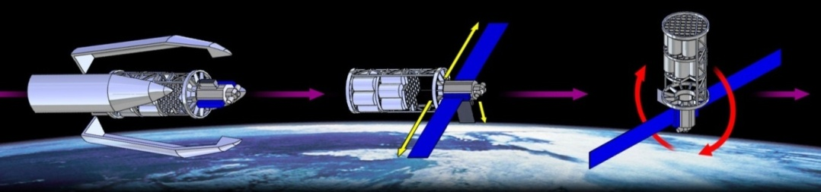
Figure 1: Spacecraft Assembly System (SCAS) launch and initialization
SCAS is rotated into this position so that the Spacecraft Being Assembled, which will be attached to OSAP using the bottom dock pointing towards the Earth, will not obstruct OSAP’s solar arrays.

After SCAS’s power system has been initialized, two Robotic Large Manipulators (LMs) shall deploy from the payload bay. Attach mechanisms securing the LMs to the CTS shall release. The LMs will then grapple onto PDGFs located on the outside of the CTS and maneuver themselves outside of the payload bay. They will then work in tandem to move the initial SBAP and dock it to the bottom (pointing towards the Earth) of OSAP. As the initial SBA piece is placed, the LMs will then climb onto the SBA using PDGFs on the SBA to assemble further pieces (see Figure 2).

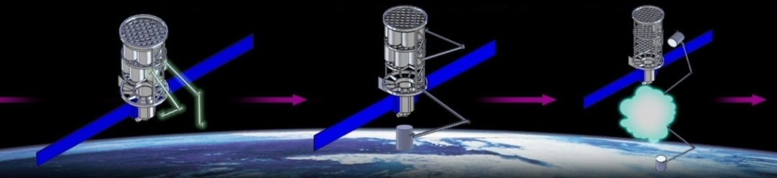
Figure 2: Robot Large Manipulators deploy and begin constructing the Spacecraft Being Assembled (SBA). The teal amorphous cloud represents the SBA.

As construction continues, eventually all the SBAPs in the initial CTS will run out and SCAS may need a SBAP resupply. These operations are shown in Figure 3. To resupply, the long dimension of SCAS is rotated parallel to the velocity vector. The OPM will provide OSAP with a reboost if needed. Then, the CTS (without the OPM) is jettisoned from SCAS and de-orbited.

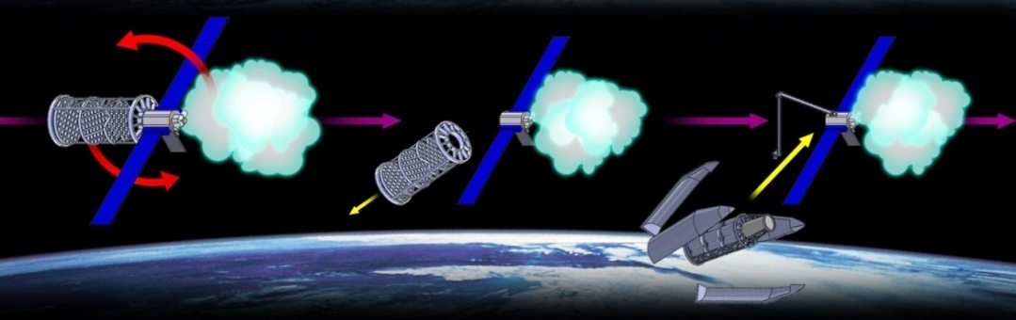
Figure 3: SCAS is rotated parallel to the velocity vector. The initial CTS is jettisoned and a new one is docked onto OSAP
New cargo will be brought up using another Ares V and CTS. The LMs will be used to mate the new CTS where the old one used to reside. After mating the new CTS, the SCAS system may choose to have the new CTS perform further reboost operations if desired. Then construction operations resume as before. SCAS is rotated perpendicular to the Earth again to maximize sunlight exposure. This is shown in Figure 4.

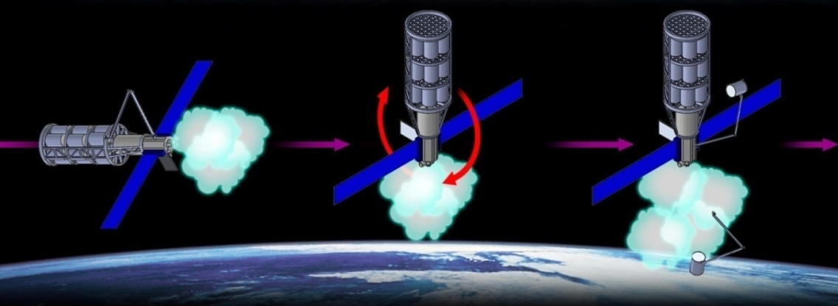
Figure 4: Assembly resumes after a CTS rendezvous and docking operation

Further assembly operations will vary depending on the SBA. Depending on the SBA’s final mass and shape, SCAS may reach a point where its control system can no longer rotate the entire body of mass. At this point, docking and adaptor modules shall be attached onto other points of the SBA. New power supplies may be attached onto the SBA to supplement OSAP’s assembly capabilities. New CTSs would find new locations to rendezvous to other than on OSAP; they may also have differently designed spacecraft buses depending on the construction operation such as propulsion capabilities. These further operations are beyond the scope of this project.

4.1 CTS Operations
Depending on the SBA, the CTS may or may not be jettisoned. Depending on its structural architecture, which has not been analyzed in detail, CTS subsystems and structural mechanisms may be cannibalized to be used on the SBA. The CTS also may remain in orbit to provide payload support for OSAP’s assembly systems. However, the sizing of the CTS and its subsystems will depend directly on its payload. As it is beyond the scope of our project to design the SBA, CTS sizing is difficult.

5 DESIGN

5.1 Design Approach
The first step taken in the design process was defining the need for the mission. The mission scope was defined and used to create a generic concept of operations and requirements. Limiting the scope of the mission allowed the team to reduce the complexity of the system. Several design concepts were designed and were subsequently evaluated against various evaluation criteria. Initial concept included an H-truss system with habitat for astronauts, an arms-carrying module, and an assembly attachment to the ISS. Trade studies were conducted to help produce different design candidates.

After evaluating the design, team EOS settled on a simple module carrying the robotic arms. The other designs presented too much complexity and were not beneficial for the goal of the mission.

5.2 Subsystem Approach
Team EOS followed the N2 diagram below when sizing the OSAP spacecraft.

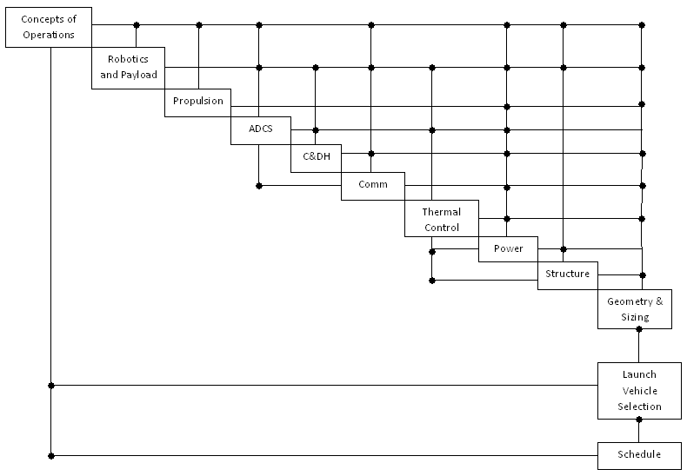
Figure 5: N-2 Diagram
The payload is the system defined as the main cargo a spacecraft carries. The payload for OSAP includes robotics and external cameras and was the first subsystem to be designed.

The ADCS and propulsion subsystems were designed simultaneously with robotics. The robotics only effect these systems by the torques imposed on OSAP during assembly operations, thus the three were developed together. The ADCS is responsible for controlling the attitude and orbit of the OSAP through moment devices and propulsion.

The C&DH and communication subsystem are designed to exchange data between Earth ground stations and OSAP, as well as OSAP and its subsystems. The C&DH and communication subsystems were designed after the robotics, propulsion, and ADCS.

Power and thermal were closely related and had to go through several iterations to finalize the requirements. The thermal subsystem regulates the temperature of the spacecraft for operational conditions.

Finally, the structure was designed with SolidWorks without in-depth structural performance analysis due to the lack of expertise and resources.

5.3 Final Design
The OSAP will be an unmanned spacecraft. Assembly of the SBA will be entirely tele-operated or automated. The robotic arms used will be similar to Canadarm2 equipped with Special Purpose Dexterous Manipulator. They will move from one spot to another by attaching their end to PDGFs. PDGFs provide both power and communications from the OSAP to the arms and will be located on the OSAP and CTS structures. As such, the SBA modules must also have PDGFs for the arms to grab them. Each Canadarm will also have Dextre end-effectors, capable of high finesse operations on the SBA. Cameras are located at each elbow joint and at the end of the Dextre. They allow operators on Earth to control the arms with visual feedback. Two External Camera Video Groups, or ETVCGs, will downlink video streams of the SBA as more modules are assembled. ETCVGs can be rotated and slew, providing a near 360 degree field of vision of the entire system. Furthermore, they can be moved by attaching them to PDGFs as well.

The ADCS will be responsible for controlling the moments of the OSAP due to the torque induced by the movements of the robotic arms, the movement of the modules, and other environmental torques. The ADCS system will also be used for the rotation of the OSAP during rendezvous with the CTS. The ADCS subsystem will use CMGs as well as cold nitrogen to rotate the spacecraft as necessary. Four CMGs, each capable of producing 4500 Nms of angular momentum, will be located inside the OSAP. 32 dry nitrogen thrusters will be clustered into groups of 4, with a total of 8 clusters located on the OSAP.

The Command and Data Handling system, or C&DH, will use a centralized architecture, which will control the arms and ETVCGs, as well as all the other subsystems. The C&DH will communicate with ground control operations through the TDRSS network via Ku-Band and S-Band signals. The Ku-Band and S-Band will downlink video observations of the SBA assembly as well as telemetry data. The S-Band will be used to uplink commands and data to the robotic arms and OSAP. The UHF band will be used to communicate with incoming CTS spacecraft for rendezvous maneuvers. The VIDS network will be used to transmit video signals to the OSAP C&DH.

The thermal system will consist of both active and passive systems. A thermal radiator will be used to expel excess heat during sun-side orbit while heaters will be used for dark-side periods. Power will be provided by both retractable solar panels and lithium ion batteries. There will be seven power operations modes.

Structure will include the OSAP body, which will house the thermal, power, ADCS, and C&DH subsystem. The OSAP main body will also have a docking system at both ends. One of the docking systems will be a multi-dock which attaches to the SBA while allowing other spacecraft to dock simultaneously (i.e. Orion). The secondary docking system will be used to attach CTS to OSAP during rendezvous operations.

6 ROBOTICS

6.1 Assumptions
6.1.1 Robotics technology beyond the year 2020 will be sufficient to perform all spacecraft assembly tasks and replace human EVA activity.
6.1.2 Robotic teleoperation from a docked manned spacecraft or from a ground station will be sufficient to perform all assembly operations.
6.1.3 The robotics used in OSAP shall meet or exceed the performance capabilities of the Mobile Servicing System used on the International Space Station in carrying capacity, dexterity, and artificial intelligence.
6.1.4 Mass, volume, dimension, and power specifications for OSAP’s robotics system can be estimated from legacy robotic systems on the International Space Station.

6.2 Robotics and Assembly Operation Philosophy
Our assembly system shall break the assembly process down into three components: Large spacecraft part and module manipulation, medium SBA part, supply, and orbital replacement unit manipulation, and small EVA-equivalent manipulation.
Both the Large and Medium manipulation has been done before on the International Space Station using the Mobile Servicing System’s Space Station Remote Manipulator System (SSRMS) and the Special Purpose Dexterous Manipulator (SPDM). We also intend to replace all human Extra-Vehicular Activity with an equivalent or superior robotics system. OSAP will be launched at the earliest in 2020. In comparison, the SSRMS and SPDM were constructed around the year 2000. By 2020, there will have been twenty years of advancement in space-robotics technology, and many engineers predict that the mechanical dexterity of assembly and maintenance robotics will approach or exceed that of a space suited human within ten years. It is not an unreasonable assumption that all EVA can be replaced by teleoperated or automated robotics by the year 2020.

By limiting human interaction with the assembly process, the OSAP shall be far safer than the Space Shuttle assembly missions for the International Space Station. OSAP shall expose only the robotics system to the hazards of the space environment – there shall no longer be any micrometeoroid risk for astronauts. In addition, the robotics system shall be able to work for far greater hours than a Space Shuttle Mission. In a shuttle mission, astronauts typically work seven hours per spacewalk and average four spacewalks per Shuttle mission. Shuttle missions last one week, and about four missions are performed per year. This totals to about five whole days of EVA every year of ISS construction and 28 whole days of Shuttle mission time per year. In contrast, OSAP shall be at the construction site 365 days per year and perform assembly work at anytime.

6.3 Baseline Robotics Payload Description
The two Large Manipulators will be used to berth, dock, and mate incoming SBAP’s launched from Earth. These manipulators can position themselves anywhere a Power Data Grappling Fixture is available. The Large Manipulators will require that every object they handle have a compatible grappling fixture for their end effectors to grab. The Large Manipulators will also have an attaching mechanism to store compatible assembly or repair parts. Some rough specifications are shown below.

6.4 2 Large Manipulators (LM)
6.4.1 Payload Manipulation Capacity in excess of 188,000 kg [TBD].
6.4.2 Unfixed, self-relocating arm that moves end to end like an inchworm.
6.4.3 7+ Degrees of Freedom (Two 3-DOF Wrist, one 1-DOF shoulder joint).
6.4.4 2 Latching End Effectors capable of grappling Power Data Grappling Fixtures (PDGFs) or unpowered grappling fixtures on opposite ends of arm.
6.4.5 The LM shall have two video cameras and two lights for each end of the arm.
6.4.6 The LM shall have payload storage attach system for medium sized payloads that the Medium Dexterous Manipulators (MDMs) can manipulate.
6.4.7 The LM is analogous to the Canadarm2 and will be modeled for our project using the size and dimensions of Canadarm2, which is shown in Figure 6. Other analogous characteristics for the LM taken from heritage and other projects are shown in Figure 7 and 8.

Figure 6: Picture of Canadarm2 Remote Manipulator System
Figure 7: Picture of Canadarm2’s Latching End Effectors

Figure 8: The inspiration for a small payload attach system to be used on the Large Manipulator, taken from an In-Space Assembly Concept for a Large Scalable Space Telescope

6.5 2 Medium Dexterous Manipulators (MDMs)
The MDM will be used to move and transport compatible medium sized objects and will be a replacement for EVA activity. The MDM will have dexterity comparable to a space suited human’s, and will be able to use a variety of tools that human astronauts traditionally use. A variety of mission specific tools will also be stored on the MDM that can be manipulated using the MDM’s Tool Changeout Mechanism. The MDM will be capable of interfacing with compatible payloads and provide power and communications. The MDM will also have a tool that emulates the grabbing and dexterous abilities of a human hand for precision assembly requirements. Some rough specifications are shown below.
6.5.1 Payload/Orbital Replacement Unit manipulation of objects from 0 to about 600 kg [TBD]
6.5.2 Greater dexterous, manipulative ability than large manipulator
6.5.3 EVA replacement system (describing the EVA capabilities of the year 2008)
6.5.4 Tool manipulation
6.5.5 Storage system for necessary tools
6.5.6 Attach or detach mechanisms, bolting and unbolting abilities
6.5.7 15+ Degrees of Freedom
6.5.8 The Medium Dexterous Manipulator shall be affixed to a Large Manipulator arm
6.5.9 Analogous to a SPDM affixed to a Canadarm2
6.5.10 The MDM will be modeled for our project using the size and dimensions of SPDM (see Figure 9)
Figure 9: Picture of the Special Purpose Dexterous Manipulator. Note its ability to attach ORU payloads onto itself and its tool changeout mechanism
Dual sets of both robotics systems shall be used for redundancy purposes as well as extending the assembly operations capabilities, which will be explained in operation concepts below. The dual systems can also replace each other’s parts using Orbital Replacement Units (ORUs) and thus meet the self-repair requirement of the OSAP system.

6.6 Robotics Operations
The Large manipulators (LM) shall be used to carry large SBAPs to the SBA and mate them. The LMs shall berth the initial SBA part and mate it onto one of OSAP’s docks. The dock will then provide power and data to the SBA. The LM’s shall continue this process of module rendezvous, berthing, and mating. The Medium Dexterous Manipulator (MDM) shall be used to perform the necessary small SBA assembly tasks. The LMs shall be used to transport the MDM as well as any ORUs, supplies, or SBAPs about OSAP and the SBA.

Many assembly projects will have different robotics requirements. Trusses without PDGFs may require a Mobile Base System to transport the LM, MDM, and FDM about its structure. Different end effectors may be switched out of the LM to provide the grappling capabilities needed to attach to truss structures or astronaut hand rails. Depending on each assembly project, different payloads to accommodate each project will be launched from the Component Transportation System.

6.7 Robotics System Transportation
To transport materials about the space construction site, many different concepts were investigated. Though a trade between propulsive and non-propulsive transportation was not fully explored, our group decided to only pursue non-propulsive transportation methods to simplify fuel calculation and sizing. By using inchworm-like robots that can move about any point with a Power Data Grapple Fixture, the door was opened for many different transportation concepts. We will briefly cover the use of PDGFs to extend the construction site onto the SBA, and using PDGFs to transport SBAPs about the construction site. A schematic of PDGFs used on the ISS is shown in Figure 10.

Figure 10: Picture of a Power Data Grapple Fixture used on the International Space Station

6.8 Large Manipulator Movement about the Construction Site
Because of the inchworm-movement ability of the LMs, any object with a PDGF can be moved onto. Thus, the arms can move onto the SBA to perform assembly tasks.This concept strictly requires that OSAP and SBA be covered with PDGFs. OSAP shall transmit and receive power, data, and communications to the SBA using the dock or by manually hooking up data cables using the manipulators. The LMs can then climb onto the SBA using their walking capability and traverse around SBA using the SBA’s PDGFs. The LMs then strategically position themselves to berth more SBAPs onto the SBA. The addition of PDGF coverage of all assembly and maintenance critical parts of the SBA greatly extends the available work area of the OSAP robotics system.

The advantages of this concept is that the entire OSAP spacecraft will not need to move to various locations to perform assembly – instead, the robots will move themselves. This reduces the power or delta-V needed to move from one construction area to another. However, this concept also requires sufficient PDGF coverage about the SBA. This shall increase mass, structure, and design requirements to the SBA. The movement ability of the LMs is illustrated in Figure 11.

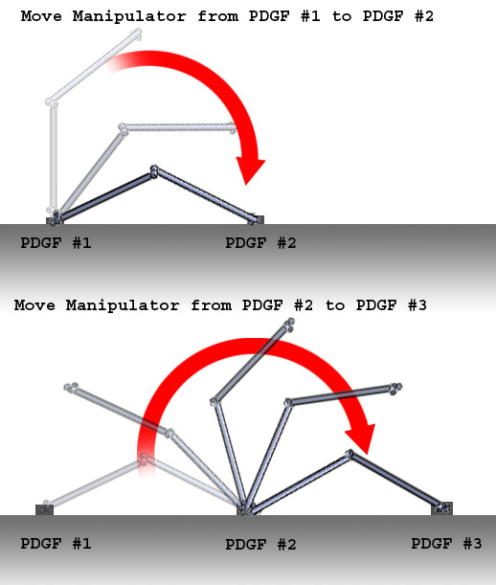
Figure 11: Large Manipulator inchworm movement across Power Data Grapple Fixtures

6.9 Conversion of SBAP’s into walking transportation devices
For SBA parts (SBAPs) covered with PDGFs, two LMs can convert the SBAP into a medium for bipedal transportation. Two LMs grab two PDGFs located on the SBAP and then provide the SBAP with power. This action would then effectively transform both the SBAP and the two LMs into a large LM doubled in length and degrees of freedom, while also acting as a walking transportation system for the SBAP. With this method, the SBAP can then be transported from its initial location to another without needing delta V maneuvering by OSAP or using a rail transportation system as used on the ISS. This operation will be called LM Duel Wield. This movement operation is illustrated in Figure 12

Obviously, any SBAP requiring this transportation mode shall require two PDGFs and the infrastructure capable of transmitting power and communications through the SBAP to the other arm. Also, 2 LMs are needed to perform this operation.

LM Duel Wield Mode can also be achieved by using a male-male Duel Wield Adapter (DWA). The DWA, an object with two PDGFs that carries power, data, and communications either way, is grappled by two LMs to double their reach..
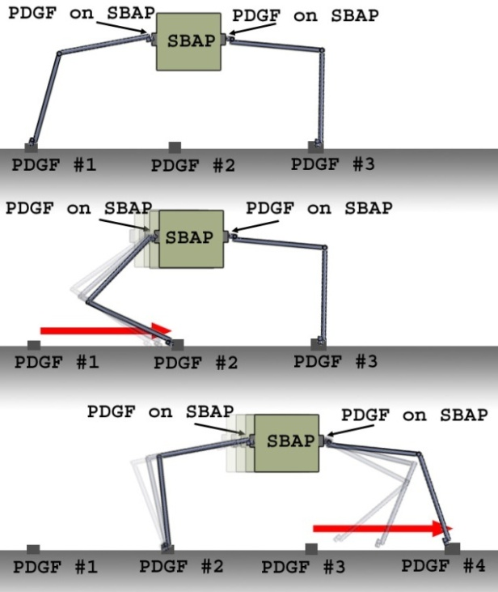
Figure 12: SBAP transportation concept about the assembly site using two Large Manipulators

6.10 OSAP traversal
For large SBA’s, the OSAP may need to relocate depending on the assembly mission requirements. OSAP large manipulators will remain fixed to OSAP and grasp SBA grapple fixtures in a synchronized walking motion. At the same time, OSAP control moment gyros will stabilize both OSAP and the SBA to prevent large moments. This concept will require a maximum grappling fixture spacing length to ensure that the Large Manipulators can reach from one fixture to another fixture on the SBA. The Control Moment Gyros will also have to be able to sustain the torques created by OSAP by the walking motion.

6.11 Robotics Stowage
The robotics payload shall be stowed in the initial CTS payload structure. Large manipulators shall be fixed on Power Data Grappling Fixtures at launch as well as any other needed support structure to help the payload survive launch. After OSAP has achieved the desired orbit, the supporting attachment mechanisms release, and the Large Manipulators shall inchworm-walk themselves out of the storage cavity and affix itself to the outside of OSAP, where they can begin assembly operations.

Depending on the construction mission, other supplies may be shipped with the initial OSAP launch, including mission specific robotics systems. These may include
- Different end effectors for different assembly tasks
  - Specialized end effectors for truss navigation
  - End effecter adaptors for different grappling fixture systems
- Mobile Base Systems used for truss navigation and supply transportation
- Various end effecter-compatible tools for specialized construction operations
- Supply of Orbital Replacement Units (ORUs) for robotics system and OSAP

6.12 OSAP and SBA Inspection and Maintenance
While it is beyond the scope of this project to completely describe maintenance and inspection operations, it is well known that previous robotic assembly arms used on the ISS and the Space Shuttle are used for spacecraft inspection. In addition, the Mobile Servicing System of the ISS was designed for the specific purpose of replacing spacecraft parts using Orbital Replacement Units.

6.13 Performance and Mass
From Canadarm1, Canadarm2 and SPDM data, we can estimate the performance of our robotics system.
Table 1: Various Manipulator Performance Specifications
 |  | Canadarm1 | Canadarm2 | DEXTR | Base System
 | Weight (kg) | 410.5 | 1800 | 1662 | 1450
Dimensions | Volume (m³) | 1.28 | 1.69 | 2.13 | 74.39
 | Length (m) | 15 | 17.6 | 3.5 | 5.7
 | Width (m) |  |  |  | 4.5
 | Height (m) |  |  |  | 2.9
 | Max Diameter (m) | 0.33 | 0.35 | 0.88 | NA
Max Payload | Mass (kg) |  | 116000 | 600
Power | Peak Power (W) |  | 2000 | 2000 | 835
 | Keep Alive (W) |  | 435 | 600 | 365
 | Tip Load Max (N) |  | 1000 | 111 | NA
 | Stopping Distance (m) ( max load) |  | 0.6 | 0.15 | NA
Speed | Unloaded (m/s) | 0.6 | 0.37
 | Loaded (m/s) | 0.06
 | Station Assembly (m/s) |  | 0.02
 | EVA support (m/s) |  | 0.15
 | Orbiter (m/s) |  | 0.012
Joint Rotation | Rotation (degrees) | 160 | 540
Degrees of Freedom |  |  | 7 | 15

The momentum generated by LM traversal was calculated using rough calculations about the principal moments of inertia of the OSAP and CTS system. The shape of the spacecraft was assumed to be a cylinder of 25 meter height and 8 meter diameter with a total mass of 150,000 kg. Using these parameters, the angular momentum generated by a Manipulator traversing at an estimated 0.118 m/s was calculated.

Table 2 shows some rough calculations for the attitude change for a given distance travelled by a single LM. Seeing that the total height of the SCAS system is about 24 meters, a walk from top to bottom of SCAS will result in a total attitude change of 3 degrees. A walk around SCAS will result in an angle change of 11 degrees.
Table 2: Angle change estimates resulting from a traversing LM assuming a 4.4 m moment arm
 | Angle change (degrees)
Distance travelled by arm (m) | About smallest moment of inertia | About largest moment of inertia
10 | 7 | 1
14 | 10 | 1
20 | 15 | 2
24 | 17 | 2
30 | 22 | 3
40 | 29 | 4
50 | 36 | 5

Table 3 shows the estimated changes in Angular Momentum as the moment arm away from the center of mass increases. One can see that at about 50 meters, the OSAP’s CMG maximum angular momentum output of 19,000 N-m-s is surpassed. Thus, SBAs that require traversal 50 meters away and perpendicular from the center of mass may need additional control systems.

Table 3: Resulting angular momentum from a walking LM by varying the moment arm.
 |  | Station Perturbation (degrees/hour)
Moment Arm (m) | Resulting Angular Momentum (N-m-s) | about smallest moment of inertia | about largest moment of inertia
4.4 | 1797 | 309 | 44
4.6 | 1879 | 323 | 46
10 | 4085 | 702 | 100
20 | 8170 | 1404 | 200
25 | 10213 | 1755 | 250
50 | 20426 | 3511 | 501
100 | 40852 | 7022 | 1002

These calculations must be taken with a grain of salt – the analysis was overly simple and many things were factored out to only assume the worst case scenario.
The analysis also shows that the LMs can actually perform some attitude adjustments by walking about the construction site for a worst case scenario control scheme.

6.14 Trade Study
For the robotic payload trade study, several different robotic payload configurations were analyzed. The 2 LM and 2 MDM configuration was chosen for redundancy – one robot should be able to fix the other if problems arise. The other configurations added far too much mass and needed too much power and would only serve to increase the rate of assembly. The simplest 1 LM, 1 MDM configuration was deemed insufficient for our project’s needs – it could not perform dual-arm operations that were highlighted previously in the report. Our group also decided that inchworm arm movement was sufficient for our robotics transportation capabilities and that a moving base to transport the robots would not be needed. A plot and table comparing the different configurations is shown in Figure 13 and Table 4.

Figure 13: Comparison of different robotics configurations
Table 4: Mass, power, and volume numbers for different robotics configurations
Configuration | Mass (kg) | Max Power (W) | Avg power (W) | Approx. Volume (m³)
1 LM, 1 MDM | 4501 | 5200 | 1346 | 5.0
2 LM, 2 MDM | 9001 | 10400 | 2691 | 9.9
2 LM, 2 MDM, 1 Moving Base | 10886 | 11486 | 3166 | 106.6
2 LM, 4 MDM | 13322 | 15600 | 4251 | 15.5
4 LM, 4 MDM, 1 Moving Base | 19887 | 21886 | 5857 | 116.6

7 ATTITUDE DETERMINATION AND CONTROL SYSTEM (ADCS)

7.1 Assumptions
ADCS for OSAP operations contains three sections: orbit selection, attitude sensors, and attitude controllers. The following are key assumptions for each section:

7.2 Orbit Design
7.2.1 Atmospheric Drag is primary orbit perturbation force.
7.2.1.1 Exponential atmosphere model (see Appendices)
7.2.2 J2 is secondary orbit perturbation force.
7.2.3 Solar radiation pressure and third body effects were not considered.
7.2.4 CTS launches will occur every 10 weeks.
7.2.5 Potential orbit selections are not limited by existing spacecraft.

7.3 Sensor Selection
7.3.1 GPS system will be available during mission duration with selective availability disabled.
7.3.2 TRL meets accuracy requirements.

7.4 Controller Selection
7.4.1 Large manipulators create primary disturbance torques during assembly operations.
7.4.2 Upon SBA reaching uncontrollable size, it must implement an independent attitude control scheme.

7.5 Orbit Design
OSAP will reside in LEO. Regardless of the structural design specifications, the system will be in a specifically chosen orbit. The SCAS will also require multiple rendezvous missions that inherently require several launches from Earth. Thus, the driving parameter in orbit design is to maximize the allowable launch payload mass to orbit. This places the OSAP in a prograde orbit (utilizing the rotation of the earth during ascent) and eliminates the possibility of performing a plane change. As this is a United States mission, this leaves only Cape Canaveral at the Kennedy Space Center as the launch facility. Figure 14 below shows the design iteration used for the final orbit selection.

Figure 14: Orbit Selection Iteration

7.6 Inclination
The launch site significantly restricts easily available launch inclinations. Assuming the absence of an orbital plan change during ascent, the minimum latitude achievable by a launch vehicle is the latitude of the launch site:
$\cos\left(i\right)=\cos\left(φ\right)sin⁡(β)$
Launching due East will results in an inclination equal to the launch latitude. This is desired for the SCAS mission as any angle away from a due East launch requires more thrust, and therefore, less available payload. Cape Canaveral is at latitude of 28.47°, therefore, the OSAP inclination will be approximately 28.5°.

7.7 Altitude
As discussed, maximizing payload capacity per launch drives the orbit selection. Lower altitude ascents require less thrust, and therefore, larger payload capacities. So, it is desired to be at the minimum available orbital altitude. Orbit perturbation, specifically altitude decay, specifies the least feasible altitude. Because the OSAP is in LEO, atmospheric drag dominates orbit perturbation.

Although the atmosphere is thin at LEO altitudes, it still has significant effects on the orbits of spacecraft. An exponential atmospheric model was used in conjunction with the Blitzer equations to perform LEO drag analysis (Appendices 21.1). The initial launch mission as specified in the concept of operations will include OSAP and several SBAP’s. This initial mission is estimated to be 140,000 kg and have a rough surface area of 550 m² to perform drag analysis in the 28.5° inclination described above. The remaining parameters are described in Table 5 below.

Table 5: Drag Model Parameters
Semi-Major Axis (km) | 330-350
Eccentricity | 0
Inclination (degrees) | 28.5
RAAN (degrees) | 93.18434
Argument of Periapsis (degrees) | 62.43275
Mass (kg) | 140000
Exposed Area (m²) | 550
Drag Coefficient | 2

From ADCS Requirement 3.4.7.2, the OSAP cannot be at an altitude below 300 km. 7.2 below shows the amount of days until the altitude has decayed to 300 km for various initial altitudes. Furthermore, from Requirement 3.4.7.3, the OSAP must maintain altitude above the re-boost limit specified in Requirement 3.4.7.2 for a minimum of two months.

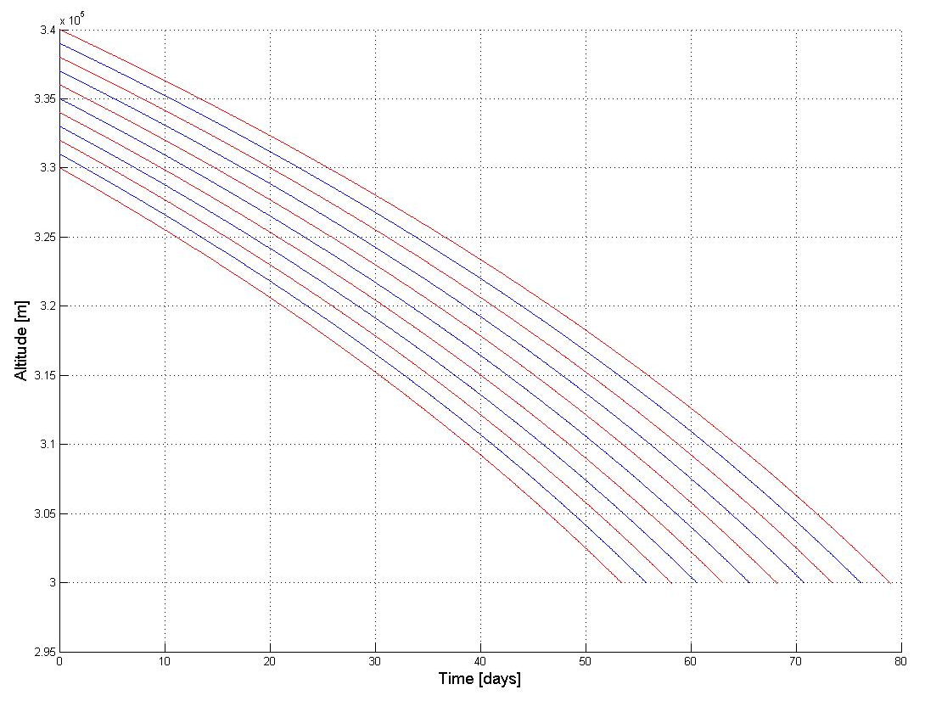
Figure 15: Atmospheric Drag Orbit Decay for Increasing Initial Altitudes (Initial SCAS Launch)

Therefore, adding a fifteen day margin to a two month re-boost window (to account for model error and ballistic differences between OSAP, SBA, and ISS), an initial altitude of 340 km is chosen, resulting in the SCAS requiring a re-boost in approximately 75 days. As rendezvous missions continue, the mass and surface area of the SBA increase. This was analyzed for 10 total missions adding 100,000 kg of mass and 250 m² of surface area per rendezvous as an estimate. The previous technique was repeated for each mission resulting in the following required re-boost altitudes to maintain a 75 day re-boost interval:

Figure 16: Re-boost Target Altitude as SBA Grows
The SBA grows in surface area and mass, the additional mass (and therefore momentum) reduces the effect of atmospheric drag. Therefore, as seen in Figure 16, as the SBA grows, the target re-boost altitude is reduced.

7.8 Resulting Sunlight Exposure
Power production and storage will be vital to other subsystems of the OSAP. Therefore, it is of importance to model the sunlight exposure for our selected orbital parameters. More specifically, it is important to know maximum durations of dark side intervals that the OSAP will need to depend solely on battery power.

Sunlight exposure depends not only on the spacecraft orientation with respect to the Earth, but on Earth’s orientation relative to the Sun. Figure 17 below shows sunlight durations during a 24 hour period at different points during the year.

Figure 17: Sunlight Exposure Interval Length
This shows that on average for the year the OSAP will spend 14.55 hours of a 24 hour period in sunlight. Furthermore, the individual sunlight intervals are on average 0.918 hours long. Similarly, we want to analyze the same data for time spent in Umbra (complete darkness):

Figure 18: Umbra Interval Length
This shows that on average for the year the OSAP will spend 9.72 hours of a 24 hour period in Umbra. Furthermore, the individual Umbra intervals are on average 0.591 hours long.

7.9 State Determination Trade Summary
OSAP has six degrees of freedom of motion: 3 translational axes and 3 rotational axes. We wish to determine and control all six. Figure 19 below summarizes the trade study performed.

Figure 19: ADCS Trade Tree

7.10 Position and Velocity Determination
While in orbit the OSAP position and velocity must be determined. Because the OSAP is in LEO, we can take advantage of GPS. GPS carrier signals are broadcast at 1575.42 MHz and 1227.60 MHz, and therefore can be captured using the UHF antenna that also communicates with TDRSS. The GPS measurements allow the flight computer to determine both position and velocity. Because the OSAP is in LEO, significant GPS errors that are incurred on the Earth’s surface (Ionosphere effects, multipath) are reduced.

Simultaneously, the onboard flight computer uses propagation algorithms to precisely propagate the orbit from an initial GPS based state vector. For high precision orbit propagation, the algorithm must consider J2, atmospheric drag, gravity gradients, solar radiation pressure, and third body effects. The propagator is updated with a GPS state vector once every orbit. Identical orbit propagation algorithms are run at mission control in order to have redundant calculations.

7.11 Rotational Attitude Determination
As specified in Requirement 3.4.5 we must be able to determine the OSAP’s attitude within 1 degree in all axes. The following systems were considered.

7.11.1 Inertial Measurement Unit (IMU)
IMU’s provide attitude change measurements using accelerometers to measure linear motion and gyroscopes to measure angular motion. The measurements are provided at high data rates, but have a tendency to drift over time. For accurate measurements using an IMU the cost drastically increases. The Honeywell Miniature Inertial Measurement Unit (MIMU) was analyzed specifically for its relatively low cost, proven mission success, and mass. The MIMU weighs only 4.7 kg and has a drift less than 0.005 °/hr.

7.11.2 Star Tracker
In order to combat the drift of an IMU, attitude sensor systems must have a reference attitude to null IMU drift bias. Star trackers identify stars in view and compare a subset of the stars to a catalogue in order to determine the spacecraft’s attitude.

7.11.3 Sun Sensor
Sun sensors come in many different designs. All in all, they detect the location of the sun relative to the spacecraft. The Sun’s distance and brightness make it an easily acquirable point reference for the optical sensor. Knowing where the sun is also provides pointing information to the solar panel arrays. Sun sensors, however, don’t work while the spacecraft is in shadow and can output false measurements from sunlight diffused by the Earth. The effects of both of these are worsened in LEO.

7.11.4 Horizon Scanner
Earth sensors allow the spacecraft to determine its attitude relative to the Earth. Because the spacecraft is in LEO, and therefore nearly half of its view is the Earth, the Earth cannot be considered a point reference. Therefore, a horizon scanner is used to measure the location of the horizon. This is accomplished by finding the threshold between the cold temperatures of space and the warm temperatures of the Earth. Complications arise in determining the exact transition point due to the atmosphere and the Sun. Generally, to improve reliability and accuracy of the measurements, two horizon sensors are used simultaneously.

7.12 Sensor Decision
Attitude determination systems require a combination of sensors in order to accurately determine the spacecraft orientation. The Appendix shows the AHP matrix used to determine what sensor characteristics drove the decision. This shows that the most important parameter is the accuracy of the system, followed by the mass and then reliability. This is compared to advantages and disadvantage of each system described above as well as the values below:
Table 6: Sensor Performance
 | MASS (kg) | POWER (W) | Accuracy
IMU | 4.7 | 32 | 0.005 (but drift)
Sun sensor | 1.5 | 2.5 | 0.0138
Star Tracker | 5.00 | 20 | 0.0166
Horizon Scanner | 4 | 10 | 0.1
Magnetometer | 1.2 | 1 | 0.5

The Honeywell Miniature Inertial Measurement Unit (MIMU) was selected as the primary attitude sensor which will also provide additional information for position and velocity. Dual sun sensors (placed to face sun during 2 operational orientations) are used to update the system to account for measurement drift as well as provide pointing information for the solar panels. Although the Sun sensor is highly accurate and light, it does not determine rotations along the Spacecraft-Sun vector very well and does not work during ecliptic operations. Therefore, dual horizon sensors will be used placed to face the Earth for both operational orientations. The pairing of the horizon and Sun sensors aid in reducing the problems with both sensors discussed above. Finally, to account for internal MIMU measurement biases and potential failures, a redundant MIMU system will be on board running simultaneously.

7.13 Rotational Attitude Control
There are several approaches to performing attitude control. This mission does not allow spin-stabilization as the OSAP/SBA structure should not rotate during the assembly process. Furthermore, we cannot rely on gravity gradient stabilization as the structure is likely to have bizarre shapes that would prevent the primary rotation axes from aligning with the gravity force vector. Therefore, the OSAP must use 3-axis stabilization. There are several devices that can be used to accomplish this described below.

7.13.1 Thrusters: Thrusters are used to impose external torques on the spacecraft. Thruster firings are nearly impulsive ‘burns’ that can create large torques very quickly. Thrusters, however, use some sort of consumable and have potential of hitting the OSAP or SBA with propulsive debris. Refer to Thrusters section for more details.
7.13.2 Momentum Exchange Devices (MEDs): MEDs take external moments imposed on the spacecraft and transfer it to a spinning object with its own angular momentum. A reaction wheel starts stationary, and as moments are imposed on the system, they begin to spin to counter the changed angular momentum. Reaction wheels are needed on all 3 axes. Similarly, momentum wheels change their rotational velocity to counteract external torques, but the momentum wheel is initialing spinning at some nominal rotation rate. This initial rotation increases the nominal angular momentum of the spacecraft. Control moment gyroscopes (CMG’s) are gimbaled momentum wheels. The CMG’s can create much larger torques than the reaction wheel or momentum wheel, but are much larger and complicated. The Honeywell HR16, the Honeywell M50 CMG, and the Honeywell AMCAS were analyzed specifically for controller candidates.

7.14 Controller Selection
There are several modes in which the active 3-axis control system will have to perform:
7.14.1 Module Rendezvous: The OSAP will be oriented to a rendezvous capable attitude prior to CTS arrival. Because both the OSAP and CTS will be GPS enabled, the position measurements will be very accurate. Having this system makes rendezvous maneuvers relatively simple.

7.14.2 Pointing: During sun-side operations the OSAP will need to be oriented such that the solar panels can collect the required sunlight. Furthermore, the OSAP will need to be oriented to communicate with the TDRSS and GPS satellites.

7.14.3 Assembly operations: During assembly, the motion of the robotic arms will impose external torques on the system, the effect of these torques are reduced as the mass of the SBA grows. This torque is somewhat tolerable, but cannot destroy the efforts of pointing attitude control. Therefore the rotational attitude control system must counter the torques created by assembly operations.

The potentially large torques imposed by assembly operations makes CMG’s the only viable primary attitude control device. The Honeywell M50 CMG and the L-3 communications DGCMG 4800/250 were analyzed specifically. The M50 is a much smaller single gimbal CMG compared to the DGCMG 4800 which is much larger and dual-gimbaled. The following parameters were compared for the two CMG’s:

Table 7: CMG Properties
 | Honeywell M50 | L-3 DGCMG 4800/250
Lifetime | 10 years | 10 years
Max Angular Momentum | 75 N-m-s | 4760 N-m-s
Max Torque | 75 Nm | 258 Nm
Input Power | 11W | 170 W
Weight | 28 kg | 272 kg
Volume | 0.00646 m³ | 2.2265 m³

The robotic arms can produce approximately 1800 N-m-s of torque. The M50 clearly cannot correct for such large disturbances. Instead, four L-3 DGCMG 4800/250’s will be placed in the OSAP to produce a combined angular momentum storage capacity of 19,000 N-m-s. Because the DGCMG 4800/250 is dual-gimbaled, each of the four CMG’s can produce angular momentum vectors in all directions. However, the CMG’s are placed in a pyramid-cross orientation to maximize redundancies in case of failure.
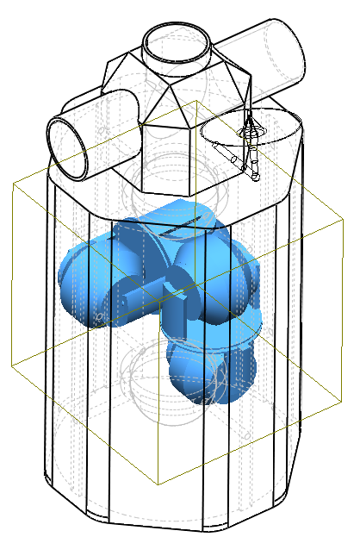
Figure 20: CMG’s in OSAP

As seen in Figure 20, the four CMG’s can reorient to create an effective angular momentum vector. Furthermore, because the CMG’s are momentum biased, they can nullify the initial total CMG created angular momentum vector. Unfortunately, the CMG’s can reach a saturation rotation speed, where they can no longer increase rotation speed to accept more angular momentum. In order to handle this, external thrusters are used to de-saturate the CMG’s. Thus, external thrusters must also be used as a control device. The thrusters can be used in place of the CMG’s, or to simply desaturate them. The selection of controller depends on the situation. For general assembly operations, the CMG’s are used to counter impose torques. For large or quick reorientation maneuvers, and any other quick maneuver needed, the external thrusters are employed. The attitude control and maneuvering thruster system (ACMTS) is discussed in detail in Propulsion Section.

7.15 Translational Attitude Control
As seen in Figure 16 altitude re-boosts are required every 75 days for the selected initial orbit altitude. There are several options for re-boost operations:
7.15.1 OSAP propulsion system provides necessary burn to raise orbit altitude.
7.15.2 CTS vehicle engine or OPM provides necessary burn to raise orbit altitude.
7.15.3 Independent resupply vehicle engine provides necessary burn to raise altitude.
7.15.4 Removable engine compatible with OSAP docking mechanisms is placed at appropriate location and provides necessary burn to raise orbit altitude.
The Translational Attitude Control selection is discussed in the Propulsion section.

7.16 ADCS Strengths and Weaknesses
The primary strength of the orbit selection allows the SCAS to boost to higher altitudes in order to increase the re-boost interval. This also allows various initial altitudes for various mission profiles. The inclination selection and altitude approach allow for maximum SBAP launch payloads. This effectively reduces the number of launches needed to complete the SBA.
However, the ADCS system still has several weaknesses:
- 10 Week launch interval may be inappropriate for actual SBA mission.
- Sun sensors are inactive during ecliptic operations.
- Rendezvous operations may require more control even with OSAP being the inactive vehicle.
- Dual CMG failure requires CMG shutdown due to momentum bias.

8 PROPULSION

8.1 Introduction
The propulsion subsystem design process was divided into two processes, one for the attitude control and maneuvering thruster system and one for the orbital maintenance system. This choice was made because of the different objectives of each system. The objective for designing the thruster system is to provide a secondary attitude control system (with the primary system being the control moment gyros) as well as a system which would give OSAP maneuvering capability. The objective for the design of the orbital maintenance system is purely to provide a means of orbit reboost. These two objectives are so grossly different that two separate design processes were taken in order to prevent inefficiency in designing one system to perform all the objectives above.

8.2 Propulsion Subsystem Assumptions
In choosing the propulsion system for both attitude control and orbit maintenance, it was assumed that operations would be carried out at any point in orbit, even on the dark side of Earth. It was also assumed that the frequency of SBA payload launch would be an average of ten weeks (approximately 70 days). Another assumption made was that the attitude control thrusters would also serve as the primary means for the OSAP maneuver around the SBA as needed.

8.3 Attitude Control and Maneuvering Thruster System (ACMTS)
When designing the ACMTS, four primary factors were used to limit the design considerations. These factors include:
8.3.1 The storage and use of reactive chemicals: In order to reduce the overall risk of mission failure, reactive chemicals would not have long-term storage on the OSAP in order to reduce the risk of explosion and subsequent damage.
8.3.2 Power consumption: Every system requires power. However, some require a significant amount. The more power consumed by the propulsion subsystem, the more power must be produced by the power subsystem. This in turn implies that more mass and volume must be added to the OSAP in order to maintain an operational status.
8.3.3 Mass and volume. Under the current design concept, the mass of the OSAP will be approximately an order of magnitude less than the mass of the SBA. The volume of the OSAP will be very similar in scale. These restraints require that the propulsion subsystem not call for massive amounts of space or mass. Also, in order to provide freedom of movement about six degrees of freedom (three translational and three rotational), the optimum number and positioning of individual thrusters is “clusters” of four thrusters placed one on each “corner” of the OSAP (see Figure 21). This adds up to 32 thrusters for optimum control, all of which must be small in order keep the mass and volume low.
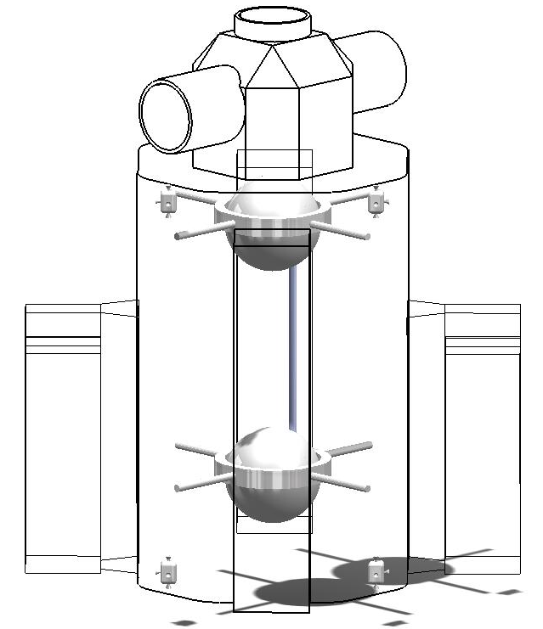
Figure 21: Configuration and Placement of attitude control thrusters and propellant tanks
8.3.4 Exhaust conditions. Exhaust conditions such as velocity, pressure, and temperature must be considered to reduce the damage done by the exhaust on surrounding structures and systems. Because of the close proximity of the thrusters to other components, such as the solar panels, radiator, and docked spacecraft, this factor severely reduces the types of systems that can be used.

Factors 1, 3 and 4 above significantly limit the use of the chemical rocket options as most of them require the use of a combustible fuel, require large amounts of propellant storage space, and expel very fast, hot, and highly pressurized gas. The only two chemical systems which were not eliminated by these factors are the cold gas thrusters and a few solid propellant systems (whose propellant, unless ignited, remains inert). Although there are solid propellant systems whose propellant is inert unless ignited, there is no solid propellant system which can be controlled once ignited, it will continue to burn until all the fuel is burnt. Also, the exhaust from a solid rocket motor will be a limiting factor in the placement of the rockets on the OSAP body. Another disadvantage is that every time a solid propellant motor is expended, it must be replaced. Because of this constant replacement condition and the restriction of no control, all solid rocket motor systems were eliminated from consideration for the ACMTS.

Factors 2 and 3 above completely eliminate all the electric propulsion systems considered. The amount of power required by each thruster for every electric propulsion system considered is on the order of 1-100 kW and the mass of the each thruster (and the associated hardware) in the electric propulsion systems is considerably higher than in chemical propulsion systems of similar size.

Because of the factors listed above, cold gas thrusters were selected for the ACMTS. Additional factors include the highly simplistic design of cold gas thruster systems (only include a pressurized tank, a valve, a nozzle, and all the plumbing necessary to connect all those) and the high TRL and reliability of these systems. Cold gas thrusters have been used almost since the beginning of human space exploration. Simplicity is a key factor because the greater the complexity of repairs for the system, the greater the need for a permanent crew to perform those repairs. The total mass of the thruster system (including valves, hoses, and thrusters) for all 32 thrusters is baselined at 2.8 kg.

8.4 ACMTS Propellant and Propellant Feed System
Every chemical propulsion system must have a propellant source, even cold gas thrusters which do not ignite the fuel. Gaseous nitrogen and gaseous helium were considered because of their relatively low molecular masses (and therefore low storage mass) and they have a TRL of 9. While helium offers a higher specific impulse which allows for a significant reduction in propellant mass, the storage volume or pressure is much greater than that of the nitrogen and the cost is significant higher as well. Because of the significantly greater storage volume and cost, helium was eliminated from the two, leaving gaseous nitrogen as the propellant for the ACMTS thrusters.

In order to keep the nitrogen in a gaseous form, the propellant tank must be insulated to maintain a temperature greater than 80K. However, to reduce the requirements on the thermal subsystem, the propellant will be kept at 273K. Based on the minimum propellant temperature, the propellant tanks are baselined to operate at a pressure of 136 atm or lower. However, the decision to keep the propellant at 273K increases the tank pressure to 464 atm (assuming constant mass and volume). Using nitrogen as the propellant, each thruster had the capability to provide between 4.5 and 111.2 N of thrust with a specific impulse of 68 sec. From the estimates and calculations in the Appendix, the total mass of needed propellant is 1100 kg. With a 20% margin, the total propellant needed is 1320 kg. This requires the total approximate volume of the propellant tanks to be 2.27 m³. Spherical propellant tanks were chosen because the necessary volume of the propellant tanks would not necessitate the use of more complicated cylindrical tanks.

The cold gas thruster system provides the one of the simplest designs available, with only the propellant tank, valve, thruster, and the plumbing between the three as the hardware necessary for the system. Two configurations of the propellant feed system were considered. The first was based on a single, central propellant tank feeding all 32 thrusters. The second was based on dual propellant tanks, one on each end of the OSAP, each feeding the 16 thrusters on the end it is closest to. The dual propellant tank (DPT) design was chosen for safety and redundancy purposes.

The DPT design would include auxiliary valves from each tank to the thrusters at the opposite end of that tank. In the event one tank is punctured, the second tank will then have the ability to maintain the attitude control and maneuvering capabilities of the OSAP until the punctured tank can be repaired or replaced. In addition, one-way valves between the two tanks will be included to allow for simple refueling. Using this design, each tank’s radius would not need to exceed 0.65 m. The DPT design is depicted in Figure 22.
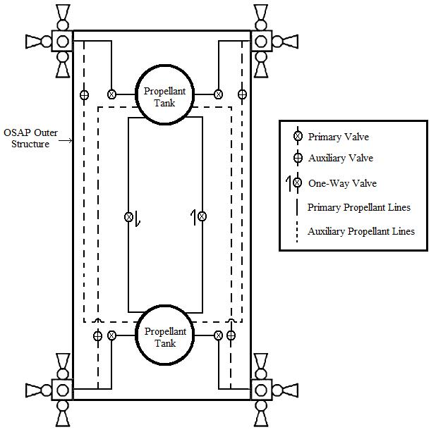
Figure 22: Schematic Diagram of the ACMTS
The propellant tank material selected is titanium because of its high strength to weight ratio. Using titanium as the material of choice, the total mass of the propellant tanks is 2178 kg.
Table 8: ACMTS Properties
 | Thrusters  & Accessories | DPT Design | Propellant  (Gaseous Nitrogen) | Total
Mass (component) [kg] | 0.0875 | 1089
Mass (total) [kg] | 2.8 | 2178 | 1320 | 3500.8
Volume (component) [m³] | 0.008575 | 1.135
Volume (total) [m³] | 0.0686 | 2.27 |  | 2.3386
Power (component) [W] | 62
Power (total) [W] | 1984 |  |  | 1984
Max Thrust (component) [N] | 111.2
Max Thrust (total) [N] | 3558.4 |  |  | 3558.4
I_{sp} [sec] | 68
Pressure [atm] |  |  | 464
Temperature [K] |  |  | 273

8.5 Orbit Maintenance System (OMS)
When designing the OMS, the limiting factors for the ACMTS were found to apply as limiting factors for the OMS as well. Because of all these factors and the necessity for high thrust to perform the ΔV maneuver needed to boost the altitude of the OSAP and the SBA, the decision was made to use a separate reboost module, sent with each payload module. Hence, reboost will not be the responsibility of the OSAP thruster system.

The OMS will consist of an expendable propulsion module which will be launched with every SBA payload launch (frequency of approximately 10 weeks or 70 days). This frequency is consistent with the estimated reboost need stated earlier. The OPM will be designed similar to the ISS Propulsion Module (IPM). The IPM (see Figure 23) began design with the mission of providing an US-funded alternative propulsion system to the ISS in the event the Russian systems were not developed and ready to provide the propulsion capabilities when needed.
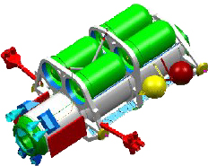
Figure 23: IPM, proposed baseline for OPM
With the baseline for the SBA being the ISS, the capabilities of the proposed IPM are the same for the OPM. The primary difference is that the IPM was designed to be a sustainable system (e.g. it could be refueled to continue to provide orbit maintenance tasks without replacing the module itself), whereas the propulsion module for the OSAP will be sized to carry only the necessary fuel for one reboost and will be ejected to burn up upon reentry into the Earth’s atmosphere. The IPM was designed to carry 9800 kg of hydrazine fuel and oxidizer (the ISS requires an average of 7000 kg of fuel each year for reboost). Using the average amount of fuel needed to reboost the ISS each year, the OSAP and SBA system will require approximately 1400 kg of hydrazine fuel and oxidizer for each reboost.

The OPM will attach itself to the end of the CTS (the end of OSAP opposite the SBA will be used when no CTS is present) to provide reboost capability as well as primary attitude control during the reboost burn. If this positioning of the OPM is not feasible because of awkward mass or volume distributions, the OPM will have the capability to maneuver and attach itself to a different attachment node on the OSAP or the SBA itself to provide the minimum moment about the OSAP and SBA system’s center of mass point to reduce the amount of attitude control necessary during the reboost burn by either the OPM or the ACMTS.

Using the above design assumptions and decisions, the OPM is scaled down from the IPM to have an approximate total mass of 2000 kg. This estimate includes the mass of propellant, oxidizer, propellant and oxidizer tanks, OPM structure, and engines.

9 COMMAND AND DATA HANDLING (C&DH)
The C&DH subsystem encompasses critical spacecraft functions, which affect not only the performance of the spacecraft, but also the spacecraft’s health. The C&DH subsystem receives and sends data from the spacecraft to the ground station, and the degree of autonomy of a spacecraft largely depends on the performance of the C&DH. In effect, the C&DH acts as the central nervous system of the spacecraft. The C&DH is made up of computers and data buses, which allow for the communications between other subsystems, such as payloads and ADCS, and ground control station and/or potentially other spacecrafts. Due to the nature of our mission, the communication and data handling of our spacecraft must allow high bandwidth for image streaming, sensor data, and fast and reliable transmission.

9.1 Type of C&DH Systems
9.2.1 Architecture
While each mission will demand a different C&DH, there are several architectures that are generally used for spacecrafts: centralized (integrated), distributed, federated, and open systems. Centralized subsystems, or integrated, uses a single processing unit, made up of several computers, which control and direct every other subsystem. The subsystems act as nodes and the central processor uses a point-to-point system, as seen in Figure 24.

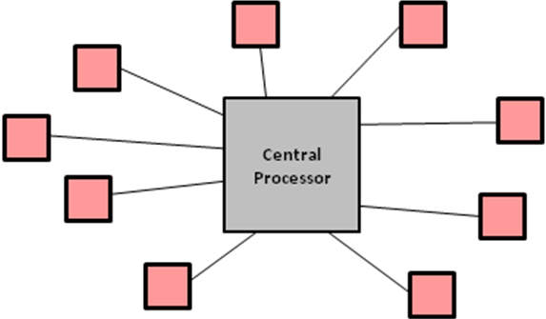
Figure 24: C&DH Architecture
The advantage of such system is that the hardware requirement is minimal. This system is also capable of achieving high performance. However, adding new nodes may require software and hardware changes to the central processors.

9.2.2 Data Bus
The MIL STD 1553B is a military serial data bus, commonly used in many old and current spacecrafts. It has been proven reliable but the bandwidth is significantly lower than the SpaceWire.

9.2 C&DH Design Process
When designing the C&DH of our OSAP system, several factors were considered before a final decision about the C&DH architecture. Those factors included reliability, spacecraft bus constraints, the complexity of the C&DH functions, and the overall C&DH level of complexity. The OSAP is similar to the ISS; hence it would take years of design and research to completely design an adequate command and data handling system. The major data throughput consists of video streams, commands from ground stations to Earth, sensor and telemetry data. The commands from ground control stations include attitude and orbit maneuvers, but most importantly, the controls for maneuvering and actions of the robotic arms. Each C&DH architecture discussed before was evaluated in a trade study to determine the best overall architecture for the OSAP system.

9.3 C&DH Final Design
We have chosen to use hybrid architecture for C&DH on OSAP. Like a federated architecture, each subsystem will have its own processor whose sole purpose is to handle command and data relays to and from the subsystem. However, like a centralized, or integrated, architecture, there will be one processor that handles command processing to and from each subsystem processor. This central processor will coordinate the commands requested by and received from each subsystem processor. This architecture splits the command handling and data processing responsibilities so that each subsystem’s processor can focus on data processing. For the majority of the subsystems, the MIL STD 1553B data bus will be used because of its high reliability. However, SpaceWire will be used as the data bus for the communications subsystem because of the high bandwidth requirement. This architecture also combines the advantages of an integrated system’s efficiency and a federated system’s partitioned nature that prevents the propagation of failure from one subsystem to another. To further bolster our C&DH robustness, there will be backup processors in case of failure of any individual processor.

10 COMMUNICATIONS

10.1 Types of Communication Architectures
Communication architecture consists of a satellite network and ground stations connected by communication links. Those links can be separated as uplink, which transmits data from the ground, and downlink, which transmits data from the spacecraft to the ground. Communication architecture is defined by the geometry of the spacecraft, communication satellites, and the ground control station. There are 5 major communication architectures (see Table 9).
Table 9: Communications Architectures
Architecture | Advantages | Disadvantages
Low Altitude, Single Satellite, Store Forward | Low cost launch, satellite.  Polar coverage. | Long message access time, long transmission delay.
Geostationary orbit | No switching between satellites.  Ground station tracking not required. | Propagation delay.  No coverage of polar regions.  High cost network.
Molniya orbit | Low cost launch.  Polar coverage. | Complex network control.  Need relays.
Geostationary orbit with cross link | No need for ground station relays.  Reduced propagation delay. | Higher satellite complexity.  No coverage of polar regions.
Low altitude, multiple satellites with crosslink | Reduced transmission power due to low altitude.  Polar coverage with inclined orbit. | Complex link acquisition.  Complex dynamic network control  High number of satellites required.

Certain architectures also support different radio frequencies. For communications, the radio frequency (RF) spectrum offer different radio bands (see Table 10).
Table 10: Radio Bands
Band | Frequency Range | Purpose
High Frequency (HF) | 3 to 30 MHz | Short broadcast, amateur radio
Very High Frequency (VHF) | 30 to 300 MHz | Line of sight Communications, aircraft comm, FM radio
Ultra High Frequency (UHF) | 300 to 1000 MHz | Television, cell phones, GPS and Two-Way Radios
Long Wave (L) | 1 to 2 GHz | Communication satellites
Short Wave (S) | 2 to 4 GHz | Weather radar, communication with shuttle and ISS
C | 4 to 8 GHz | Communication satellites, weather radio
Cross (X) | 8 to 12 GHz | Communication Satellites
Ku | 12 to 18 GHz | Used for television broadcast, video streaming

The RF band is chosen based on the needed data rate. Thus, in order to design the communication system, the communication architecture and the frequency band must be chosen based on the design process discussed in the next section.

10.2 Communication Heritage
The EOS project mission will be very similar to the ISS. Like the ISS, the OSAP will stay in orbit and use moving arms to assemble and move parts. Therefore, the ISS communication system was analyzed.

The ISS communication subsystem was broken down into several communication systems, each responsible for transmitting different data types. The ISS communication system consists of a UHF, S-Band, Ku-Band, and VDS network system.

The main difference between the ISS and the OSAP is the inhabitation of humans aboard the ISS Internal communication, internet, and other networks were required for the ISS However, such networks are unnecessary in the design of OSAP.

10.3 Communication Design Process
The communication subsystem design evaluated several factors before choosing an overall architecture and sizing the components of the subsystems.

10.4 Data rates
The transmission data include video streams, commands, and telemetry data. Video downlink accounts for a major portion of the total bandwidth (see Table 11). The ETVCGs video cameras use 800 X 600 pixels resolutions, with each pixel represented by 8 bits for full color spectral band. The video signals are sent using a state of the art compression scheme, resulting in a 5:1 compression ratio. During external operation modes, at most 6 cameras (4 robotic arms cameras + 2 ETVCGs), will transmit videos. Therefore, the video bandwidth, including compression and data protection overhead (20%), would require a transmission of roughly 23.2 Mbps.

Bandwidth due to telemetry, including GPS, thermal sensors, and other data cannot be accurately calculated. However, telemetry data should not exceed 500 kbps. The mission control station will also be able to send voice over radio for potential EVAs. Voice over radio bandwidth is 64 kbps. Therefore, the total downlink bandwidth is estimated to be 25 Mbps, which include overhead due to error detection and correction bits.
Table 11: Downlink Bandwidth
Downlink | Bandwidth
Video streams | 23.2 Mbps
Telemetry | 500 kbps
Voice | 64 kbps

Uplink will consists mostly of commands to robotic arms; ETVCGs, ADCS system, and voice over radio for potential EVAs (see Table 12). Commands will most likely be complex but will not be greater than 1 Mbps, while voice over radio requires 64 kbps.
Table 12: Uplink Bandwidth
Uplink | Bandwidth
Commands | 1 Mbps
Voice | 64 kbps

10.5 Communication Network
Due to the similarity between the ISS and the OSAP functions, the communication system of the OSAP will be strongly influenced by the ISS like the ISS, the OSAP will use TDRSS.
The Tracking and Data Relay Satellite System, or TDRSS, is a configuration of satellites set in geosynchronous altitude of 34,500 km. The satellite constellation was scheduled to be retired by the 1990’s, but was eventually upgraded and serves as the relay system for several spacecraft missions, including the ISS, the Hubble Telescope, and many more. The TDRSS currently only communicates with the White Sands ground control, and was configured to be able to penetrate the ionosphere without loss of efficiency.

However, another driving requirement indicates that the latency shall not exceed 1 second between forward and backward link. Latency arises from signal propagation delay and latency inside the multiplexers and diplexers of the satellites. Signal propagation delay depends on the distance between the relay satellites, the OSAP platform, and the mission control.
Latency inside the circuitry of receivers and transmitters of all parties involved depends on the efficiency of the multiplexer/diplexers. The communication subsystem is designed around the assumption that the circuitry latency is negligible compared to propagation delays.

In Figure 25, the geometry of the TDRSS satellites and the location on orbit of OSAP, the latency of communication due to propagation delay is calculated to be 0.45 seconds one way. Therefore, between commands and feedback data, the total latency a human controller would experience is 0.9 seconds, which satisfies the latency requirements.
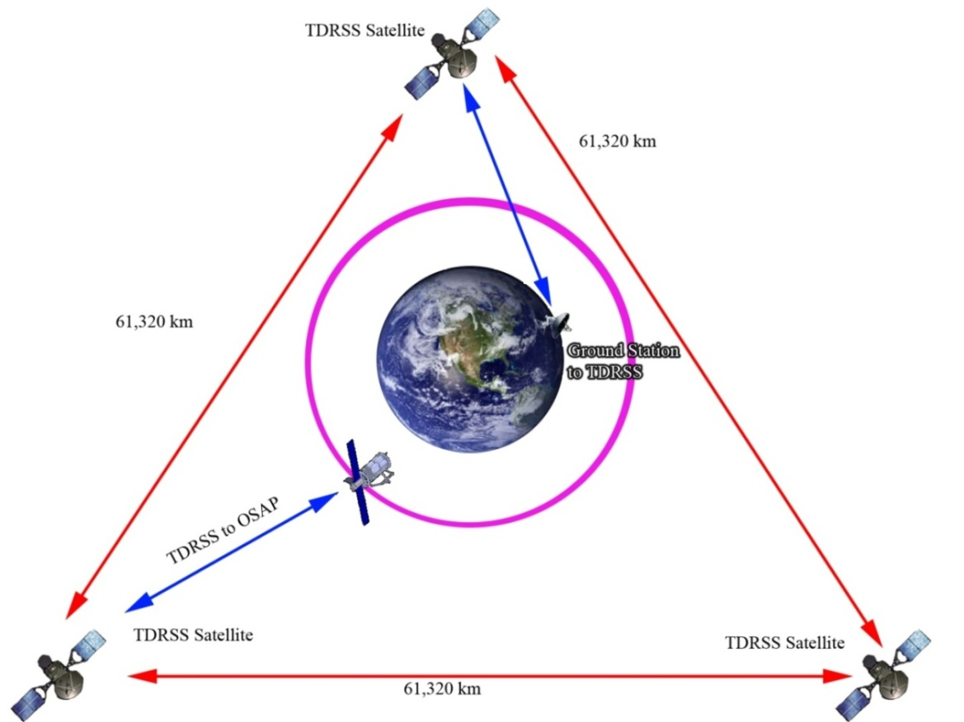
Figure 25: TDRSS Geometry with respect to OSAP

10.6 Communication Band
The communication system is broken into 4 different subsystems, which will allow for different operations. The overall communication system includes S-Band, UHF, VDS, and Ku-Band subsystem. Each subsystem will be responsible for different data transmissions.

10.7 S-Band
The S-Band will be responsible for uplink commands and open 2-way channels from the ground control to the OSAP. The S-Band can downlink at a data rate of 192 kbps and uplink at a data rate of 72 kbps when it is operating in High Data Rate (HDR) mode. Should it operate in Low Data Rate (LDR) mode, the return link rate is 12 kbps and the forward link is 6 kbps. The S-Band can also transmit audio between the OSAP and the ground station. Although the OSAP will be unmanned, audio transmissions might be needed if EVA missions are undertaken. The data is encrypted using a Reed Solomon algorithm and will reduce transmissions errors.
Table 13: S-Band Subsystem
Component | Specifications | Purpose
Signal Processor | Weight: ~ 1 kg  Power: ~90W | Processes and encodes telemetry and command data.
Transponder | Weight: ~ 1 kg  Power: ~ 12 W | Modulates the signal into digital stream.
Radio Frequency Group | Weight: ~ 3.0 kg  Power: ~ 20 W | Amplifies signal and broadcast RF through antennas to TDRSS.

10.8 UHF Subsystem
The UHF subsystem will be responsible for communication in space outside the OSAP. It will serve to link any EVAs, orbiter, and manned spacecraft to the OSAP. The UHF will be used for rendezvous and docking operations. The UHF subsystem consists of space to space radios and external antennas.
Table 14: UHF Subsystems
Component | Specifications | Purpose
UHF Radio | Weight: 10 kg  Power: ~ 100 W | Processes and encodes telemetry and command data.
External Antenna | Weight: ~10 kg  Power: N/A | Modulates the signal into digital stream.

10.9 Video Distribution System
The VDS will provide communication between the VAPH and external cameras. The VDS subsystem will be composed of a Common Video Interface Unit (CVIU), External Video Switch Unit (EVSU), Sync and Control Unit (SCU), PDGFs, and Video Baseband Signal Processor (VBSP). Those components could not be estimated in terms of volumes, weight, and power.
Table 15: VDS Distribution System
Component | Purpose
CVIU | Interface between fiber-optic and component.
EVSU | Route video signal and read external camera status.
SCU | Synchronizes the images.
VBSP | Converts video signal from fiber-optic to digital data.

10.10 Ku-Band
The Ku-Band will be used as the main data transmission from the OSAP to the TDRSS satellites. This subsystem will downlink heavy data bandwidth, mostly composed of streaming videos from the OSAP platform. The maximum downlink data rate of the Ku-Band is 50 Mbps, but further expansion may lead to up to 150 Mbps. Due to system overhead, however, roughly 44 Mbps of data are available. The Ku-Band components are listed below.

Table 16: Ku-Band Subsystem
Component | Specifications | Purpose
Multiplexer | Weight: ~ 2kg  Power: ~ 250W/channel | Switches communication channels and video streams.
Modem | Weight: ~ 3 kg  Power: ~ 3 W | Route data over the network.
Antenna | Weight: ~140 kg  Radius: 1.5 m | Modulate data into RF signal.

10.11 Communication Configuration
The communication antenna will be located on the dock. The computers for the C&DH will be located on the side for easy access to storage drives. The antenna is gimbaled and can rotate 360 degrees with an elevation angle between 0 and 45 degrees.
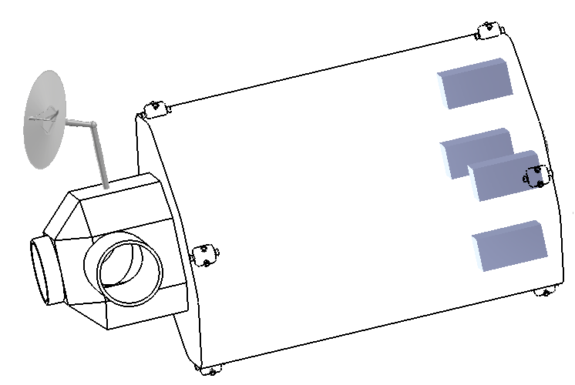
Figure 26: Antenna Rotation on OSAP
The gimbaled antenna allows the communication to track and follow the TDRSS relay satellites as the OSAP orbits around the Earth.

11 THERMAL

11.1 Types of Thermal Control Systems
For the thermal control system several different options were looked at. These systems consist of both passive and active systems. The passive thermal control systems are:
- Paint and surface finishes
- Multi-Layer Insulation (MLI)
- Heat pipes
- Radiators
The active thermal control systems are:
- Louvers
- Cold plates
- Heaters
- Heat pumps and pumped fluid

11.2 Thermal Control Subsystem Design Process
11.2.1 Assumptions
In designing the thermal control system, it was assumed that the SBA will have its own thermal control system. It is important for the SBA and OSAP to have their own thermal control systems, because the heat energy from the sun, albedo, and blackbody radiation increases with the introduction of new modules. It was also assumed that the OSAP robotics would have a built-in thermal control system. The last assumption made was that all power sent to electronic devices, such as sensors, lights, cameras, antenna gimbals, and computers, are converted to internal heat waste. This would create approximately 10 kW of internal heat during sun side operations, 8 kW during dark side operations, and 500 W during survival mode.

11.2.2 Thermal Design Trades
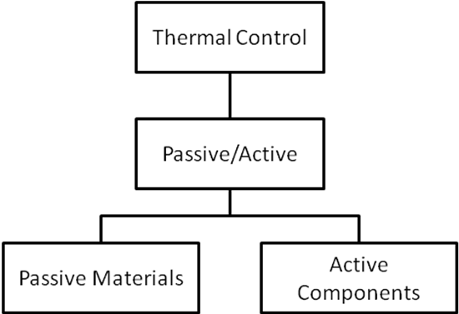
Figure 27: Thermal Control Trade Tree
The first trade conducted was to determine whether or not the OSAP would have a passive, active, or combined thermal control system. It was determined that the OSAP would need both active and passive thermal control systems to properly maintain the OSAP’s temperature (discussed further in Section 11.2.4). Next, passive materials were chosen for the OSAP design. It was determined that white paint would be used on the surface of the OSAP, and Multi-Layered Insulation (MLI) would be used to cover external components. Finally, research was conducted to find an active control system that would effectively keep the OSAP’s temperature stable. The ISS’ active thermal control system was found to be a suitable solution for the OSAP design, and a reduced model was built to satisfy the OSAP’s thermal control needs.

11.2.3 Thermal Design Heritage
The active thermal control system of the OSAP uses heritage from the ISS active control system. The ISS puts a high demand on its thermal control system because it has humans on board, however the OSAP does not have this restriction because human involvement will be minimal to none. The OSAP will have a higher amount of operation tasks, though, which will increase the internal energy produced. Therefore, even though the OSAP does not have humans, its higher demands in operation may make its thermal requirements similar to the ISS. One simplification of the OSAP thermal system is that it can use ammonia in all of its heat pipes, whereas the ISS system uses water in some of its modules because humans are on board. The OSAP is also much smaller than the ISS, so a reduced model will be used in conjunction with the passive system.

11.2.4 Thermal Control System
After the assumptions were made, the process which is shown in Figure 8.2 was used to design and size the thermal control system. The temperature limits of the OSAP used in the design process are shown in Table 8.1. Next, the internal heat generated was determined as discussed in paragraph 8.3.1. The solar flux, albedo, and blackbody extremes of the OSAP were then calculated using a thermal control process code that is discussed in further detail in the Appendix. White paint was picked as the preferred surface finish because of its high emissivity and low absorbability properties. The thermal control code then used the balance heat equation to find the average temperature of the spacecraft. For sun side operations the average temperature was calculated to be 287 K, which is in the acceptable range. However, the dark side operations temperature and survival mode temperature was calculated to be 243 K and 224 K respectively, which is too low of a temperature for the system. Thus, heritage thermal systems were looked into to provide thermal control on the dark side. The active thermal control system on the ISS was chosen because it shares certain operation tasks and has a similar amount of thermal control that has to be provided to the system. Both the active and passive systems used will be discussed further in the next sections.

Table 17: Temperature Ranges of Components
 | Representative Temperature Ranges (°C)
Component | Operational | Survival
Solar Panels | -150 to 100 | -200 to 130
Batteries | 0 to 15 | -10 to 25
C&DH | -20 to 60 | -40 to 75
Antenna Gimbals | -40 to 80 | -50 to 90
Antennas | -100 to 100 | -120 to 120
N₂ Gas Tanks | -185 to 0
Reaction Wheels | -10 to 40 | -20 to 50
IMUs | 0 to 40 | -10 to 50
Star Trackers | 0 to 30 | -10 to 40
Communication | 10 to 30 | -30 to 45

11.2.4.1 Passive Thermal Control System
As discussed earlier, white paint was chosen as the preferred surface coating of the OSAP. The white paint used will have an emissivity of 0.82 and absorbtivity of 0.25. These properties of white paint will effectively allow the OSAP to remain within the operational temperature range during sun side operations. In conjunction with the white paint, MLI will be used to cover certain components of the OSAP. The use of MLI will add further protection from the solar, albedo, and blackbody heat energy during sun side operations, and it will allow the OSAP to retain some heat energy during dark side operations.

11.2.4.2 Active Thermal Control System
As discussed earlier, the active thermal control system of the OSAP is a reduced model of the ISS active control system. The active thermal control system will be divided into 2 loops; each loop (as seen in Figure 28) will consist of:
- 1 Pump Module
- 1 Ammonia Tank Assembly (ATA)
- 1 Nitrogen Tank Assembly (NTA)
- 2 Interface Heat Exchangers (IFHX)
- 1 Radiator
- 2 Cold Plates
- 2 Heaters

Figure 28: Active thermal control loop
The pump module is a heat pump that pumps fluid, ammonia in this case, which circulates around the OSAP and it components through pipes that accumulate heat. The pump module provides circulation, temperature, and pressure control of the fluid. Ammonia was chosen as the working fluid because of its wide range of operating temperatures. The Ammonia Tank Assembly (ATA) is used to contain the liquid ammonia, and works in conjunction with the Nitrogen Tank Assembly (NTA). The NTA contains high pressure nitrogen used for controlled pressurization of the ATA. Initially, the fluid accumulates heat from the internal components through pipes. This is then circulated to an Interface Heat Exchanger (IFHX). The IFHX is an interface that exchanges heat from the internal thermal control system to the external control system. The fluid is then circulated to the radiator. The radiator is used to radiate heat collected from the ammonia loops into space. The calculated area of the radiator needed to sufficiently radiate the OSAP’s waste heat is 15 m². Once the fluid has circulated through the radiator it is piped back either through the IFHXs or a cold plate. The cold plate is used to provide cooling to electrical systems. Each loop also includes 2 heater strips that are used to avoid ammonia freezing during non-operational and low heat periods.

11.3 Thermal Control Subsystem Strengths and Weaknesses
Strengths:
- Radiators have enough capacity to keep the OSAP within its operational temperature ranges during hot periods
- Thermal control system based off of heritage system
- In case one loop fails or is damaged there is redundancy in the 2 loop design
Weaknesses:
- The heating components may not have sufficient capacity to keep the OSAP in operational temperature ranges during cold periods
- The thermal control MATLAB code may not be a sufficient model for the thermal control system; it may not include all the thermal factors of a real world situation.

12 POWER

12.1 Power Systems
12.1.1 Primary Power Source
After conducting trade studies (see Appendix 21.4) on the numerous power options, solar power generation was selected as the primary power source. There have been two main options on how to produce power. One was the use of solar arrays to power the station. The second was the use of fuel cell technology. The major advantage of fuel cell technology is that there is no need for batteries and outputs higher power. However its major drawback includes a constant need of fuel, fragility, and high initial and maintenance costs. On the other hand, solar arrays theoretically have infinite energy source (sun) and a longer life span but take more space and have a lower power output.

12.1.1.1 Solar Array Configuration
Deployable and gimbaled flexible solar array shall be used on OSAP. Once again, there were two main options for solar array configuration. Rigid solar arrays are very durable and can be folded to cut down on volume. However, flexible solar arrays take much less mass and much less volume than rigid solar arrays. Repairs are much easier with a flexible array than a rigid one due to its less complex design. On the other hand, rigid solar arrays experience less vibration due to perturbation caused by construction. To circumvent this unwanted occurrence, damping will be placed on the arrays to cut down on the vibrations. Having deployable solar arrays allows the arrays to be retracted when necessary. Gimbaled solar arrays allow easier tracking of the sun, increasing efficiency.

12.1.1.2 Solar Array Material
The two main cells used in space for solar arrays have been silicon and gallium-arsenide with germanium substrates. However, NASA has transitioned to gallium-arsenide with germanium substrates. This material allows for higher efficiency and lower annual performance degradation rate. Ultra Triple Junction GaInP2/GaAs/Ge has a beginning of life power of 330 W/m² and will be used on OSAP

12.1.2 Secondary Power Source
The purpose of the secondary power source is to provide power during the ecliptic period of the orbit. Many space missions used to rely on nickel metal hydride batteries and nickel cadmium batteries. However, NASA has been transitioning to lithium ion batteries. There are two main reasons. First and foremost, lithium ion batteries have a lower self-discharge rate (5% a month) than nickel metal hydride (30% a month) and nickel cadmium (10% a month). Lithium ion also has a specific energy density per kilogram of 70-110 W-hr/kg (see Appendix 21.4), resulting in a reduction in mass and volume when compared to the nickel based batteries.

12.1.3 Powering via PDGF
There will be a power connection between OSAP and the SBA. This shall allow the robotic arms to connect to PDGF’s located on the SBA and receive power from OSAP. The power connection shall pass through the dock.

12.2 Power Modes
The OSAP station will operate under different nominal power modes to optimize power generation and reduce the mass of the power subsystem. These modes depend on orbit location and activity required. There are a total of seven power modes, listed below.

Table 18: Brief Overview of Power Modes
Mode | Description | Time Period | Power
Sun Standard | Powers computers, control systems, and batteries | Sun | 12 kW
Ecliptic Standard | Batteries power computers and control systems | Ecliptic | 9.7 kW
Reboost | Power to thrusters and CMGs | Sun/Ecliptic | 11 kW
Proximity Operations | Power both robotic arms for vehicle rendezvous, communication instrumentation;  Batteries may be used if shadowing occurs | Sun | 16.6 kW
Sun External Operations | Power both robotic arms, thrusters, CMGs, communication instrumentation | Sun | 26.9 kW
Ecliptic External Operations | Power ONE robotic arm, thrusters, CMGs, communication instrumentation | Ecliptic | 21.1 kW
Survival | Power solely propulsion systems | Sun/Ecliptic | 5.2 kW

12.3 Power Sizing
12.3.1 Solar Arrays
The maximum power that the solar arrays must provide is 52927 W (see Appendix 21.4). The maximum allowed inclination angle away from perpendicular to sunlight is 15º. Therefore the end of life (EOL) power of the solar arrays after 10 years with 15º inclination is 245 W/m². The arrays will have an area of 206 m² (see Figure 12.1) and a mass of roughly 250 kg, not including battery mass. This mass includes the arrays and housing. The solar array housing takes 4 m³ of volume. In case shadowing occurs, the batteries shall provide extra power.
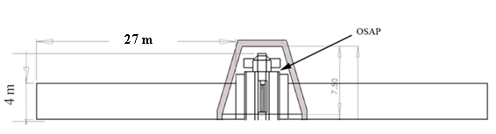
Figure 29: Solar Array Dimensions

12.3.2 Batteries
The maximum power that the batteries will have to provide is 21144 W (see Appendix 21.4). The mass will be doubled to dissipate heat, reduce degradation, and provides emergency power when shadowing occurs on the solar panels. The battery mass shall be 604 kg and the volume shall be 0.35 m³. The batteries will be kept within the solar array housing.

To keep degradation at a minimum, the charge range will be kept between 40% – 80%. This ensures that voltage will not decrease if kept at too low of a charge. The number of cycles will not increase if the charge is kept too high.

13 STRUCTURE

13.1 Structural Design Scope
The purpose of the Orbiting Spacecraft Assembly Platform (OSAP) structural subsystem is to assist the assembly, help initial Spacecraft Being Assembled Parts (SBAP) payload survive launch, survive the lower earth orbit (LEO) space environment, and provide a platform for which the assembly payload may begin assembly operations.

Our project will not focus on structural analysis or the design of structural mechanisms, as such analysis is beyond the ability of our group. Instead we will only design high level structural requirements and describe the placement of spacecraft subsystems and the general spacecraft container.

13.2 Launch Vehicle
We have chosen the Ares V for the Spacecraft Assembly System (SCAS) launch vehicle. The proposed Ares V rocket will have more LEO launch payload than any other rocket ever constructed with an estimated payload from 140,000 to 188,000 kg. Although the Ares V is only in the preliminary design phase, the initial payload fairing diameter is estimated to be around 8.8 meters. Multiple fairings have been proposed, as seen in Figures 30 and 31. The largest of these fairings has an approximate usable volume of 1410 m³ and a total height of 26.2 m and will be used in our report for our spacecraft payload fairing.

With a LEO payload mass greater than about 8 times that of the Space Shuttle, the Ares V will be able to deliver large SBAP components that other launch vehicles cannot. With the largest fairing diameter ever imagined, SBAPs can be wider and more bulky than parts used for previous assembly projects. For example, the International Space Station’s parts launched by the space shuttle were limited by the Space Shuttle’s payload bay diameter of 4.6 meters. A space station the size of the ISS, launched by the Ares V, would be twice as wide and be shipped up in merely two or three launches, instead of about the 30 missions performed for the ISS.

The Ares V will be purportedly ready by the year 2018. However, the project may be cancelled or the specifications may change by then. However, the entire OSAP structure and concept of operations depends on the success of the Ares V project. By loading as much mass as possible on a single launch vehicle, we hope to minimize the mass of the spacecraft bus needed to transport SBAPs from Earth to the OSAP assembly system using the Component Transportation System (CTS). Our group has decided to not design the subsystems of the CTS due to the dearth of information about the SBAP payload and our group’s inability to design or size the structural attach mechanisms which hold SBAPs to the CTS.

The cancellation of Ares V may signal the lack of desire for large space missions, and in such a political environment, the desire for gigantic spacecraft may also be lacking.

Figure 30: Proposed Ares V payload fairing dimensions

Figure 31: Even larger proposed Ares V payload fairing dimensions

13.3 SCAS geometry
The baseline SCAS geometry has the OSAP spacecraft resting on top of a CTS payload structure. The preliminary spacecraft geometry is shown in Figure 32.
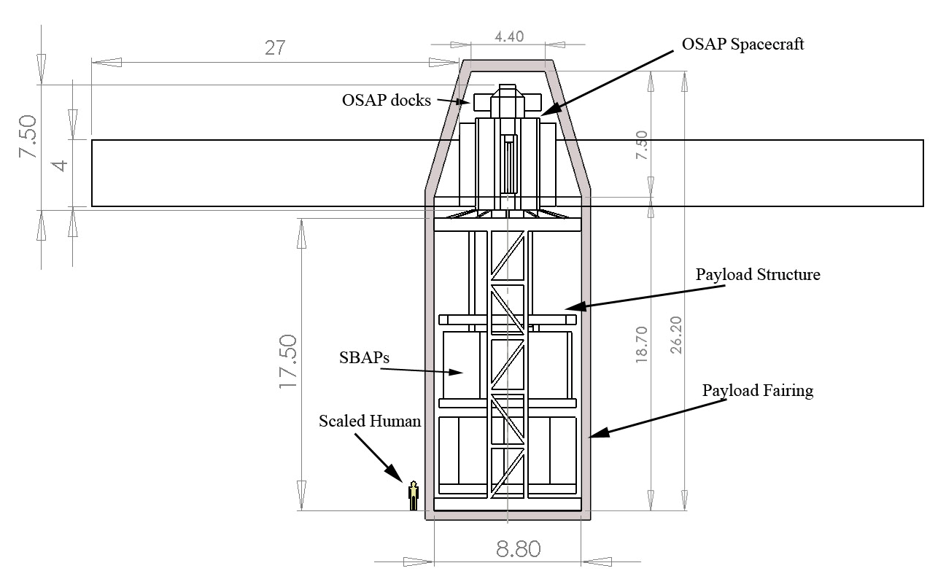
Figure 32: Preliminary SCAS geometry compared to a 5’7” human

As OSAP shall fill the top of the payload shroud, the rest of the Ares V payload fairing will be available to transport up SBAPs and the assembly equipment. The baseline for the OSAP design has two sides of the spacecraft cylindrical surface used to carry the solar arrays. A third side will be used to carry the thermal radiators. The last side will be used to facilitate LM traversal from the CTS to the SBA. This side must be relatively uncluttered to allow the LMs to safely navigate across OSAP. This arrangement can be seen in Figure 33. The top of OSAP shall have 3 docks: one dock shall be used to connect OSAP to the SBA. The other two docks will be used for contingency missions for visiting spacecraft.

The bottom CTS portion is large enough to fit two LMs when the arms are folded for compactness. A structural mechanism will be needed to secure the LMs to the CTS, then release the arms for robotic deployment. The design of this securing mechanism is beyond the scope of our project. In addition, a structure such as two truss beams will be needed to support OSAP above the rest of the payload. Payload racks may be needed to support SBAPs with attaching and releasing mechanisms. Further structural design of the CTS is beyond the scope of our project.
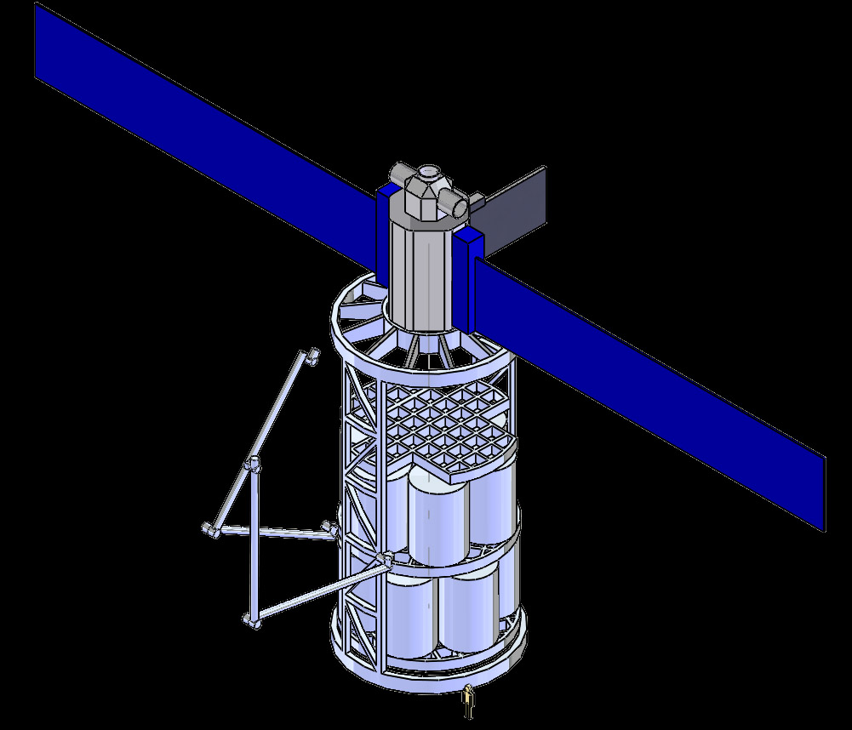
Figure 33: Picture of OSAP structural arrangement with a scaled human on the bottom

14 MASS TABLE
Extremely rough mass and volume calculations were used in this project. Due to the undersigned structure, our group assumed a 30% mass fraction of the total spacecraft mass for the structural subsystem (a typical number for many spacecraft missions), and a 1% mass fraction for the wiring. Unfortunately these mass fractions may not be valid for the large spacecraft we are constructing. The results are shown below in Tables 19 to 21.
Table 19: Mass Budget for OSAP
 | Mass | Sum | Contingency | Overall | Sum of Level
Element | Level 3 | CBE |  | Allocated | Level 1
1.0 Payload |  |  |  |  | 156.0 kg
1.2 ETVCGs |  | 120.0 kg | 30.00% | 156.0 kg
2.0 Spacecraft Bus (dry) |  |  |  |  | 21151.3 kg
2.1 Propulsion |  | 646.7 kg | 20.00% | 776.0 kg
2.1.1 Thrusters | 2.8 kg
2.1.2 Propellant tank | 640.0 kg
2.1.5 Line, Valves, etc. | 3.9 kg
2.2 ADCS |  | 1106.9 kg | 20.00% | 1328.3 kg
2.2.1 IMU (2x) | 9.4 kg
2.2.2 Sun Sensor | 1.5 kg
2.2.3 Horizon Sensor | 8.0 kg
2.2.4 CMGs (4x) | 1088.0 kg
2.3 Communications |  | 165.0 kg | 30.00% | 214.5 kg
2.3.1 S-Band Subsystem | 5.0 kg
2.3.2 UHF Subsystem | 10.0 kg
2.3.3 VIDS Subsystem | 10.0 kg
2.3.4 Ku-Band Subsystem | 140.0 kg
2.4 C&DH |  | 111.0 kg | 30.00% | 144.3 kg
2.4.1 Processors | 1.0 kg
2.4.2 Data Bus | 2.0 kg
2.4.3 Data Storage | 8.0 kg
2.4.4 Computer Racks | 100.0 kg
2.5 Power |  | 2837.5 kg | 30.00% | 3688.7 kg
2.5.1 Solar Arrays | 250.0 kg
2.5.2 Batteries | 524.4 kg
2.5.3 PMAD | 1850.0 kg
2.5.4 Wiring | 213.1 kg
2.6 Structure |  | 6392.2 kg | 0.00% | 6392.2 kg
2.6.1 Primary
2.6.2 Secondary
2.7 Thermal Control System |  | 6621.0 kg | 30.00% | 8607.3 kg
2.7.1 Passive
2.7.2 Active | 6621.0 kg
3.0 Spacecraft Dry Mass |  |  |  |  | 21307.3 kg
4.0 Propellant
4.1 Dry Nitrogen |  |  |  |  | 1320.0 kg
5.0 Loaded Mass |  |  |  |  | 22627.3 kg

Table 20: Mass Budget for the initial CTS
Item | Mass | Sum | Contingency | Overall | Sum of Level
Initial CTS | Level 3 | CBE |  | Allocated | Level 1
1.0 Robotic Payload |  | 6925.0 kg | 30.00% | 9002.5 kg | 9003 kg
2.0 Spacecraft Bus (dry) |  |  |  |  | 50384 kg
2.1 Power |  | 593.9 kg | 30.00% | 772.0 kg
2.1.1 Wiring | 593.9 kg
2.2 Structure |  | 49611.8 kg | 0.00% | 49611.8 kg
3.0 CTS Dry Mass |  |  |  |  | 59386 kg
4.0 SBAP Maximum Payload Mass |  |  |  |  | 105986 kg
5.0 Total Allowable Mass |  |  |  |  | 165373 kg

Table 21: Approximate Mass totals for SCAS System
Total Launch Vehicle Mass | 188000 kg
OSAP Mass | 23000 kg
CTS Maximum Mass | 160000 kg

From these tables, we can estimate the total SBAP mass that can be carried on the initial Ares V launch to be approximately 110,000 kg. OSAP itself will weigh approximately 23,000 kg. The CTS without the SBAP payload will weigh approximately 60,000 kg. Once again, these numbers are extremely rough, especially for the CTS, which are made of almost exclusively structure.

15 VOLUME TABLE
The volume calculations will be even less accurate as mass fractions of mass fractions will be used to calculate wiring and structural volume. These numbers merely prove that the CTS and OSAP will be able to fit within the voluminous Ares V.
Table 22: OSAP Volume
Item | Volume used | Sum | Margin | Overall | Sum of Level
Element | Level 3 | CBE | Contingency | Allocated | Level 1
1.0 ETVCGs Payload | 0.5 | 0.5 | 0.3 | 0.7 | 0.65
2.0 Spacecraft Bus (dry) |  |  |  |  | 83.715
2.1 Propulsion |  | 2.4 | 0.2 | 2.9
2.1.1 Thrusters | 0.1
2.1.2 Propellant tank | 2.2
2.1.5 Line, Valves, etc. | 0.1
2.2 ADCS |  | 6.5 | 0.2 | 7.8
2.2.1 IMU (2x) | 0.2
2.2.2 Sun Sensor | 0.2
2.2.3 Horizon Sensor | 0.1
2.2.4 CMGs (4x) | 6
2.3 Communications |  | 0.53 | 0.3 | 0.7
2.3.1 S-Band Subsystem | 0.01
2.3.2 UHF Subsystem | 0.01
2.3.3 VIDS Subsystem | 0.01
2.3.4 Ku-Band Subsystem | 0.5
2.4 C&DH |  | 0.13 | 0.3 | 0.2
2.4.1 Processors | 0.01
2.4.2 Data Bus | 0.01
2.4.3 Data Storage | 0.01
2.4.4 Computer Racks | 0.1
2.5 Power |  | 6.35 | 0.3 | 8.3
2.5.1 Solar Arrays | 4
2.5.2 Batteries | 0.35
2.5.3 PMAD | 1
2.5.4 Wiring | 1
2.6 Structure |  |  |  | 63.9
2.7 Thermal Control System |  | 3 | 0.3 | 3.9
2.7.1 Passive | 1
2.7.2 Active | 2
3.0 Spacecraft Dry Volume |  |  |  |  | 84.365
4.0 Propellant (Dry Nitrogen) |  |  |  |  | 2.2
5.0 Loaded Volume |  |  |  |  | 86.565
6.0 Allowable Volume |  |  |  |  | 260
Table 23: CTS Volume
Item | Volume | Sum |  | Overall | Sum of Level
Initial CTS | Level 3 | CBE | Contingency | Allocated | Level 1
1.0 Robotic Payload |  | 7.6 | 30% | 9.9 | 9.9
2.0 Spacecraft Bus (dry) |  |  |  |  | 497.4
2.1 Power |  | 1.0 | 30% | 1.3
2.1.1 Wiring | 1.0
2.2 Structure |  | 496.1 | 0% | 496.1
3.0 Spacecraft Dry Volume |  |  |  |  | 507.4
1.0 SBAP Maximum Payload Volume |  |  |  |  | 642.7
7.0 Total Allowable Volume |  |  |  |  | 1150

16 MISSION TIMELINE
Because there is limited information on the possible launch schedule of the Ares V, it was not considered in the schedule. The only factor we can estimate is the estimated assembly time required for SCAS.

To construct the 400,000 kg ISS, approximately 600 hours of EVA were completed. This amounts to about 25 whole days of work. Assuming that all robotics operations will be done in daylight (which may not be true depending on assembly operations), we can come up with a conservative estimate of the total time needed to assemble an ISS-like spacecraft. However, we have no way to know how quickly the robotics will perform. Table 24 shows the possible range for the time needed to construct an ISS-like project.
Table 24: Days needed for SBA Assembly
Robotics efficiency compared to EVA | Days needed for assembly
10% | 413
20% | 206
25% | 165
50% | 83
75% | 55
100% | 41

To estimate our mission schedule, we shall arbitrarily assume the 25% efficiency case. For this case, 165 days of work will be needed, or about 5.5 months from the initial SCAS launch. In addition, approximately four to five Ares V launches will be needed to lift the necessary mass into orbit, assuming that the CTS spacecraft bus will not be recycled into the SBA. Another day will be needed to launch other CTS for approximately every 100,000 kg of SBAP used. If the entire CTS will be recycled into the SBA, then only three launches are needed. This will bring the total mission time into around 170 days, weather permitting.

In contrast, the ISS assembly mission is taking over 10 years to complete, beginning on November 20, 1998. The ISS was predicted to be finished in 2005. Assuming that had everything gone right it would have taken 6 years to build the ISS; our system should outperform the ISS assembly missions by a factor of 13. Unfortunately, it is difficult to directly compare the assembly projects, as ISS had part completion problems, launch vehicle failures, and had an unfavorable inclination for US missions.

The SCAS End-of-Life operation depends heavily on the SBA. After the construction of the first SBA, subsequent SBAs can be assembled by SCAS. Also, OSAP can integrate itself into a particular SBA if desired. When OSAP degrades to a state no longer useful to NASA, it will probably be deorbited.

17 ESTIMATED COSTS
The cost estimate is given in millions USD for 2008 inflation values. Recurring Costs is left empty here. It encompasses maintenance of the orbiting and ground systems as well as mission launches for new materials while OSAP is under contract. Construction Labor includes only the costs associated with initial construction of the orbiting and ground systems.
Table 25: Estimated Cost Table
Item | Cost per Unit ($ mil) | Quantity | Component Price | Subtotal | Item Total
1.0 Payload |  |  |  |  | $402
1.1 Robotics (DEXTR+Candarm2) | 200 | 2 |  | 400
1.2 ETVCGs | 1 | 2 |  | 2
2.0 Spacecraft Bus (dry) |  |  |  |  | $3057.52
2.1 Propulsion |  |  |  | 330.05
2.1.1 Thrusters | 10 | 32 | 320
2.1.2 Propellant tank | 5 | 2 | 10
2.1.5 Line, Valves, etc. | 0.05 | 1 | 0.05
2.2 ADCS |  |  |  | 203
2.2.1 IMU | 0.5 | 2 | 1
2.2.2 Sun Sensor | 0.5 | 2 | 1
2.2.3 Horizon Sensor | 0.5 | 2 | 1
2.2.4 CMGs | 50 | 4 | 200
2.3 Communications |  |  |  | 1.9
2.3.1 S-Band Subsystem | 0.5 | 1 | 0.5
2.3.2 UHF Subsystem | 0.3 | 2 | 0.6
2.3.3 VDS Subsystem | 0.5 | 1 | 0.5
2.3.4 Ku-Band Subsystem | 0.3 | 1 | 0.3
2.4 C&DH |  |  |  | 3.45
2.4.1 Processors | 0.25 | 9 | 2.25
2.4.2 Data Bus | 0.1 | 9 | 0.9
2.4.3 Data Storage | 0.2 | 1 | 0.2
2.4.4 Computer Racks | 0.1 | 1 | 0.1
2.5 Power |  |  |  | 15.12
2.5.1 Solar Arrays | 15 | 1 | 15
2.5.2 Batteries | 0.1 | 1 | 0.1
2.5.3 PMAD | 0.01 | 1 | 0.01
2.5.4 Wiring | 0.01 | 1 | 0.01
2.6 Structure | 2500 | 1 |  | 2500
2.7 Thermal Control System |  |  |  | 4
2.7.1 Passive | 1 | 1 | 1
2.7.2 Active | 3 | 1 | 3
3.0 Consumables |  |  |  |  | 0
4.0 Propellant | 5 | 1 |  |  | $5
5.0 Material Transport |  |  |  |  | $40
5.1 Initial Cost | 40 | 1 |  | 40
5.2 Recurring Costs |  |  |  | 0
6.0 Labor |  |  |  |  | $1000.12
6.1 Design Labor | 0.12 | 1 |  | 0.12
6.2 Construction Labor | 1000 | 1 |  | 1000
7.0 Total System Cost |  |  |  |  | $4504.64 B

18 DESIGN EVALUATION
After designing the OSAP station, the strength and weaknesses were evaluated. Due to the time constraints, much works remain to be done.

18.1 Design Strengths
The most important strength of this design is that the construction methods used in the design have all been tested and used in practice. This will be important when detailed design of the mission and the detailed concept of operations are developed because it reduces the amount of studies and research needed for the construction mission.

Another very important strength is that the OSAP will be largely self-sufficient. The assumption that the robotics will be sufficiently mature by 2020 provides for station maintenance to be automated. There will not be a need for manned repair missions as the ETVCGs and the cameras mounted on the robotic arms will inspect for damage while the small manipulators will handle repair functions.

The OSAP will also perform construction quickly. It has taken years to fully construct the ISS using the Shuttle and limited robotic capability of the station. With the OSAP, final assembly of SBA components will be faster than the current on-orbit assembly methods (namely the ISS and Shuttle). Instead of taking years to construct a spacecraft similar to the ISS in size, the OSAP will be able to perform the construction in a matter of months. Also, having remotely controlled and automated robotics allows for faster assembly than if human crews were trained to perform the assembly via EVAs.

The design for the construction architecture is flexible in the way that the size of SBA is not limited by the robotic arm architecture. The robotic manipulators can accept and handle a variety of component size and shapes. Although the design is baselined on the ISS, the SBA is not limited to that size.

18.2 Design Weaknesses
Although the SCAS has met all of its requirements and can successfully construct objects within its scope, there are still some areas that can be improved upon. Some of these areas have inherent weaknesses associated with them, i.e. the scope. The following paragraphs will discuss what areas need to be improved upon and strengthened. This discussion highlights a few of the weaknesses of the design and is not intended to be all inclusive.
The first weakness of the design is that the OSAP does not provide any shielding to the SBA from space environmental hazards. A spacecraft being built on Earth would not have the risk of being hit by micrometeorites and space debris. Thus, there are some added risks to constructing spacecraft in space, rather than on Earth. Therefore, in order to improve upon the EOS design, a method of deflection and protection must be developed.

The second weakness of the design is that the construction of the SBA is limited to a modular design. It does not have the capabilities to take raw materials and construct modules out of them. Thus, the OSAP is not a full construction site and would need to be upgraded to have more advanced construction capabilities.

The third weakness of the design is that the SBA construction is limited by the OSAP’s standards. For example, all SBA modules must have PDGFs on them so that the robotic arms have something to attach to when constructing the SBA. The SBA must also be able to provide power to the robotic arms through the PDGFs. The SBA must also have docking interfaces on its structure that are compatible with the OSAP so that the OSAP can dock onto the SBA. The additional mass added to the SBA from these interfaces can then become unnecessary after the SBA is deployed on its mission.

Lastly, the current design is dependent on the development of the ARES V, as discussed earlier. If the ARES V fairing dimensions and payload mass capacity are altered then the OSAP design will have to be modified as well. If the ARES V is completely scrapped and no payload launch vehicle is designed to takes its place, then the current method of SBA module launch would have to be altered as well. Thus the design would be more robust if the launch of the OSAP did not rely on the development of just one launch vehicle.

18.3 Future Work
The EOS team has succeeded in developing the design of the SCAS system within the intended scope of the mission. However, due to limitations in time, material, and expertise knowledge, further development remains in several fields.

The CTS requires significant design development once the SBA has been selected. Currently the CTS is designed to carry modules of unknown size and mass. Once the SBA design and SBA modules are known, the CTS can be developed to the final accurate specifications. Furthermore, it may be beneficial to use the CTS architecture on the spacecraft being assembled. It is likely that the structure could be used for something, especially since the launch system has already paid to take the mass into orbit.

For each CTS rendezvous mission, the mass, center of gravity, surface area, and volume of the SCAS changes. Therefore, for each mission, the orbit parameters must be updated for the specific properties. This knowledge will allow orbit designers to select torque equilibrium attitudes. These attitudes orient the SCAS such that the induced gravity gradient torques counteract the atmospheric drag torques resulting in minimal attitude perturbation per orbit. Using these orientations reduces the amount of active station keeping. Furthermore, for each mission a specific re-boost altitude will be selected and may not be the 10 week interval assumed during design. If the next mission will not arrive for a longer interval, the SCAS will simply be taken to a higher initial altitude.

CTS rendezvous operations were simplified due to the OSAP being the inactive spacecraft. Both the OSAP and CTS are GPS enabled, allowing them to accurately navigate to close proximity. However, the appropriate launch times and maneuvers necessary for the CTS to accomplish this were not analyzed.

Currently, the SCAS has no space debris avoidance system. The SCAS will need to use the Space Surveillance Network (SSN) to detect potential debris, and determine necessary attitude maneuvers to avoid collision for the OSAP as well as the SBA. As the SBA grows in size, this becomes a more difficult problem.

The OPM module was designed to be expendable. Development of the OPM should continue in order to evaluate if altitude re-boosts may be accomplished more efficiently and easily. Considerations are an expendable solid rocket booster and a version of the OPM that is refueled rather than expended.

Other thruster orientations should be considered to make a larger torque arm for CMG de-saturation. Placing a thruster on the end of a LM or on the SBA are viable design options. Reducing the amount of thrust necessary to de-saturate the CMG’s reduces the amount of consumables required.

Development of OSAP flight software and computer systems was very limited. The flight code architecture will need to be developed completely.

There was no development of ground system design. The OSAP will be communicating with human controllers on earth. The architecture of the user interface was not developed. Furthermore, the communication ground station placement and type were not selected.
The SCAS design still requires reliability analysis. In order to survive the designed 10 year lifespan, the mean time between failure must be calculated for all components. If the component is expected to fail, redundancies must be put in place. The depth and quality of the reliability analysis can significantly increase the operational success of the SCAS. Keeping the SCAS operational allows the assembly of the SBA to be accomplished as quickly as possible.

19 CONCLUSION
Due to the retirement of the space shuttle, a low earth assembly system will no longer be available in a few years. Such system would be necessary not only for Earth orbiting space stations, but for interplanetary missions as well. A low earth assembly system provides huge benefits such as reduced launch to orbit costs and less limited spacecraft dimensions. This results in potential huge spacecrafts being built in space which could launch with minimal fuel consumption.
Four months after the initial Request for Proposal from the customer, Team EOS has created the Spacecraft Assembly System. We believe that our design will meet the needs of the customer. The design consists of two major systems, the Orbiting Spacecraft Assembly Platform and the ground system encompassing the Component Transport System and ground control.
The OSAP is designed to efficiently and quickly assembly large spacecraft from prefabricated modules sent from Earth. These modules will be designed and assembled independently by the customer who will contract use of the OSAP for the duration of spacecraft assembly. The OSAPs greatest assets are the two robotic arms that will perform nearly all of the assembly procedures. The OSAP will orbit the Earth at an altitude of 341 km. Its orbit is designed to allow predictable ground launches for efficient delivery of new materials.
The OSAP’s main strengths reside in its simplicity and efficiency as compared to the International Space Station and the Space Shuttle. The OSAP will be unmanned, so the complexity and safety factors are not driving factors. The OSAP can also assemble spacecrafts faster than the Space Shuttle could, and at a much lower theoretical cost.
Despite these positive outlooks, there still remains work to complete design the design of the OSAP and CTS. Large sections of the remaining work include structural and spacecraft bus design of the CTS and the design of all computer software and systems. Many smaller components of the OSAP like telemetry sensors also remain to be designed. Several analyses, such as reliability and risk analyses, should also be conducted.

20 REFERENCES
20.1 Introduction
[1] Harland, David M. and Catchpole, John E. Creating the International Space Station. MPG Books Ltd, Bodmin, Cornwall, UK. 2002.

[2] NASA Office of Exploration: Beyond Earth’s Boundaries, Human Exploration of the Solar System in the 21st Century. 1998 Annual Report to the Administrator. Retrieved 30 October 2008. <http://ntrs.nasa.gov/archive/nasa/casi.ntrs.nasa.gov/19910008860_1991008860.pdf>.

[3] Rhatigan, Jennifer L., Hanley, Jeffrey M., Geyer, Mark S. Formulation of NASA’s Constellation Program. NASA Lyndon B. Johnson Space Center. Houston, Texas. Retrieved 29 October 2008. <http://ston.jsc.nasa.gov/collections/TRS/_techrep/SP-2007-563.pdf>

[4] Constellation Design Reference Missions and Operational Concepts. National Aeronautics and Space Administration. Revision B, Change 001. January 7, 2008. Retrieved 29 October 2008. <http://www.nasa.gov/directorates/esmd/library/constellation_documents.html>

[5] Constellation Architecture Requirements Document (Card). National Aeronautics and Space Administration. Revision B. February 13, 2008. Retrieved 29 October 2008.
<http://www.nasa.gov/directorates/esmd/library/constellation_documents.html>

20.2 Robotics
[1] Craig R. Carignan, Gardell G. Gefke, Brian J. Roberts. “SPST470 – Intro to Space Mission Design: Space Robotics.” University of Maryland, College Park: Department of Aerospace Engineering. <http://www.ssl.umd.edu/projects/rangertsx/data/spacerobotics-UNDSPST470.pdf>.

[2] Nancy J. Currie, Brian Peacock. “International Space Station Robotic Systems Operations – A Human Factors Perspective.” Johnson Space Center: Habitabnility and Environmental Factors Division. Visiting 11/2008. <http://hefd.jsc.nasa.gov/pubs/ISS%20Robotics%20Human%20Factors%20Perspective.pdf>

[3] Frank DiGiuseppe. “SPDM Overview.”American Institute of Aeronautics and Astronautics. May 5, 2005. Last visited 11/2008. <http://www.aiaa.org/tc/sos/ws2005/docs/1automation%20track%20presentations/Special%20Purpose%20Dexterous%20Manipulator%20-%20FDG.pdf>.

[4] “International Space Station: Media Resources.” National Aeronautics and Space Administration. Visited 10/20/2008. <http://www.nasa.gov/mission_pages/station/news/index.html>.

[5] International Symposium on Artificial Intelligence and Robotics and Automation in Space. Last visited 11/2008. <http://robotics.estec.esa.int/i-SAIRAS/isairas2001/papers/Paper_AM131.pdf>.

[6] "Low Impact Docking System." Wikipedia, The Free Encyclopedia. 18 May 2008, 14:39 UTC. 7 Dec 2008 <http://en.wikipedia.org/w/index.php?title= Low_Impact_Docking_System&oldid=213251446>.

[7] Rod McGregor and Layi Oshinowo. “Flight 6A: Deployment and Checkout of the Space Station Remote Manipulator System (SSRMS).” Canadian Space Agency. Proceeding of the 6th

[8] “Shuttle Reference Manual.” National Aeronautics and Space Administration: Human Space Flight. Updated 4/07/2002. Visited 10/24/2008. <http://spaceflight.nasa.gov/shuttle/reference/shutref/verboseindex.html>.

[9] “Space Station User’s Guide.” SpaceRef.com. Visited 10/20/2008. <http://www.spaceref.com/iss/operations.html>.

[10] “Space Station Assembly. Canadarm2 and the Mobile Servicing System: Subsystems” National Aeronautics and Space Administration. Visiting 10/2008. <http://www.nasa.gov/mission_pages/station/structure/elements/subsystems.html>.

[11] “The Shuttle Remote Manipulator System – The Canadarm” Reprinted courtesy of MacDonald Dettwiler Space and Advanced Robotics Ltd. IEEE Canada. <http://www.ieee.ca/millennium/canadarm/canadarm_technical.html>.

[12] “What is the Canadarm2?” Canadian Space Agency. Visited 10/2008. <http://www.asc-csa.gc.ca/eng/educators/resources/sts-100/canadarm2.asp>.

[13] W. R. Oegerle, L. R. Purves, J. G. Budinoff, R. V. Moe, T. M. Carnahan, D. C. Evans, C. K. Kim. “Concept for a Large Scalable Space Telescope: In-Space Assembly.” SPIE Digital Library. <http://spiedl.aip.org/getabs/servlet/GetabsServlet?prog=normal&id=PSISDG00626 500000162652C000001&idtype=cvips&gifs=yes>

20.3 ADCS
[1] Bate, R.R.,Mueller,D., and White,J.E., Fundamentals Of Astrodynamics, Dover, New York, 1971.

[2] Kaplan, M. H., Modern Spacecraft Dynamics and Control, Wiley, New York, 1976.

[3] Wertz, J.R., and Larson, W. J., eds., Space Mission Analysis and Design, Kluewer Academic Publishers, 1991.

[4] Wade, Mark., Cape Canaveral, http://astronautix.com/sites/capveral.htm, (Current May 2008)

[5] Kurokawa, Haruhisa, A Geometric Stufy of Single Gimbal Control Moment Gyros, Mechanical Engineering Laboratory, 1998.

[6] Enge,Per and Misra, Pratap, Global Positioning System: Signals, Measurements, and Performance. Ganga-Jamuna Press, 2006.

[7] Yunck,Thomas, Melboure, William,Thornton, C. L., GPS-Based Satellite Tracking System for Precise Positioning. IEEE 1985.

[8] Kulkarni, Jayant and Campbell, Mark., An Approach to Magnetic Torque Attitude Control of Satellites via ‘H$∞$’ Control for LTV Systems. IEEE, 2004.

[9] Su, K.,Ren, D.H.,You, Z.,Zhou, Q., Application of MIMU/Magnetometer Integrated System on the Attitude Determination of Micro Satellite. International Conference on Intelligent Mechatronics and Automation. 2004.

[10] Honeywell Aerospace Electronic Systems, M50 Control Moment Gyroscope. Honeywell International Inc., 2004.

[11] Honeywell Aerospace Electronic Systems, Constellation Series Reaction Wheels. Honeywell International Inc., 2003.

[12] Honeywell Aerospace Electronic Systems, MIMU-Miniature Inertial Measurement Unit. Honeywell International Inc., 2003.

[13] Honeywell Aerospace Electronic Systems, M50 Control Moment Gyroscope. Honeywell International Inc., 2003.

[14] Mission Operations Directorate, International Space Station Familiarization. NASA, 1998

[15] Vallado,David, Fundamentals of Astrodynamics and Applications 3rd Edition, Microcosm Press/Springer, 2007.

20.4 Propulsions
[1] Close, Ali. "Marotta U.K. Products: Cold Gas Thruster Valve." Marotta U.K. Ltd. 9 Nov. 2008 <http://www.marotta.co.uk/pages/prgasthrust1.htm>.

[2] de Groot, W. A. Propulsion Options for Primary Thrust and Attitude Control of Microspacecraft. Rep.No. NASA/CR-1998-206608. Lewis Research Center, NASA. Brook Park, OH: NYMA, Inc., 1998.

[3] Huang, David H. and Huzel, Dieter K. Modern Engineering for Design of Liquid-Propellant Rocket Engines. AIAA. 1992.
[4] Nanson, Richard A. "Navier-Stokes/Direct Simulation Monte Carlo Modeling of Small Cold Gas Thruster Nozzle and Plume Flows." Thesis.

[5] Salmon, Andrew. The Story Of Russian Rocket Engines - Energomash Museum. April 1998.

[6] Sidi, Marcel J. Spacecraft Dynamics & Control: A Practical Engineering Approach. New York, NY: Cambridge UP, 1997.

[7] Turchi, Peter J. Propulsion Techniques: Action and Reaction. AIAA. 1998.

[8] Wade, Mark. "Cold Gas Thruster Module." Astronautix. 1997. 4 Nov 2008. <http://www.astronautix.com/engines/colodule.htm>.

[9] Zandbergen, B.T. C. Modern liquid propellant rocket engines; 2000 Outlook. Delft, The Netherlands: Delft University of Technology, Faculty of Aerospace Engineering, 2000.

20.5 Command and Data Handling (C&DH)
[1] Mission Operations Directorate, International Space Station Familiarization. NASA, 1998

[2] Wertz, J.R., and Larson, W. J., eds., Space Mission Analysis and Design, Kluewer Academic Publishers, 1991.

20.6 Communication
[1] Mission Operations Directorate, International Space Station Familiarization. NASA, 1998

[2] Wertz, J.R., and Larson, W. J., eds., Space Mission Analysis and Design, Kluewer Academic Publishers, 1991.

20.7 Thermal
[1] Christian, John A. Thermal Control Subsystem (TCS) & Structures Subsystem. Lightsey Research Group. The University of Texas at Austin. 2008.

[2] Alvidres, Hector. Hoetger, Debora. Thermal Control. The University of Texas at Austin. Retrieved November 23, 2008. <http://www.tsgc.utexas.edu/archive/subsystems/thermal.pdf>

[3] Active Thermal Control System (ATCS) Overview. Boeing. Retrieved November 23, 2008. <http://www.boeing.com/defense-space/space/spacestation/systems/docs/ISS%20Active%20Thermal%20Control%20System.pdf>

20.8 Power
[1] Griffin & French, Space Vehicle Design, Second Edition, AIAA Education Series, 2004, pg 473.

[2] Space Solar Panels, Spectrolab Photovoltaic Products, Boeing, 2004.

[3] Larson, W.J. and Pranke, L.K., Human Spaceflight Mission Analysis & Design, 2003

[4] Pisacane, V.L., Fundamentals of Space Systems, Second Edition, JHU/APL Series in Science and Engineering, 2005, pg 359.

[5] Systems Machining and Design, pg 419

[6] Battery University, Isidor Buchmann, 2003, <http://www.batteryuniversity.com/parttwo-34.htm>

20.9 Structure
[1] Wertz, James R., Larson, Wiley J. Space Mission Analysis and Design, 3rd ed. Microcosm Press. Hawthrone: CA, 2007. pp 459-496.
[2] Thomas R. Spilker. “The Value of the Ares V Launch Vehicle for Planetary Science Missions.” Jet Propulsion Laboratory, California Institute of Technology. August 16, 2008. <http://event.arc.nasa.gov/aresv-sss/home/ppt/AresV-sss/SAT/am/5Spilker/SSEApplicnsAres5.pdf>

[3] H. Philip Stahl. “Ares V an Enabling Capability for Future Space Science Missions.” NASA Technical Reports Server. <http://ntrs.nasa.gov/archive/nasa/casi.ntrs.nasa.gov/2007 0038319_2007037037.pdf>.

20.10 Estimated Costs
[1] Wertz, J.R., and Larson, W. J., eds., Space Mission Analysis and Design, Kluewer Academic Publishers, 1991.

21 APPENDICES

21.1 ADCS
21.1.1 MATLAB Code

Atmosdrag.m
%computes altitude decay for given initial orbital parameters.
%requires exponentialatmosphericmodel.m
function []=atmosdrag()
clear
clc
close all
hold on

%Enter earth constant values
mu=3.986e5; %Earth's graviational parameter [km^3/s^2]
Re=6378137; %Earth Radius [m]
we=2*pi/86164; %rad/s

colorchooser=1;
colorstring='rb';%grcmk';
alt=330000
while alt<341000
%Enter orbit information
a =Re+alt;%6828922%6714922; %semi major axis [m]
e =0;%.001; %eccentricity
i =28.7*pi/180;%51.95668*pi/180; %incliniation [rad]
RAAN=93.18434*pi/180; %RAAN [rad]
w =62.43275*pi/180; %arg periapsis [rad]
m =140000;%217859; %mass [kg]
A =550;%50 %exposed area [m^2]
Cd =2; %drag coeffecient

%initallize variables (will recompute in each pass of the loop)

time(1)=0;
hp_plot(1)=a*(1-e)-Re;
ha_plot(1)=a*(1+e)-Re;
hp=hp_plot(1);
j=2;

%perform a while loop until the s/c is below specified altitude.
while hp>300000;

%Calculate remaining orbital properties
n =sqrt(mu/((a/1000)^3));
Rp=a*(1-e); %[m]
Ra=a*(1+e); %[m]
period=(2*pi*sqrt(((a/1000)^3)/mu))/(3600*24); %[days]

%get the perigee altitude and call the exponential subroutine to get
%density information
hp=Rp-Re;
ha=Ra-Re;
%[h_zero,rho_zero,capH] =
[h_zero,rho_zero,capH] =exponentialAtmosphericModel(hp);

%now calculate the perigee density

rho_p=rho_zero*exp(-(hp-h_zero)/capH);

%Calculate parameters to be used in the Blitzer equations
Q=1-((2*we*((1-e)^(3/2))/(n*sqrt(1+e)))*cos(i));
delta=Q*A*Cd/m;
c=(Ra-Rp)/capH;

%Calculate the bessel functions to be used in the Blitzer equations
J0=besseli(0,c);
J1=besseli(1,c);
J2=besseli(2,c);
J3=besseli(3,c);
J4=besseli(4,c);

%finally calculate the changes over 1 orbit revolution (blitzer)
delta_a=-2*pi*delta*(a^2)*rho_p*(J0+2*e*J1+3*(e^2)/4*(J0+J2)+(e^3)/4*(3*J1+J3))*exp(-c);

delta_e=-2*pi*delta*a*rho_p*(J1+e/2*(J0+J2)-(e^2)/8*(5*J1+J3)-(e^3)/16*(5*J0+4*J2-J4))*exp(-c);

delta_i=-(pi*a*we*delta*rho_p)/(2*n*sqrt(Q))*sin(i)*(J0-(2*e*J1)+(J2-2*e*J1)*cos(2*w))*exp(-c)*180/pi;

delta_RAAN=-(pi*a*we*delta*rho_p)/(2*n*sqrt(Q))*(J2-2*e*J1)*sin(2*w)*exp(-c)*180/pi;

delta_w=-delta_RAAN*cos(i)*180/pi;

%update the parameter values
a=a+delta_a;
e=e+delta_e;
i=i+delta_i;
RAAN=RAAN+delta_RAAN;
w=w+delta_w;

%fill out plotting arrays
hp_plot(j)=hp;
ha_plot(j)=ha;
time(j)=time(j-1)+period;

j=j+1;

end
hold on
figure(1)
if colorchooser>length(colorstring)
colorchooser=1;
end
grid on
plot(time,hp_plot,colorstring(colorchooser));
%plot(time,ha_plot,'r');
title('Atmospheric Drag Orbit Decay');
xlabel('Time [days]');
ylabel('Altitude [m]');
alt=alt+1000;
colorchooser=colorchooser+1;
end

exponentialAtmosphericModel.m
% Written By Dr. Sean Buckley
% Modified By Andy Rector (September 2008)
% Vallado, David, Fundamentals of Astrodynamics and Applications 3rd Edition, %Microcosm Press/Springer, 2007.
function [h_zero,rho_zero,capH] = exponentialAtmosphericModel(h_ellp);
% h_ellp is in meters
% h_zero is in meters
% rho_zero is in kg/m^3
% capH is in meters

if (h_ellp < 0.),
error('***** ERROR - h_ellp less than zero');
end

if ((h_ellp >= 0.) && (h_ellp < 25.e3)),
h_zero = 0.;
rho_zero = 1.225e0;
capH = 7.249e3;
end

if ((h_ellp >= 25.e3) && (h_ellp < 30.e3)),
h_zero = 25.e3;
rho_zero = 3.899e-2;
capH = 6.349e3;
end

if ((h_ellp >= 30.e3) && (h_ellp < 40.e3)),
h_zero = 30.e3;
rho_zero = 1.774e-2;
capH = 6.682e3;
end

if ((h_ellp >= 40.e3) && (h_ellp < 50.e3)),
h_zero = 40.e3;
rho_zero = 3.972e-3;
capH = 7.554e3;
end

if ((h_ellp >= 50.e3) && (h_ellp < 60.e3)),
h_zero = 50.e3;
rho_zero = 1.057e-3;
capH = 8.382e3;
end

if ((h_ellp >= 60.e3) && (h_ellp < 70.e3)),
h_zero = 60.e3;
rho_zero = 3.206e-4;
capH = 7.714e3;
end

if ((h_ellp >= 70.e3) && (h_ellp < 80.e3)),
h_zero = 70.e3;
rho_zero = 8.770e-5;
capH = 6.549e3;
end

if ((h_ellp >= 80.e3) && (h_ellp < 90.e3)),
h_zero = 80.e3;
rho_zero = 1.905e-5;
capH = 5.799e3;
end

if ((h_ellp >= 90.e3) && (h_ellp < 100.e3)),
h_zero = 90.e3;
rho_zero = 3.396e-6;
capH = 5.382e3;
end

if ((h_ellp >= 100.e3) && (h_ellp < 110.e3)),
h_zero = 100.e3;
rho_zero = 5.297e-7;
capH = 5.877e3;
end

if ((h_ellp >= 110.e3) && (h_ellp < 120.e3)),
h_zero = 110.e3;
rho_zero = 9.661e-8;
capH = 7.263e3;
end

if ((h_ellp >= 120.e3) && (h_ellp < 130.e3)),
h_zero = 120.e3;
rho_zero = 2.438e-8;
capH = 9.473e3;
end

if ((h_ellp >= 130.e3) && (h_ellp < 140.e3)),
h_zero = 130.e3;
rho_zero = 8.484e-8;
capH = 12.636e3;
end

if ((h_ellp >= 140.e3) && (h_ellp < 150.e3)),
h_zero = 140.e3;
rho_zero = 3.845e-9;
capH = 16.149e3;
end

if ((h_ellp >= 150.e3) && (h_ellp < 180.e3)),
h_zero = 150.e3;
rho_zero = 2.070e-9;
capH = 22.523e3;
end

if ((h_ellp >= 180.e3) && (h_ellp < 200.e3)),
h_zero = 180.e3;
rho_zero = 5.464e-10;
capH = 29.740e3;
end

if ((h_ellp >= 200.e3) && (h_ellp < 250.e3)),
h_zero = 200.e3;
rho_zero = 2.789e-10;
capH = 37.105e3;
end

if ((h_ellp >= 250.e3) && (h_ellp < 300.e3)),
h_zero = 250.e3;
rho_zero = 7.248e-11;
capH = 45.546e3;
end

if ((h_ellp >= 300.e3) && (h_ellp < 350.e3)),
h_zero = 300.e3;
rho_zero = 2.418e-11;
capH = 53.628e3;
end

if (h_ellp >= 350.e3),
h_zero = 300.e3;
rho_zero = 2.418e-11;
capH = 53.628e3; % error('***** ERROR - h_ellp greater than 350 km - not implemented');
end

21.1.2 Resulting Payload Mass for Target Altitudes
Table 26: Resulting Payload Mass for Target Altitudes
Altitude (km) | Orbit Velocity (km/s) | ATLAS V 552 Payload (kg)
300 | 10.925 | 20100
325 | 10.905 | 19900
350 | 10.885 | 19700
375 | 10.865 | 19500
400 | 10.845 | 19200
425 | 10.825 | 19000
450 | 10.805 | 18800
475 | 10.785 | 18500
500 | 10.766 | 18200

Figure 34: Mass vs. Altitude
21.1.3 Time Intervals
Calculated using AGI Satellite Tool Kit for a given 24 Hour period during the specified month.
Table 27: Sunlight Intervals
Start Time (UTCG) Stop Time (UTCG) Duration (sec) | Duration
1 Jan 2007 12:25:07.777 1 Jan 2007 13:21:06.830 3359.052 | 3359.052
1 Jan 2007 13:55:56.541 1 Jan 2007 14:51:57.598 3361.057 | 3361.057
1 Jan 2007 15:26:45.320 1 Jan 2007 16:22:48.407 3363.088 | 3363.088
1 Jan 2007 16:57:34.118 1 Jan 2007 17:53:39.257 3365.139 | 3365.139
1 Jan 2007 18:28:22.933 1 Jan 2007 19:24:30.144 3367.212 | 3367.212
1 Jan 2007 19:59:11.765 1 Jan 2007 20:55:21.072 3369.307 | 3369.307
1 Jan 2007 21:30:00.616 1 Jan 2007 22:26:12.039 3371.423 | 3371.423
1 Jan 2007 23:00:49.486 1 Jan 2007 23:57:03.050 3373.563 | 3373.563
2 Jan 2007 00:31:38.377 2 Jan 2007 01:27:54.098 3375.721 | 3375.721
2 Jan 2007 02:02:27.287 2 Jan 2007 02:58:45.189 3377.902 | 3377.902
2 Jan 2007 03:33:16.218 2 Jan 2007 04:29:36.323 3380.104 | 3380.104
2 Jan 2007 05:04:05.173 2 Jan 2007 06:00:27.499 3382.326 | 3382.326
2 Jan 2007 06:34:54.145 2 Jan 2007 07:31:18.720 3384.575 | 3384.575
2 Jan 2007 08:05:43.143 2 Jan 2007 09:02:09.982 3386.839 | 3386.839
2 Jan 2007 09:36:32.163 2 Jan 2007 10:33:01.290 3389.127 | 3389.127
2 Jan 2007 11:07:21.206 2 Jan 2007 12:00:00.000 3158.794 | 3158.794
1 Apr 2007 12:00:00.000 1 Apr 2007 12:16:11.324 971.324 | 971.324
1 Apr 2007 12:52:14.583 1 Apr 2007 13:47:01.870 3287.287 | 3287.287
1 Apr 2007 14:23:04.792 1 Apr 2007 15:17:52.428 3287.636 | 3287.636
1 Apr 2007 15:53:55.015 1 Apr 2007 16:48:42.993 3287.978 | 3287.978
1 Apr 2007 17:24:45.251 1 Apr 2007 18:19:33.569 3288.319 | 3288.319
1 Apr 2007 18:55:35.501 1 Apr 2007 19:50:24.155 3288.653 | 3288.653
1 Apr 2007 20:26:25.766 1 Apr 2007 21:21:14.750 3288.984 | 3288.984
1 Apr 2007 21:57:16.047 1 Apr 2007 22:52:05.353 3289.306 | 3289.306
1 Apr 2007 23:28:06.340 2 Apr 2007 00:22:55.965 3289.625 | 3289.625
2 Apr 2007 00:58:56.646 2 Apr 2007 01:53:46.582 3289.936 | 3289.936
2 Apr 2007 02:29:46.964 2 Apr 2007 03:24:37.210 3290.246 | 3290.246
2 Apr 2007 04:00:37.298 2 Apr 2007 04:55:27.845 3290.547 | 3290.547
2 Apr 2007 05:31:27.644 2 Apr 2007 06:26:18.489 3290.844 | 3290.844
2 Apr 2007 07:02:18.006 2 Apr 2007 07:57:09.138 3291.132 | 3291.132
2 Apr 2007 08:33:08.380 2 Apr 2007 09:27:59.792 3291.413 | 3291.413
2 Apr 2007 10:03:58.765 2 Apr 2007 10:58:50.454 3291.689 | 3291.689
2 Apr 2007 11:34:49.164 2 Apr 2007 12:00:00.000 1510.836 | 1510.836
1 Jul 2007 12:00:00.000 1 Jul 2007 12:52:42.685 3162.685 | 3162.685
1 Jul 2007 13:29:12.441 1 Jul 2007 14:23:32.226 3259.784 | 3259.784
1 Jul 2007 15:00:02.080 1 Jul 2007 15:54:21.763 3259.684 | 3259.684
1 Jul 2007 16:30:51.720 1 Jul 2007 17:25:11.298 3259.578 | 3259.578
1 Jul 2007 18:01:41.354 1 Jul 2007 18:56:00.827 3259.473 | 3259.473
1 Jul 2007 19:32:30.984 1 Jul 2007 20:26:50.351 3259.367 | 3259.367
1 Jul 2007 21:03:20.611 1 Jul 2007 21:57:39.870 3259.259 | 3259.259
1 Jul 2007 22:34:10.233 1 Jul 2007 23:28:29.384 3259.151 | 3259.151
2 Jul 2007 00:04:59.849 2 Jul 2007 00:59:18.894 3259.045 | 3259.045
2 Jul 2007 01:35:49.466 2 Jul 2007 02:30:08.404 3258.938 | 3258.938
2 Jul 2007 03:06:39.076 2 Jul 2007 04:00:57.904 3258.828 | 3258.828
2 Jul 2007 04:37:28.681 2 Jul 2007 05:31:47.399 3258.718 | 3258.718
2 Jul 2007 06:08:18.281 2 Jul 2007 07:02:36.887 3258.605 | 3258.605
2 Jul 2007 07:39:07.876 2 Jul 2007 08:33:26.370 3258.494 | 3258.494
2 Jul 2007 09:09:57.465 2 Jul 2007 10:04:15.848 3258.383 | 3258.383
2 Jul 2007 10:40:47.049 2 Jul 2007 11:35:05.321 3258.272 | 3258.272
1 Oct 2007 12:00:00.000 1 Oct 2007 12:12:26.338 746.338 | 746.338
1 Oct 2007 12:48:19.041 1 Oct 2007 13:43:15.953 3296.913 | 3296.913
1 Oct 2007 14:19:09.310 1 Oct 2007 15:14:05.552 3296.242 | 3296.242
1 Oct 2007 15:49:59.558 1 Oct 2007 16:44:55.136 3295.579 | 3295.579
1 Oct 2007 17:20:49.790 1 Oct 2007 18:15:44.705 3294.915 | 3294.91
1 Oct 2007 18:51:40.006 1 Oct 2007 19:46:34.261 3294.255 | 3294.255
1 Oct 2007 20:22:30.203 1 Oct 2007 21:17:23.807 3293.603 | 3293.603
1 Oct 2007 21:53:20.384 1 Oct 2007 22:48:13.336 3292.953 | 3292.953
1 Oct 2007 23:24:10.548 2 Oct 2007 00:19:02.851 3292.303 | 3292.303
2 Oct 2007 00:55:00.691 2 Oct 2007 01:49:52.357 3291.667 | 3291.667
2 Oct 2007 02:25:50.820 2 Oct 2007 03:20:41.847 3291.027 | 3291.027
2 Oct 2007 03:56:40.932 2 Oct 2007 04:51:31.328 3290.396 | 3290.396
2 Oct 2007 05:27:31.027 2 Oct 2007 06:22:20.794 3289.767 | 3289.767
2 Oct 2007 06:58:21.107 2 Oct 2007 07:53:10.251 3289.144 | 3289.144
2 Oct 2007 08:29:11.168 2 Oct 2007 09:23:59.694 3288.526 | 3288.526
2 Oct 2007 10:00:01.212 2 Oct 2007 10:54:49.128 3287.916 | 3287.916
2 Oct 2007 11:30:51.241 2 Oct 2007 12:00:00.000 1748.759 | 1748.759

Table 28: Umbra Intervals
Start Time (UTCG) Stop Time (UTCG) Duration (sec) | Duration
1 Jan 2007 12:00:00.000 1 Jan 2007 12:24:57.418 1497.418 | 1497.418
1 Jan 2007 13:21:17.239 1 Jan 2007 13:55:46.145 2068.905 | 2068.905
1 Jan 2007 14:52:08.045 1 Jan 2007 15:26:34.887 2066.842 | 2066.842
1 Jan 2007 16:22:58.889 1 Jan 2007 16:57:23.648 2064.759 | 2064.759
1 Jan 2007 17:53:49.774 1 Jan 2007 18:28:12.423 2062.649 | 2062.649
1 Jan 2007 19:24:40.698 1 Jan 2007 19:59:01.219 2060.521 | 2060.521
1 Jan 2007 20:55:31.662 1 Jan 2007 21:29:50.031 2058.369 | 2058.369
1 Jan 2007 22:26:22.666 1 Jan 2007 23:00:38.863 2056.197 | 2056.197
1 Jan 2007 23:57:13.712 2 Jan 2007 00:31:27.714 2054.001 | 2054.001
2 Jan 2007 01:28:04.803 2 Jan 2007 02:02:16.584 2051.781 | 2051.781
2 Jan 2007 02:58:55.932 2 Jan 2007 03:33:05.478 2049.546 | 2049.546
2 Jan 2007 04:29:47.103 2 Jan 2007 05:03:54.387 2047.284 | 2047.284
2 Jan 2007 06:00:38.319 2 Jan 2007 06:34:43.322 2045.003 | 2045.003
2 Jan 2007 07:31:29.579 2 Jan 2007 08:05:32.277 2042.698 | 2042.698
2 Jan 2007 09:02:20.883 2 Jan 2007 09:36:21.255 2040.372 | 2040.372
2 Jan 2007 10:33:12.230 2 Jan 2007 11:07:10.255 2038.025 | 2038.025
1 Apr 2007 12:16:20.148 1 Apr 2007 12:52:05.852 2145.704 | 2145.704
1 Apr 2007 13:47:10.703 1 Apr 2007 14:22:56.053 2145.350 | 2145.35
1 Apr 2007 15:18:01.266 1 Apr 2007 15:53:46.267 2145.001 | 2145.001
1 Apr 2007 16:48:51.841 1 Apr 2007 17:24:36.495 2144.654 | 2144.654
1 Apr 2007 18:19:42.426 1 Apr 2007 18:55:26.739 2144.313 | 2144.313
1 Apr 2007 19:50:33.019 1 Apr 2007 20:26:16.998 2143.979 | 2143.979
1 Apr 2007 21:21:23.621 1 Apr 2007 21:57:07.269 2143.648 | 2143.648
1 Apr 2007 22:52:14.233 1 Apr 2007 23:27:57.551 2143.319 | 2143.319
2 Apr 2007 00:23:04.852 2 Apr 2007 00:58:47.852 2143.000 | 2143
2 Apr 2007 01:53:55.479 2 Apr 2007 02:29:38.164 2142.685 | 2142.685
2 Apr 2007 03:24:46.114 2 Apr 2007 04:00:28.490 2142.377 | 2142.377
2 Apr 2007 04:55:36.754 2 Apr 2007 05:31:18.832 2142.077 | 2142.077
2 Apr 2007 06:26:27.404 2 Apr 2007 07:02:09.185 2141.781 | 2141.781
2 Apr 2007 07:57:18.062 2 Apr 2007 08:32:59.550 2141.489 | 2141.489
2 Apr 2007 09:28:08.724 2 Apr 2007 10:03:49.930 2141.206 | 2141.206
2 Apr 2007 10:58:59.392 2 Apr 2007 11:34:40.322 2140.930 | 2140.93
1 Jul 2007 12:52:50.696 1 Jul 2007 13:29:04.598 2173.903 | 2173.903
1 Jul 2007 14:23:40.237 1 Jul 2007 14:59:54.240 2174.002 | 2174.002
1 Jul 2007 15:54:29.776 1 Jul 2007 16:30:43.877 2174.101 | 2174.101
1 Jul 2007 17:25:19.311 1 Jul 2007 18:01:33.510 2174.199 | 2174.199
1 Jul 2007 18:56:08.841 1 Jul 2007 19:32:23.140 2174.299 | 2174.299
1 Jul 2007 20:26:58.367 1 Jul 2007 21:03:12.767 2174.400 | 2174.4
1 Jul 2007 21:57:47.886 1 Jul 2007 22:34:02.386 2174.500 | 2174.5
1 Jul 2007 23:28:37.402 2 Jul 2007 00:04:52.007 2174.605 | 2174.605
2 Jul 2007 00:59:26.913 2 Jul 2007 01:35:41.621 2174.708 | 2174.708
2 Jul 2007 02:30:16.418 2 Jul 2007 03:06:31.230 2174.812 | 2174.812
2 Jul 2007 04:01:05.924 2 Jul 2007 04:37:20.835 2174.911 | 2174.911
2 Jul 2007 05:31:55.419 2 Jul 2007 06:08:10.432 2175.013 | 2175.013
2 Jul 2007 07:02:44.908 2 Jul 2007 07:39:00.028 2175.120 | 2175.12
2 Jul 2007 08:33:34.392 2 Jul 2007 09:09:49.619 2175.227 | 2175.227
2 Jul 2007 10:04:23.871 2 Jul 2007 10:40:39.202 2175.330 | 2175.33
2 Jul 2007 11:35:13.345 2 Jul 2007 12:00:00.000 1486.655 | 1486.655
1 Oct 2007 12:12:34.791 1 Oct 2007 12:48:10.786 2135.995 | 2135.995
1 Oct 2007 13:43:24.396 1 Oct 2007 14:19:01.060 2136.664 | 2136.661
1 Oct 2007 15:14:13.985 1 Oct 2007 15:49:51.319 2137.334 | 2137.334
1 Oct 2007 16:45:03.560 1 Oct 2007 17:20:41.561 2138.001 | 2138.001
1 Oct 2007 18:15:53.122 1 Oct 2007 18:51:31.784 2138.663 | 2138.663
1 Oct 2007 19:46:42.667 1 Oct 2007 20:22:21.991 2139.323 | 2139.323
1 Oct 2007 21:17:32.203 1 Oct 2007 21:53:12.180 2139.977 | 2139.977
1 Oct 2007 22:48:21.723 1 Oct 2007 23:24:02.349 2140.626 | 2140.626
2 Oct 2007 00:19:11.233 2 Oct 2007 00:54:52.504 2141.271 | 2141.271
2 Oct 2007 01:50:00.726 2 Oct 2007 02:25:42.641 2141.915 | 2141.915
2 Oct 2007 03:20:50.211 2 Oct 2007 03:56:32.760 2142.549 | 2142.549
2 Oct 2007 04:51:39.682 2 Oct 2007 05:27:22.863 2143.181 | 2143.181
2 Oct 2007 06:22:29.141 2 Oct 2007 06:58:12.951 2143.809 | 2143.809
2 Oct 2007 07:53:18.589 2 Oct 2007 08:29:03.020 2144.431 | 2144.431
2 Oct 2007 09:24:08.025 2 Oct 2007 09:59:53.071 2145.047 | 2145.047
2 Oct 2007 10:54:57.448 2 Oct 2007 11:30:43.108 2145.660 | 2145.66

Table 29: Average Sunlight and Average Umbra

 | SUNLIGHT
 | Seconds | Hours
JANUARY 1
TOTAL | 53765.229 | 14.935
MIN | 3359.052 | 0.933
MAX | 3389.127 | 0.941
AVG | 3373.762 | 0.937
APRIL 1
TOTAL | 51825.755 | 14.396
MIN | 3287.287 | 0.913
MAX | 3291.689 | 0.914
AVG | 3289.573 | 0.914
JULY 1
TOTAL | 52048.264 | 14.458
MIN | 3258.383 | 0.905
MAX | 3259.784 | 0.905
AVG | 3259.093 | 0.905
OCTOBER 1
TOTAL | 51880.298 | 14.411
MIN | 3287.916 | 0.913
MAX | 3296.913 | 0.916
AVG | 3292.347 | 0.915
AVERAGE
TOTAL | 52379.887 | 14.550
MIN | 3298.160 | 0.916
MAX | 3309.378 | 0.919
AVG | 3303.694 | 0.918

 | UMBRA
 | Seconds | Hours
JANUARY 1
TOTAL | 32304.370 | 8.973
MIN | 2038.025 | 0.566
MAX | 2068.905 | 0.575
AVG | 2053.797 | 0.570
APRIL 1
TOTAL | 34291.513 | 9.525
MIN | 2140.930 | 0.595
MAX | 2145.704 | 0.596
AVG | 2143.220 | 0.595
JULY 1
TOTAL | 34105.785 | 9.474
MIN | 2173.903 | 0.604
MAX | 2175.330 | 0.604
AVG | 2174.609 | 0.604
OCTOBER 1
TOTAL | 34254.443 | 9.515
MIN | 2135.995 | 0.593
MAX | 2145.660 | 0.596
AVG | 2140.903 | 0.595
AVERAGE
TOTAL | 33739.028 | 9.372
MIN | 2122.213 | 0.590
MAX | 2133.900 | 0.593
AVG | 2128.132 | 0.591

21.1.4 Mission Iteration Initial Altitudes
Each SCAS mass and surface area below was used to compute the appropriate initial altitude such that there is a 75 day period before the SCAS reaches an altitude of 300km.
Table 30: Mission Iterations Initial Altitudes
Mission Number | Mass (1000 kg) | Area (m²) | Altitude (km)
1 | 140 | 550 | 340
2 | 240 | 800 | 335
3 | 340 | 1050 | 332.5
4 | 440 | 1300 | 331.5
5 | 540 | 1550 | 331
6 | 640 | 1800 | 330.5
7 | 740 | 2050 | 330
8 | 840 | 2300 | 329.5
9 | 940 | 2550 | 329.25
10 | 1040 | 2800 | 329
21.1.5 ADCS Sensors and Controller Selection

Table 31: Attitude Sensor AHP Prioritization Matrix
Prioritization
 | Mass | Accuracy | Power | Reliability
Mass | 1 | 1/2 | 3 | 2
Accuracy | 2 | 1 | 4 | 2
Power | 1/3 | 1/4 | 1 | 1
Reliability | 1/2 | 1/2 | 1 | 1
Sums | 3.83 | 2.25 | 9 | 6
 |  |  |  |  | Weights
Mass | 0.260 | 0.2222 | 0.3333 | 0.3333 | 0.2874
Accuracy | 0.521 | 0.4444 | 0.4444 | 0.3333 | 0.4359
Power | 0.086 | 0.1111 | 0.1111 | 0.1666 | 0.1189
Reliability | 0.130 | 0.2222 | 0.1111 | 0.1666 | 0.1576

Table 32: Sensor Specifications
 | Mass (kg) | Power (W) | Accuracy | Bandwidth
IMU | 4.7 | 32 | 0.005 (but drift)
Sun sensor | 1.5 | 2.5 | 0.013888889 | med-high
Star Tracker | 5.00 | 20 | 0.016666667 | low
Horizon Scanner | 4 | 10 | 0.1 | low-med
Magnetometer | 1.2 | 1 | 0.5 | high

Table 33: L-3 Communications DGCMG 4800/250 Specifications
Design Life | 10 years
Angular Momentum | 4760 Nms
Rotor Factor of Safety | 4
Nominal Speed | 6,600 RPM
Max Output Torque | 258 Nm
Max Gimbal Rate | +/-3.1 deg/sec
Input Power | 120 Vdc
Data Transfer | 1553
Weight | 272 Kg
Dimensions | 130cm x 137cm x 125cm
Unlimited Gimbal Freedom | Both Axes
Random Vibration | 8.4 Gs RMS
Thermal Vacuum | -42 to +72 C

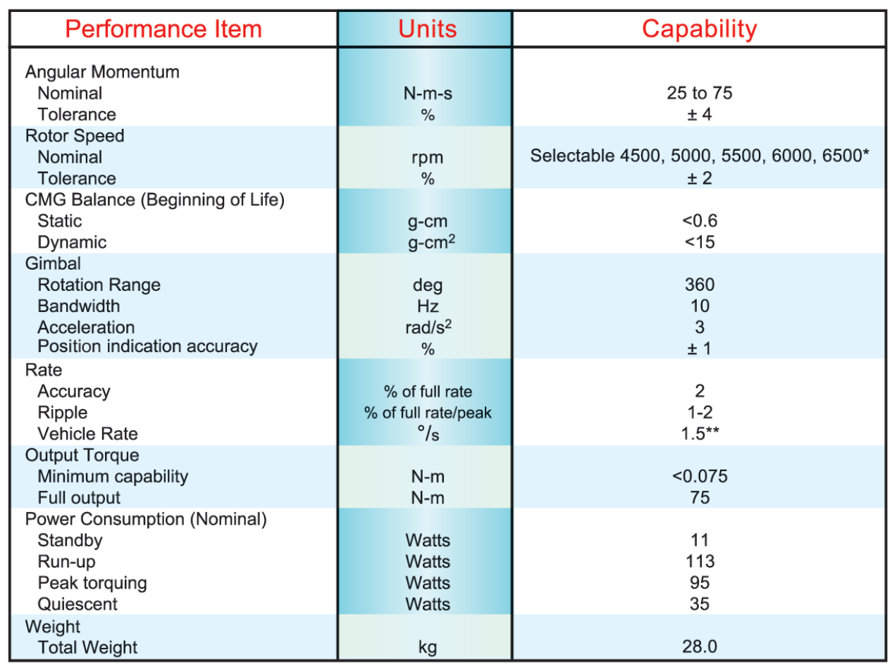
Figure 35: Honeywell CMG Specifications

21.2 Propulsions
To calculate the propellant mass that must be stored on the OSAP, the mass flow through each thruster was calculated from Equation 1.

$T=v_{e}\dot{m}$ (1)

Where v_{e} is the exhaust exit velocity, $\dot{m}$ is the mass flow rate through each thruster, and T is the thrust produced by each thruster. The exhaust exit velocity was obtained from the specific impulse I_{sp} of each thruster using Equation 2.

$I_{sp}=\frac{v_{e}}{g_{o}}$ (2)

Where g_{o} is the Earth’s gravitational acceleration at the surface. The exhaust exit velocity was found to be 666.4 s, leading to a mass flow rate of 0.167 kg/s.

In order to calculate the mass of propellant used by each thruster, the time each thruster is operating must be known. Since a detailed analysis of this time is beyond the scope of this project, the assumption was made that each thruster would fire a one-second burst of propellant at full capacity each day for every day between resupply (approximately every 10 weeks, or 70 days). From this assumption, the total mass of propellant used by each thruster between resupply is 11.68 kg. For the entire thruster system, the total mass of propellant used is 373.78 kg. Because the time assumption was made, a 30% margin on the total propellant mass carried on OSAP was used. The total propellant mass is therefore 486 kg.

To get the volume need for the propellant tanks, the gaseous nitrogen propellant was approximated to be a perfect gas and the perfect gas equation was used (Equation 3).

$P=ρRT$ (3)
Where P is the tank pressure and was baselined to be 136 atm, ρ is the propellant density, R is the gas constant for gaseous nitrogen, and T_{o} is equal to the propellant storage temperature and was baselined to be 235K. This temperature is well above the condensing point for nitrogen and prevents extremely massive or bulky thermal control from being needed to keep the propellant sufficiently cold. This gives a propellant density of 197.6 kg. Then the definition of density (Equation 4) was used to calculated the propellant tank volume necessary.

$ρ=\frac{m}{V}$ (4)
Where m is the total mass of propellant and V is the propellant tank volume. The necessary propellant tank volume is 2.27 m³, leading to a tank radius of 0.85 m.

In order to calculate the mass of the propellant tank, Equation 5 was used in which m_{tank} is the mass of the propellant tank, P_{b} is defined as twice the tank pressure, V is the tank volume, and φ is a constant given by material choice (titanium in this case).

$m_{tank}=\frac{P_{b}V}{φg_{o}}$ (5)
The mass of the propellant tank is 640 kg.

Although the propellant temperature chosen was well above the condensing temperature for nitrogen and prevents massive thermal systems from being need, it was decided to increase the storage temperature to 273 K to further reduce the need for thermal systems to keep the propellant cool. With this new temperature, the new tank pressure is 158 atm. This increase in pressure increases the propellant tank mass to 742 kg.

The last modification made to the design of the thruster system was the choice to use a dual propellant tank design. This modification does not change any of the above calculations except that each propellant tank will have a volume of 1.135 m³, hence a radius of 0.6 m, and a mass of 371 kg.
Table 34: Final Thruster System Properties
Quantity | Value
T | 111 N
I_{sp} | 68 s
g_{o} | 9.8 m.s⁻¹
M_{t} | 486 kg
P | 158 atm
T_{o} | 273 K
R_{N2} | 296.94 J.kg^{-1.}K⁻¹
φ | 10,000
m_{tank} | 371 kg
V_{tank} | 1.135 m³
r_{tank} | 0.6 m

21.3 Thermal
The thermal control MATLAB code used a heat energy balance method as described by John Christian in his Thermal Control Subsystem (TCS) & Structures Subsystem lecture. The energy inputs used in the model were direct solar radiation, reflected sunlight (albedo), blackbody radiation from nearby planets, and internally generated power. This is then set equal to the net power radiated to space.
Q_{sun} + Q_{albedo} + Q_{BB} + Q_{internal} = Q_{space} (1)

The direct solar radiation is calculated by:
(2)

where Q_{sun} is the direct solar radiation, α_{sc} is the average spacecraft absorptivity, A_{projected} is the projected area of the spacecraft, S_{E} is the solar constant, and R_{sc} is the distance of the spacecraft from the sun.

The reflected sunlight term is calculated by: (3)
where Q_{albedo} is the reflected sunlight, is the total spacecraft surface area, F_{sc-p} is the view factor of the spacecraft to the planet, and a is the planets albedo.

The blackbody radiation term is given by:
(4)

where Q_{BB} is the blackbody radiation term from the nearby planet, σ is the Stefan-Boltzmann constant, is the average emissivity of the spacecraft, T_{p} is the blackbody temperature of planet, and T_{sc} is the temperature of the spacecraft.

The internal energy, Q_{internal}, was roughly approximated to be 10 kW for sun side operations, 8 kW for dark side operations, and 500 W for survival mode.

The power radiated to space is given by:
(5)

Finally equations (1) through (5) are combined, and the temperature of the spacecraft, T_{sc}, is solved for.
(6)
The outer skin of the spacecraft was assumed to be white paint with an emissivity of 0.82 and absorbability of 0.25. The blackbody temperature of Earth is 290K. The solar flux near Earth is 1353 W/m². Lastly the area of a cylinder was used in the calculations of total spacecraft area and projected area. After the average spacecraft temperature was calculated, the amount of energy required to keep the spacecraft at 283 K was estimated.
%Qsun+Qalbedo+Qbb+Qinternal=Qspace=Qpaint+Qprad+Qarad+QHP=Qdisp
% Inputs
asc= .25; %average spacecraft absorptivity
rsc= 4; %radius of spacecraft, m
l=6.5; % height of spacecraft
Aproj= 2*rsc*l; % projected area of spacecraft, m^2
Se= 1353 ; % solar constant @ 1 AU, W/m^2
Rsc=1; %distance of spacecraft from sun, AU
h=322; %300-322 ft
Asc= 2*pi*rsc*l; %total surface area of spacecraft
theta=asin(6378/(6378+h));
Fscp=.5*(1-cos(theta)) %view factor of spacecraft to planet
a=.3; %Average albedo of planet Earth
sigma= 5.67*10^(-8); %Stefan-Boltzmann constant, W/m^2-K^4
e= .82; % average spacecraft emissivity
Tp= 290; %Blackbody Temperature of Planet, K
Tsc= 283; %Temperature of Spacecraft, K
Qinternal= 10000 %Qin,sun=10000 W, Qin,dark=8000 W Qin,surv=500 W
eff=.9; %efficiency of radiator
%Sun Side
Qsun=asc*Aproj*Se*(1/Rsc)^2
Qalbedo=asc*[Asc]*Fscp*[a*Se*(1/Rsc)^2]
Tsccalc=[Fscp*Tp^4+(Qsun+Qalbedo+Qinternal)/(Asc*sigma*e)]^(1/4)
%Dark Side
Qsun=0
Qalbedo=0
Tsccalc=[Fscp*Tp^4+(Qsun+Qalbedo+Qinternal)/(Asc*sigma*e)]^(1/4)

21.4 Power
21.4.1 AHP Prioritization Matrix for Power
Table 35: AHP Prioritization Matrix for Power
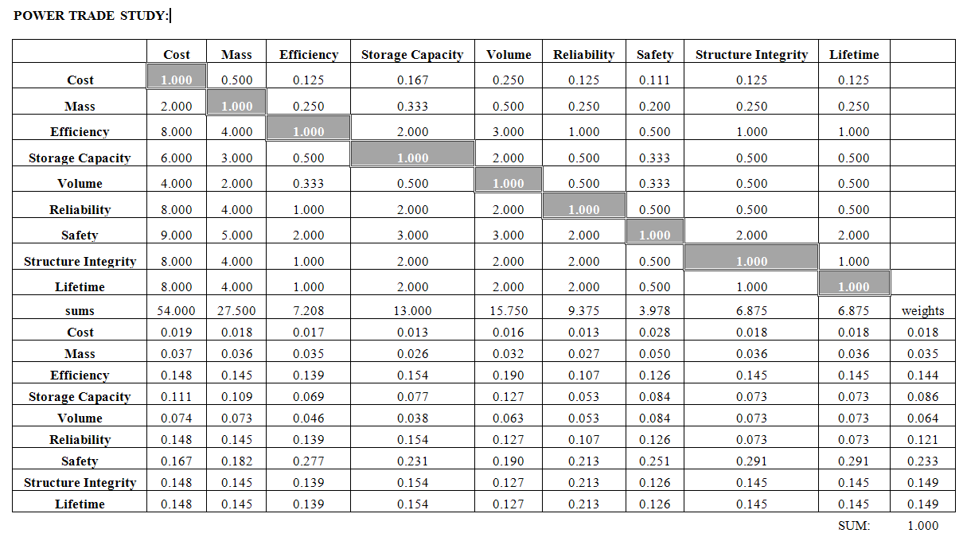

21.4.2 Primary Power Source
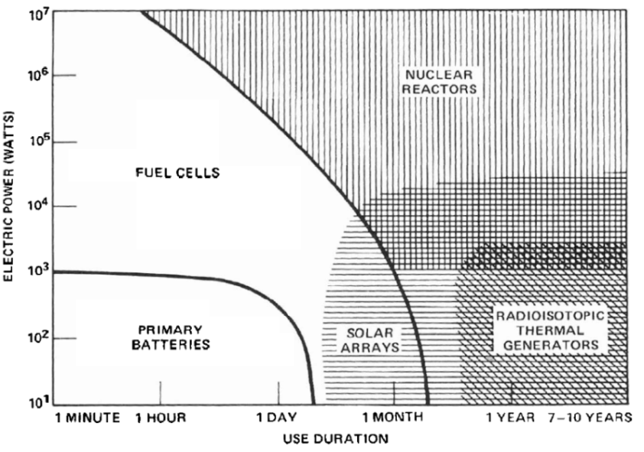
Figure 36: Electrical Power with respect to Use Duration
As seen in the figure above, fuel cells have limited use duration. Nuclear reactors are banned in Low Earth Orbit due to safety and political reasons. Primary batteries are not rechargeable and have very low electrical power. Solar arrays have the longevity needed and adequate power for OSAP. Radioisotopic thermal generators don’t give enough power. Solar panels will be used for OSAP.

21.4.3 Solar Array Type
When choosing between flexible and solar arrays, there were several factors to look into: Mass, Volume, Efficiency, Durability/Safety and Maintenance.

Flexible arrays take 10% the mass and 17% the volume that rigid arrays take. They are also more efficient due to its simpler design and as a result require less maintenance. Both rigid and flexible arrays can be stowed away, making volume less of an issue. Flexible arrays require less maintenance if damaged by space debris, though rigid arrays are more durable. Vibrations cause minor issues with flexible arrays and damping can easily be done to avoid complications for the flexible arrays, ensuring safety and adequate durability. Therefore flexible arrays shall be used.

21.4.4 Secondary Power Source
Lithium-Ion batteries can store more power than other batteries. Lithium Ion batteries also have a lower self-discharge rate (5% a month) than nickel metal hydride (30% a month) and nickel cadmium (10% a month). Lithium-Ion batteries may be more corrosive, but can be properly shielded to keep this problem to a minimum. Therefore, Lithium-Ion batteries shall be used on OSAP.

21.4.5 Ecliptic Arm Usage
For our ecliptic external operations stage, we had to decide how many robotic arms will be used. As a result, we get the following table and graph:

Table 36: Power and Mass Usage Comparison
 | Two arms | One arm | No arms
Battery Mass (kg) | 797 | 604 | 541
Power (W) | 27904.2 | 21144.2 | 18930

Figure 37: Power and Mass Usage Comparison
As the figure above shows, using two arms take much more power and mass when compared to one arm. As a result of this, during our ecliptic external operations stage, one arm will be used.

21.4.6 Power Equations

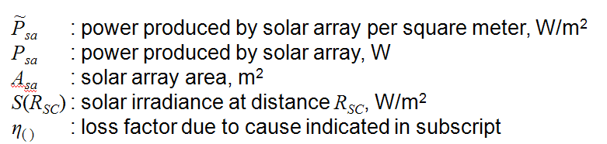

ξ = Percent solar array degradation per year
τ = Life span of the spacecraft (years)
Germanium arsenide with germanium substrates has 2.75% yearly degradation. Therefore, in 10 years we get:
When calculating P_{sa}, we are basing it on end of life power. Doing this ensures that we have enough power at the end of the solar arrays life for OSAP.

Keeping the angle 15% off perpendicular we get:

These are usually specified by the manufacturer. S_{E} is the solar constant equal to 1366 W/m². The following tables show comparisons of beginning and end of life power.

Table 37: Solar Array Beginning of Life Performance
Solar Arrays | Performance
Single Junction Silicon | 166 W/m²
Single Junction GaAs/Ge | 228 W/m²
Dual Junction GaInP2/GaAs/Ge | 252 W/m²
Triple Junction GaInP2/GaAs/Ge | 289 W/m²
Improved Triple Junction GaInP2/GaAs/Ge | 316 W/m²
Ultra Triple Junction GaInP2/GaAs/Ge | 330 W/m²

Table 38: Solar Array End of Life Performance
Solar Arrays | Performance
Single Junction Silicon | 122 W/m²
Single Junction GaAs/Ge | 168 W/m²
Dual Junction GaInP2/GaAs/Ge | 186 W/m²
Triple Junction GaInP2/GaAs/Ge | 213 W/m²
Improved Triple Junction GaInP2/GaAs/Ge | 233 W/m²
Ultra Triple Junction GaInP2/GaAs/Ge | 245 W/m²

Battery capacity is found using the following equation:

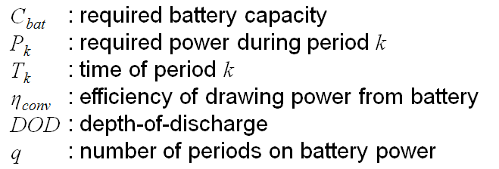
Using this equation and manufacturer specifications, the following comparison has been found:

Table 39: Specific Energy Density for each Battery Type
Battery Type | Specific Energy Density (W-hr/kg)
Nickel-Cadmium, NiCd | 25-30
Nickel-Hydrogen, Ni-H₂, individual pressure vessel | 35-43
Nickel-Hydrogen, Ni-H₂, common pressure vessel | 40-56
Nickel-Hydrogen, Ni-H₂, single pressure vessel | 43-57
Lithium-Ion, Li-Ion | 70-110

The following equation was used to determine how much power the solar panels will have to provide using EOL power ratings.
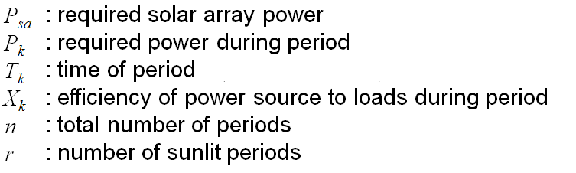
Assuming a 10 year lifespan and an X_{K} of 0.6 along with the power tables for each mode we find:
P_{sa,max} = 52928 W
P_{sa,min} = 39019 W (assuming η_{degradation} = 0.76 and η_{pointing} = 0.97)
From this we conclude that the solar panel area is around 216 m² (assuming EOL power of 245 W/m²). Flexible solar arrays weigh 0.2 kg/m², meaning the arrays weigh 40 kg. The housing weighs 210 kg making the total mass equal to 250 kg. The solar array housing with the arrays takes roughly 4 m³.

Using the power tables and seeing the maximum power output during ecliptic orbit of 21144 W, we determined the battery mass should be 302 kg. Doubling this number we get:
Battery mass: 604 kg

It takes 580 cm³ to store 1 kg of Lithium Ion battery. Therefore:
Battery volume: 0.35 m³.
21.4.7 Power Modes
21.4.7.1 Sun Standard Mode
The solar arrays shall provide power for the onboard computers, controls systems and, if necessary, recharge the batteries. The robotic arms will be in stand-by mode. This mode shall occur when there is no construction/assembly.
Table 40: Sun Standard Mode
 | Sum | Margin | Overall | Sum of Level
Element | CBE | Contingency | Allocated | Level 1
1.0 Payload |  |  |  | 3796 W
1.1 Canadarm2 (Dexter+Candarm1) | 2690 W | 30.00% | 3497 W
1.2 ETVCGs | 230 W | 30.00% | 299 W
2.0 Spacecraft Bus (dry) |  |  |  | 8245.8 W
2.1 Propulsion | 0 W | 20.00% | 0 W
2.2 ADCS | 766.5 W | 20.00% | 919.8 W
2.3 Communications | 840 W | 20.00% | 1008 W
2.4 C&DH | 1260 W | 30.00% | 1638 W
2.5 Thermal Control System | 3600 W | 30.00% | 4680 W
2.6 PMAD
3.0 Total Allocated Power |  |  |  | 12041.8 W
4.0 Power Margin |  |  |  | 123%
4.0 Total Allocated Power |  |  |  | 12041.8 W

21.4.7.2 Ecliptic Standard Mode
The batteries shall provide power for the onboard computers and control systems. The robotic arms will be in stand-by mode. This mode shall occur when there is no construction/assembly.
Table 41: Ecliptic Standard Mode
 | Sum | Margin | Overall | Sum of Level
Element | CBE | Contingency | Allocated | Level 1
1.0 Payload |  |  |  | 3796 W
1.1 Canadarm2 (Dexter+Candarm1) | 2690 W | 30.00% | 3497 W
1.2 ETVCGs | 230 W | 30.00% | 299 W
2.0 Spacecraft Bus (dry) |  |  |  | 5905.8 W
2.1 Propulsion | 0 W | 20.00% | 0 W
2.2 ADCS | 766.5 W | 20.00% | 919.8 W
2.3 Communications | 840 W | 20.00% | 1008 W
2.4 C&DH | 1260 W | 30.00% | 1638 W
2.5 Thermal Control System | 1800 W | 30.00% | 2340 W
2.6 PMAD
3.0 Total Allocated Power |  |  |  | 9701.8 W
4.0 Power Margin |  |  |  | 177%
4.0 Total Allocated Power |  |  |  | 9701.8 W

21.4.7.3 Reboost Mode
Power shall be provided to the thrusters and CMGs for attitude control. If needed, the solar arrays shall be retracted. The robotic arms will be in stand-by mode.

Table 42: Reboost Mode
 | Sum | Margin | Overall | Sum of Level
Element | CBE | Contingency | Allocated | Level 1
1.0 Payload |  |  |  | 299 W
1.1 Canadarm2 (Dexter+Candarm1) | 0 W | 30.00% | 0 W
1.2 ETVCGs | 230 W | 30.00% | 299 W
2.0 Spacecraft Bus (dry) |  |  |  | 10765.8 W
2.1 Propulsion | 2100 W | 20.00% | 2520 W
2.2 ADCS | 766.5 W | 20.00% | 919.8 W
2.3 Communications | 840 W | 20.00% | 1008 W
2.4 C&DH | 1260 W | 30.00% | 1638 W
2.5 Thermal Control System | 3600 W | 30.00% | 4680 W
2.6 PMAD
3.0 Total Allocated Power |  |  |  | 11064.8 W
4.0 Power Margin |  |  |  | 143%
4.0 Total Allocated Power |  |  |  | 11064.8 W

21.4.7.4 Proximity Operations Mode
Power shall be provided for BOTH robotic arms for module reception and external vehicle rendezvous. For solely safety reasons, Proximity Operations will not run during ecliptic orbit.
Table 43: Proximity Operations Mode
 | Sum | Margin | Overall | Sum of Level
Element | CBE | Contingency | Allocated | Level 1
1.0 Payload |  |  |  | 10699 W
1.1 Canadarm2 (Dexter+Candarm1) | 8000 W | 30.00% | 10400 W
1.2 ETVCGs | 230 W | 30.00% | 299 W
2.0 Spacecraft Bus (dry) |  |  |  | 5905.8 W
2.1 Propulsion | 0 W | 20.00% | 0 W
2.2 ADCS | 766.5 W | 20.00% | 919.8 W
2.3 Communications | 840 W | 20.00% | 1008 W
2.4 C&DH | 1260 W | 30.00% | 1638 W
2.5 Thermal Control System | 1800 W | 30.00% | 2340 W
2.6 PMAD
3.0 Total Allocated Power |  |  |  | 16604.8 W
4.0 Power Margin |  |  |  | 62%
4.0 Total Allocated Power |  |  |  | 16604.8 W

21.4.7.5 Sun External Operations Mode
Power shall be provided for BOTH robotic arms to move along the OSAP and SBA (via the PDGF). Power shall also be provided to the thrusters and CMG to counteract moments caused by the robotic arms and other interactions with the SBA.
Table 44: Sun External Operations Mode
 | Sum | Margin | Overall | Sum of Level
Element | CBE | Contingency | Allocated | Level 1
1.0 Payload |  |  |  | 10699 W
1.1 Canadarm2 (Dexter+Candarm1) | 8000 W | 30.00% | 10400 W
1.2 ETVCGs | 230 W | 30.00% | 299 W
2.0 Spacecraft Bus (dry) |  |  |  | 9985.8 W
2.1 Propulsion | 2100 W | 20.00% | 2520 W
2.2 ADCS | 766.5 W | 20.00% | 919.8 W
2.3 Communications | 840 W | 20.00% | 1008 W
2.4 C&DH | 1260 W | 30.00% | 1638 W
2.5 Thermal Control System | 1800 W | 30.00% | 2340 W
2.6 PMAD | 1200 W | 30.00% | 1560 W
3.0 Total Allocated Power |  |  |  | 20684.8 W
4.0 Power Margin |  |  |  | 30%
4.0 Total Allocated Power |  |  |  | 26890.2 W

21.4.7.6 Ecliptic External Operations Mode
Power shall be provided for ONE robotic arm to move along the OSAP and SBA (via the PDGF). Power shall also be provided to the thrusters and CMG to counteract moments caused by the robotic arms and other interactions with the SBA.
Table 45: Ecliptic External Operations Mode
 | Sum | Margin | Overall | Sum of Level
Element | CBE | Contingency | Allocated | Level 1
1.0 Payload |  |  |  | 5499 W
1.1 Canadarm2 (Dexter+Candarm1) | 4000 W | 30.00% | 5200 W
1.2 ETVCGs | 230 W | 30.00% | 299 W
2.0 Spacecraft Bus (dry) |  |  |  | 10765.8 W
2.1 Propulsion | 2100 W | 20.00% | 2520 W
2.2 ADCS | 767 W | 20.00% | 919.8 W
2.3 Communications | 840 W | 20.00% | 1008 W
2.4 C&DH | 1260 W | 30.00% | 1638 W
2.5 Thermal Control System | 3600 W | 30.00% | 4680 W
2.6 PMAD
3.0 Total Allocated Power |  |  |  | 16264.8 W
4.0 Power Margin |  |  |  | 30%
4.0 Total Allocated Power |  |  |  | 21144.2 W

21.4.7.7 Survival Mode
In case of a subsystem failure, the OSAP will enter survival mode. Major subsystems shall shutdown except for the propulsions systems and Ku Band. C&DH is in standby mode. This is a default setting for survival. Varying components may be shut down depending on the situation.
Table 46: Survival Mode
 | Sum | Margin | Overall | Sum of Level
Element | CBE | Contingency | Allocated | Level 1
1.0 Payload |  |  |  | 0 W
1.1 Canadarm2 (Dexter+Candarm1) | 0 W | 30.00% | 0 W
1.2 ETVCGs | 0 W | 30.00% | 0 W
2.0 Spacecraft Bus (dry) |  |  |  | 5185 W
2.1 Propulsion | 2100 W | 20.00% | 2520 W
2.2 ADCS | 0.0 W | 20.00% | 0 W
2.3 Communications | 130 W | 20.00% | 156 W
2.4 C&DH | 130 W | 30.00% | 169 W
2.5 Thermal Control System | 1800 W | 30.00% | 2340 W
2.6 PMAD
3.0 Total Allocated Power |  |  |  | 5185 W
4.0 Power Margin |  |  |  | 419%
4.0 Total Allocated Power |  |  |  | 5185.0 W

21.5 Structure
It was decided that the initial payload structure would be detachable to reduce mass on orbit due to project time constraints.

Estimating the payload structural support mass to be 30% (the mass fraction of structure on the space shuttle) of the maximum payload mass of approximately 140,000 kg, we anticipate 52,000 kg for the CTS mass, a considerable sum.

Cons of such a system would be reduced moment generation by the propulsion system – the payload structure has twice the diameter of the OSAP spacecraft and moving attitude control thrusters onto the structure would increase the moment generating capabilities by a factor of 2. Also, the solar arrays can be affixed onto the wider diameter of the CTS and would instead not get shadowed on by the CTS. Structural docking mechanisms would add mass to both OSAP and CTS. Permanently affixed CTS to OSAP would also allow for fluid transfer between OSAP and CTS because of the difficulty in transferring fluids through one docking mechanism to another.

There are some advantages of having a detachable initial CTS. Shedding the 52,000 kg structure will lower our spacecraft’s moment of inertia and decrease our control system performance requirements. In addition, a detachable CTS will be a requirement if the designers of the SBA want to cannibalize the CTS and use its parts for the SBA. A detachable CTS will thus increase the operational capabilities of SCAS.

With no customer requirements for the SBA, our group decided to choose the more operation-flexible detachable CTS architecture over the higher performing non-detachable architecture.

21.6 Communication
21.8.1 Latency
The latency can be found by finding the distance between the satellites and OSAP, as seen on figure 10.1.
The propagation delay can be calculated by dividing the distance r by the speed of life c.
$$t=\frac{r}{c}$$
By finding the maximum distance a signal would have to travel between the ground station to the OSAP, the maximum delay can be found.
$$t_{max}=\frac{r_{max}}{c}$$
The maximum delay propagation was found to be .47 seconds forward. However, the delay due to hardware was not calculated.
21.8.2 Communication Sizing
To determine data rate of video streams, the resolution of the camera must be known. The resolution of ETVCGs is 800X600 pixels. For full bit color representation, 24 bits must be used.
$$Data=Res*Num_{bits}=11520000 bits$$
Data can be compressed using compression algorithms. Using a 5:1 compression ratio
$$Data Compressed=Data*Compression=2304000 bits$$
Using a 10 fps, the total data rate transmission is
$$Data rate=DataCompressed*fps=23040000 bits, or 23.04 Mbps$$

21.7 Organization Chart
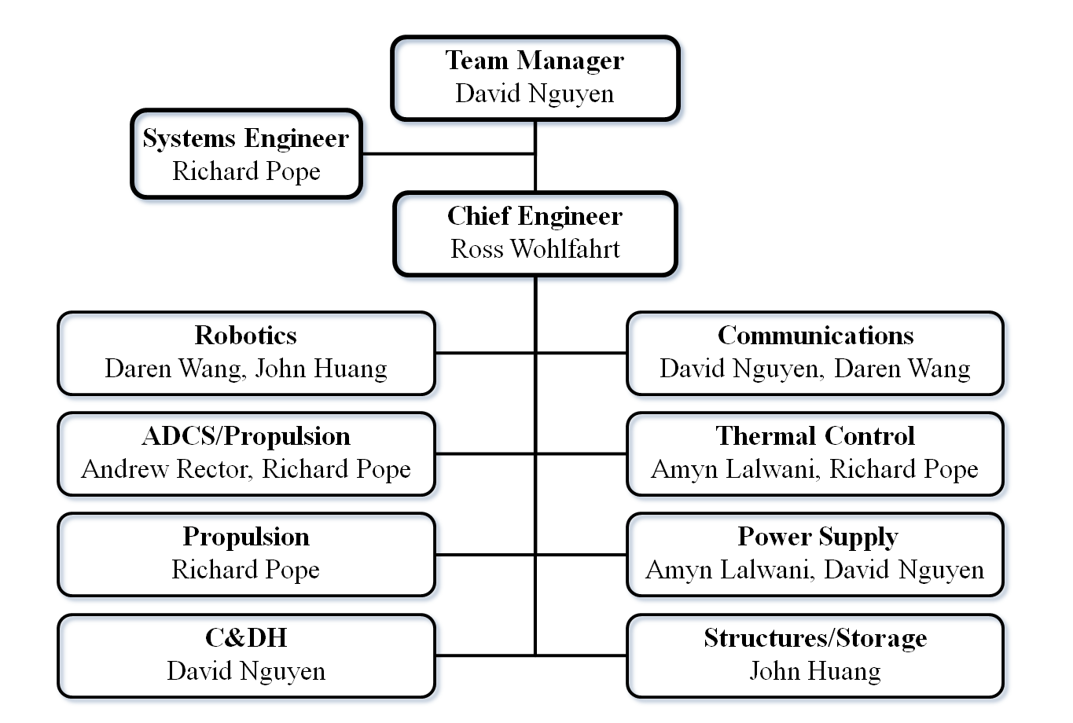

21.8 Résumés

